1. My mother works as a nurse. She comes from Ajloun.
2. The sun rises in the east. Plants need sunlight and water to grow.
3. They go to the club on Fridays. They walk to school every day.
4. Our first lesson starts at 8:30. The train to London leaves at six o’clock in the morning.

Simple Present

Function:

1-Something that is true at present. (permanent)

*He works at the hotel.

2-Things that are always true. (facts)

*It rarely rains in the desert.



3-Things that happen as a routine in the present. (daily /habitual)

*He lays the tables and serves the dinner every day.

4-Schedual or fixed events in the future. (timetable)



*The train to London leaves at 6:30 am.

Time Expressions: -

-every day/week/month/year.

-on Mondays /Tuesdays-------.

-In the morning /afternoon /evening.

-at night /at the week end.

-Adverbs of frequency.

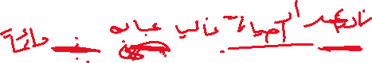

(always, usually, often, sometimes, seldom, rarely, never)



*Emily never watches horror films.

*They are always late.

*They don’t usually buy expensive cars.



Adabi

Form: -

Sentence: - Ali works, brushes, watches, fixes, goes plays, tries,

dresses

They work

Negative: -Ali doesn’t work /They don’t work (Don’t or doesn’t + base verb)

Question: -Does /Do + S + base verb?

Does Ali work?

Do they work?

Note: - The simple present form of verb to be: -

I am he, she, it -is they, we, you -are

Negative: - I am not , is not ,are not .

Questions: -Am I…..? Is he……? Are they……?

Verb be /do /have can work as a main verb and a helper .

He is happy. (main) He does his homework .(main)

He is eating. (helper) He doesn’t do his homework .(helper )

He has two houses. (main )

He doesn’t have a car. ( main)

He has bought a car. (helper )

____________________________________________________________

3elmi

1.My sister is doing her homework now.

2. My father is looking for a new job.

3. You are always losing your things.

4. My friend is seeing the dentist tomorrow in the clinic at 6 o’clock.

Present Continuous

Function: -

1-To talk about something that is happening at the moment of speaking.

*She is reading right now.

2-For actions that happen repeatedly in the present.

We use it with always. (irritation /anger / annoyance)

*You are always forgetting to pay the bills.

3-To discuss something temporary. (around the time of speaking)

*Helen is working hard these days.

4- Fixed arrangement, to talk about the future when time and place have been decided.

Melanie is getting married at 3 o’clock this afternoon.

Form: -

I + am +v+ing .

he, she, it + is +v +ing

they, we, you + are +v +ing.

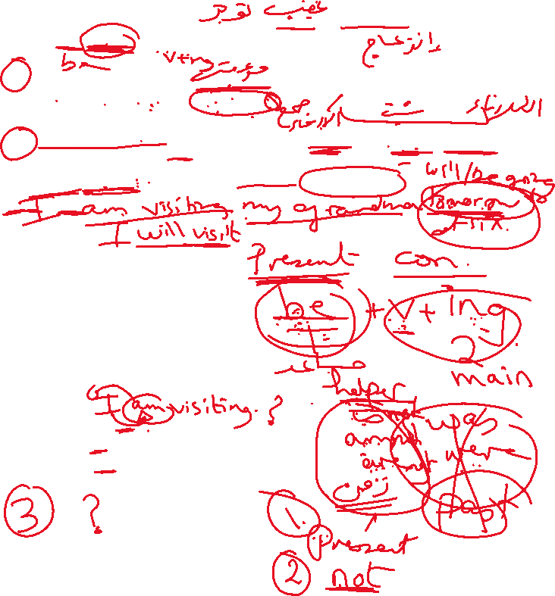

Negative :-I am not +v +ing

he /she/it is not +v+ing

they /we /you are not + v+ing

Questions: -Am I +v+ing…?

Is he /she /it +v+ing …?

Are they/we /you + v+ ing …..?

Time Expressions: _

Now /nowadays /at present /at the moment /right now /tonight /

These days /Look ! / Listen! / Watch out ! / Be careful!



Stative verbs

Do you know how to use stative verbs like *think*, *love*, *smell* and *have*?

Look at these examples to see how stative verbs are used.

*I think that's a good idea.  
I love this song!  
That coffee smells good.  
Do you have a pen?*

**Grammar explanation**

Stative verbs describe a state rather than an action. They aren't usually used in the present continuous form.

*I don't know the answer. ~~I'm not knowing the answer.~~  
She really likes you. ~~She's really liking you.~~  
He seems happy at the moment. ~~He's seeming happy at the moment.~~*

Stative verbs often relate to:

* thoughts and opinion: a*gree*, *believe*, *doubt*, *guess*, *imagine*, *know*, *mean*, *recognise*, *remember*, *suspect*, *think*, *understand*
* feelings and emotions: *dislike*, *hate*, *like*, *love*, *prefer*, *want*, *wish*
* senses and perceptions: *appear*, *be*, *feel*, *hear*, *look*, *see*, *seem*, *smell*, *taste*
* possession and measurement:  *belong*, *have*, *measure*, *own*, *possess*, *weigh.*

**Verbs that are sometimes stative**

A number of verbs can refer to states or actions, depending on the context.

*I think it's a good idea.  
Wait a moment! I'm thinking.*

The first sentence expresses an opinion. It is a mental state, so we use present simple. In the second example the speaker is actively processing thoughts about something. It is an action in progress, so we use present continuous.

Some other examples are:

***have***

*I have an old car.* (state – possession)  
*I'm having a quick break.* (action – having a break is an activity)

***see***

*Do you see any problems with that?* (state – opinion)  
*We're seeing Tadanari tomorrow afternoon.* (action – we're meeting him)

***be***

*He's so interesting!* (state – his permanent quality)  
*He's being very unhelpful.* (action – he is temporarily behaving this way)

***taste***

*This coffee tastes delicious*. (state – our perception of the coffee)  
*Look! The chef is tasting the soup*. (action – tasting the soup is an activity)

Fill in the blanks with the Present Simple or Present Continuous:

1. Ted ____________ **(take)** a shower right now.

2. What ____________ (**we / have)** for dinner tonight?

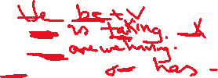

3. My brother __________________ **(have)** a daughter and a son.

4. I __________________ (**not / solve)** some math problems at the moment.

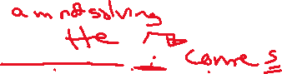

5. My grandfather often ______________ **(come)** over for dinner at the weekends.



6. My school _________________ **(begin)** at nine every day.



7. What time ________________ **(you / wake up)** on weekdays?

8. What ________________ **(you / do)** tomorrow night?

9. I usually ____________ **(not / work)** on Sundays but today I _______________ (**work).**

10. She _______________ (**not / sleep**) now, she _______________ **(study).**

11. How often _________________ (**you / review)** your lessons?

12. I _________________ **(not / go)** on holiday this summer.

13. Can you speak slowly please, I __________________ **(not / understand)** you.

14. She _________________ (**work)** as a secretary in a big company.

15. Miss Clara __________________ **(take)** a violin class every Wednesday.

16. It _______________ **(be**) usually so humid here in summer time.

17. Don’t forget to take your coat, it ___________________ **(be)** cold outside.

18. This flower __________________ **(smell)** so good.

19. That coat over there ___________________ **(not / belong**) to me.

20. Where _________________ **(you / live)?**