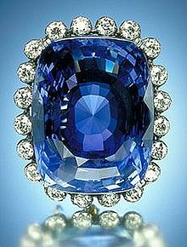

**Sapphire**

………………………………………………………………………………………………………………………………………………………………



**Suspicious**



**Depart**

………………………………………………………………………………………………………………………………………………………………

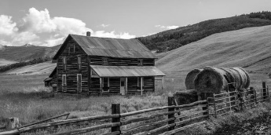

**Isolated**

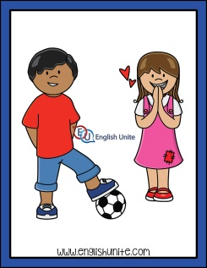

**Admire**

………………………………………………………………………………………………………………………………………………………………

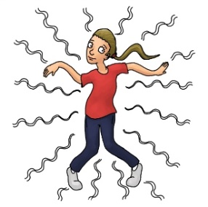

**Wriggle**



**Skeptical**

………………………………………………………………………………………………………………………………………………………………



**Hazardous**

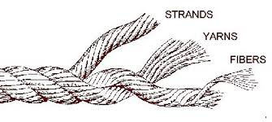

**Strand**

………………………………………………………………………………………………………………………………………………………………

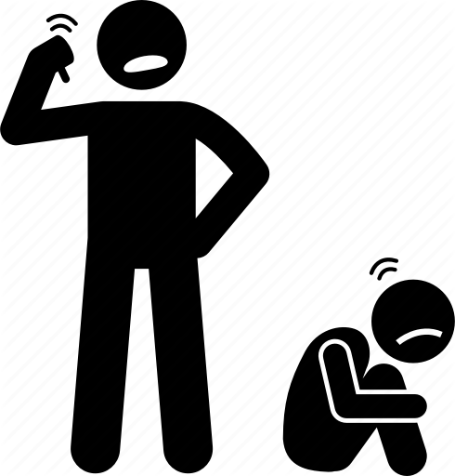

**Discourage**



**Labor**

………………………………………………………………………………………………………………………………………………………………

**Gratefully**



**Shone**

………………………………………………………………………………………………………………………………………………………………



**Base**



**Unseen**

………………………………………………………………………………………………………………………………………………………………

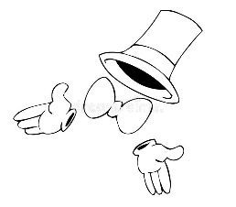

**Fade**

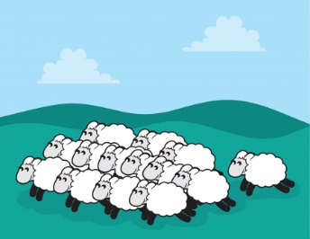

**Herds**

………………………………………………………………………………………………………………………………………………………………