-

The National Orthodox School/AL-Ashrafieh

Science Worksheet/**Unit 8: Magnetism**

Name: Date: / /2023

Grade: 6(A+B)

**1- Structure of an atom**

-All matters are made of atoms.

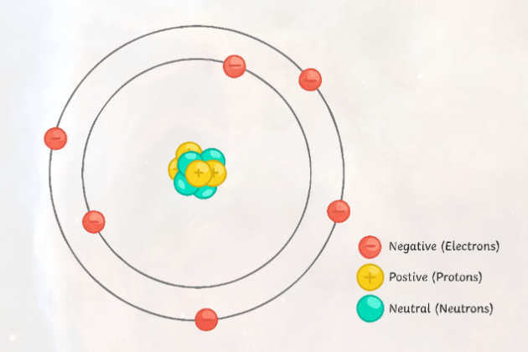- Atoms are made up of protons, neutrons and electrons

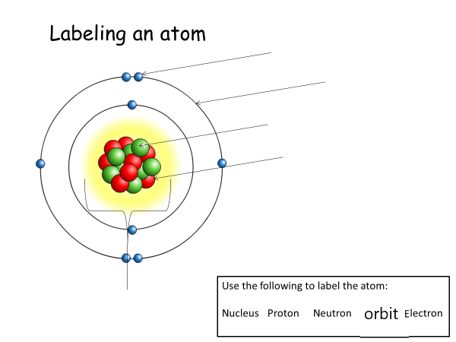

## **2- Types of Charges**

There are two types of charges:

1. **Positive Charge** is one who lost its electrons and becomes

positively charged.

1. **Negative Charge**is one which gains electrons and becomes

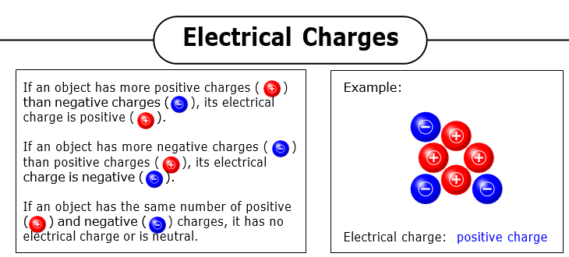 negatively charged.

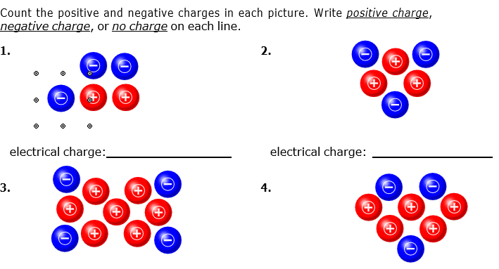



## **2- Static Electricity**

**Static electricity** is the **build-up of an electrical charge** on the surface

of an object.

**- Examples of static electricity in our life:**

1- When we rub the comb into hairs and take it near small pieces of

paper, all the paper pieces get attracted towards the comb

2- When pants or skirts stick to your legs

3- Walking across a carpet.

* **Static electricity can be produced by:**

1. **Friction 2- Conduction 3- Induction**
2. **By rubbing**

When two neutral objects are rubbed against each other, one object may pull electrons away from the other creating one positive object and one negative object.

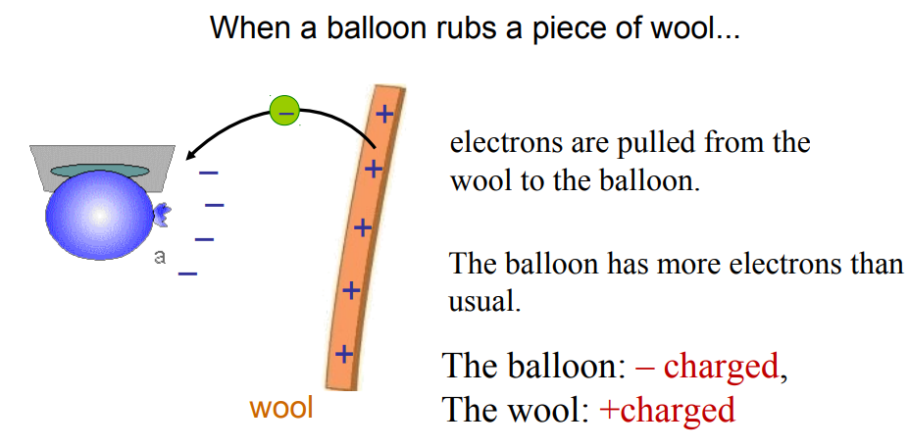

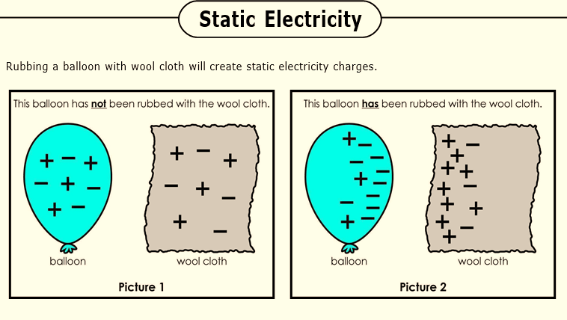

1) In Picture 1, does the balloon have a positive charge, negative charge, or no charge?

2) In Picture 1, does the cloth have a positive charge, negative charge, or no charge?

3) In Picture 2, does the balloon have a positive charge, negative charge, or no charge?

4) In Picture 2, does the cloth have a positive charge, negative charge, or no charge?

5) Complete the blanks for the following two materials

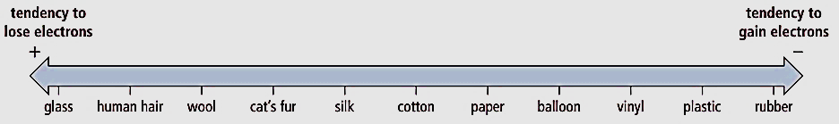

**Object 2: Glass**

**Object 1: Rubber**

- __________and ___________ have high ability to gain electrons.

- The final charge on object 1: _____ . The final charge on object 2: ___

1. **By conduction (By direct touching)**

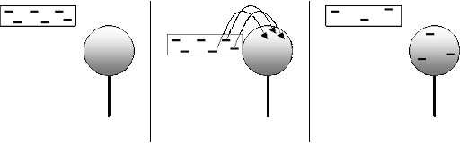Charging by conduction: the transfer of electrons from one object to another by direct contact. (Like when you rub your feet on the carpet, but the charges move to your hands)

**The resulting object will then have the same charge.**

1. **By induction**

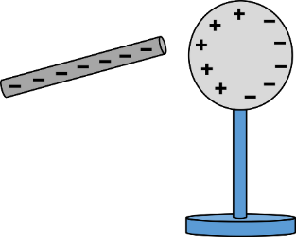 Induction charging is a method used to charge an object without actually touching the object to any other charged object.

When an uncharged object is placed very close to a charged object without touching, the nearer end acquires a charge opposite to the charge on the charged object and the two bodies attract. The net charge on the bodies remains the same and body is charged until they are kept close.

**Good and bad conductors of electricity**

|  |  |
| --- | --- |
| **Good conductors** | **Bad conductors (insulators)** |
| **A substance which allows electric current to flow through it.** | **A substance that does not allow electric current to flow through it** |
| **All metals are good conductors of electricity.** | **Insulators are usually non metals.** |
| **Eg. aluminium, copper, silver, water, graphite, human body.** | **Eg : glass, wood, plastic, rubber** |

**Choose the correct answer.**

1- When plastic is charged by rubbing it with a cloth:

a- It can repel small pieces of paper

b- It can attract small pieces of paper

c- It does nothing when brought near small pieces of paper

2- When a piece of plastic becomes positively charged it has:

a- gained protons b- gained electrons c- lost electrons

3- When negatively charged body is brought near a suspended positively charged ball, the ball gets:

a- attracted b- repelled c- stay at same place

4- A material that allows the free flow of electric charges**.**

a- conductor b- insulator c- none of them

5- In charging by induction a charged body and an uncharged body:

a- Touch each other b- Do not touch each other c- Both 1 and 2 are correct

6- When a piece of plastic becomes negatively charged it has:

a- gained protons b- gained electrons c- lost electrons

7- When two plastic rods with the same charge are brought near each other they:

a- repel b- attract c- point north

