**Name:** _______________ **worksheet:** Acids & Alkalis

**Date:** ________________ **Grade:** 6CS

**Objectives:**

* Compare the properties of acids and alkalis and give examples.
* Know the pH of acidic, alkaline and neutral solutions.

***Question One:*** *Compare and contrast acids and alkalis by completing the following table.*

|  |  |  |
| --- | --- | --- |
|  | ***Acids*** | ***Alkalis*** |
| ***pH range*** |  |  |
| ***What to look for in chemical formula*** |  |  |
| ***Production of ions*** |  |  |
| ***Taste*** |  |  |
| ***Examples*** |  |  |

***Question Two:*** *Classify the following examples as acids, bases, or salts.*

HBr ________________ KCl ________________

Mg(OH)2 ________________ H3PO4 ________________

HClO ________________ KNO2 ________________

Al(OH)3 ________________ HFO4 ________________

Ba(OH)2 ________________ CaCO3 ________________

***Question Three:*** *Name the following acids and alkalis.*

HCl _______________________ HNO3 _______________________

H2SO4_______________________ NaOH _______________________

KOH _______________________ Mg(OH)2_______________________

***Question Four:*** *Use the pH scale to answer the following questions.*

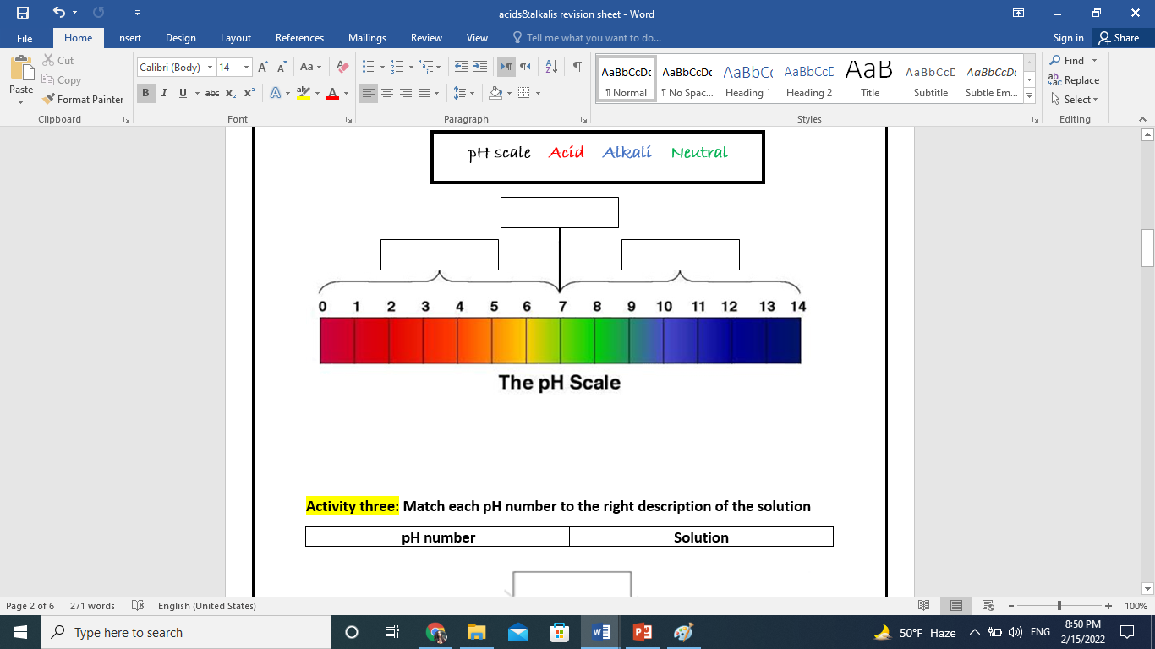

1. Fill in the boxes with the correct words.
2. How would you describe a substance with a pH of 6? _______________________
3. Sodium hydroxide is a very strong base so it would have a pH of ___________.
4. What pH would you expect a strong acid to have? ______________
5. Neutral substances would have a pH of ______________.

***Question Five:***

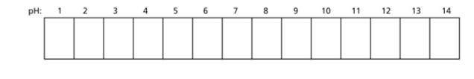The pH scale demonstrates how strong an acid or an alkali is. The colors on a pH color chart show the color that universal indicator turns with acids and alkalis of different strengths.

A B C D E

___________ ___________ __________ ___________ ___________

a) *Color the pH color chart below to show what color universal indicator turns with different strengths of acids and alkalis.*

b) *Identify the labels A to E, choosing from the words below:*

***strong acid weak acid strong alkali weak alkali neutral***

***Question Six:***

*Fill in the table below with the expected results of using* ***litmus paper.***

|  |  |  |  |
| --- | --- | --- | --- |
|  | Acidic solution | Neutral solution | Alkaline solution |
| Blue litmus paper |  |  |  |
| Red litmus paper |  |  |  |

***Question Seven:*** Complete the following sentences.

1. A neutralization reaction will always produce ________________________.
2. A solution is neutral at pH__________________.
3. An alkali is able to “cancel” out an acid. The chemical name for cancelling out the acid is ________________________.

***Question Eight:*** Complete the following neutralization reactions.

_________ + KOH KBr + _________

Potassium must come from the base. Therefore, the base must be KOH.

Bromine must come from the acid. Therefore, the acid must be HBr.

HCl + _________ _________ + H2O