
Worksheet (7)
Grade One
Name: Date: 10 / 4/2023 _______________________________________________________________
Objective: To spell plural nouns correctly.
Singular and plural
We can write nouns in the singular or the plural form.
Singular means just one.
Plural means more than one.
To make regular nouns plural, add -s or es at the end of the nouns. 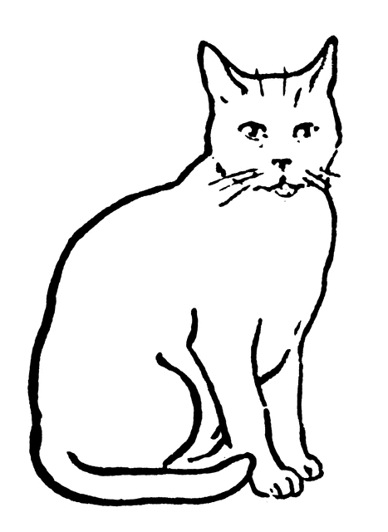

One cat two cats
Singular noun plural noun
Most nouns add –s
pen- pens
cup- cups

Nouns ending in (ch, -sh, -s, -x, -z)
add –es
box-boxes
watch - watches

Irregular plural nouns: Nouns that don’t follow the rule.
Examples:
Singular | Plural
tooth | teeth
mouse | mice
man | men
goose | geese
person | people

Some nouns stay the same
Examples:
Singular | Plural
fish | fish
sheep | sheep
deer | deer

- Make the singular noun plural.
Singular | Plural
hat | hats
girl | girls
watch | watches
mouse | mice
fish | fish

2.Fill in the correct plural forms of the words:

1.I see three women_(woman) there.

2.There are two boxes (box) on the table.

4.There are a lot of mice(mouse) there.

5.I like to eat apples (apple).

6.I don’t like fish(fish).
8.Look at these buses(bus). They are red.

T.Taghreed

