
Meaning Worksheet (3)/ Unit Seven
Grade One
Name: Date: /5/2023
Objectives: 1-To identify the meaning of new words.
2- To practise using the new words in sentences.
1)Study the words below:
word | meaning
warm | 
hot | 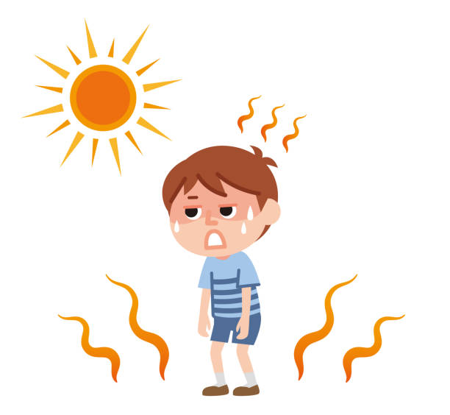
cool | 
cold | 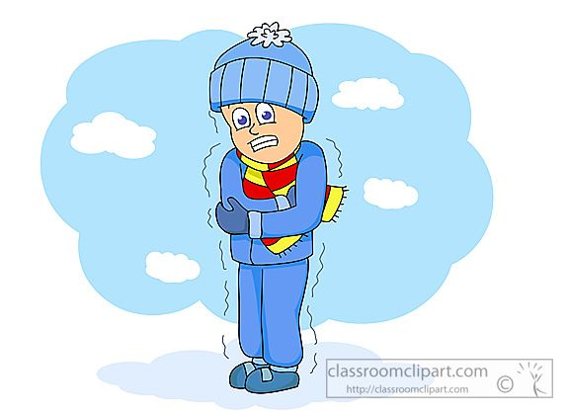
rain | 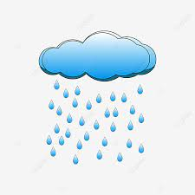
snow | 
long | 
short | 
time | 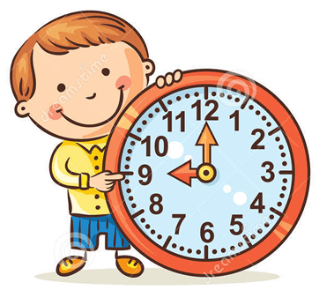
weather | 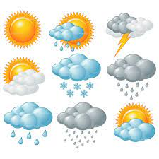

2) Circle the correct word:

weather -long - short

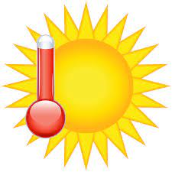
cold - cool - hot

3)Fill in the blanks with the correct word:
weather cold time warm hot
1- What time is it? It is 6 o’clock.
2- In spring, the weather gets warm.
3- This tea is very hot.
4- It is snowing outside! It’s really very cold.
5- I don’t like cold weather.

3)Use the following words in sentences of your own.
-short: ____________________________
- cool: ______________________________

T. Taghreed Alnimri Coordinator’s signature:

