 The Primary Stage of Grades 1-3

Individual (2)

Name: ______________ Grade: Two ( )

Date: *_______________*  Term two

* **Write a summary of Polar Bears report based on the facts you have heard.**

|  |
| --- |
|  |

appearance (looks like) food

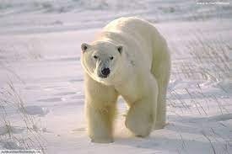 habitat

**Success criteria for writing**

|  |  |  |
| --- | --- | --- |
| **Structure and content** | Points | Comments |
| There is a heading | 1 |  |
| There are subheadings | 1.5 |  |
| There is a simple introduction | 0.5 |  |
| The text explains the subheadings | 3 |  |
| The text has a caption | 1 |  |
| **Vocabulary** |  |  |
| The text has interesting words | 1 |  |
| **Punctuation and grammar** |  |  |
| Sentences have full stops, questions marks or exclamation marks at the end | 1 |  |
| There are capital letters at the beginning of sentences, names and places | 1 |  |
| Verbs are in the present tense | 1 |  |
| Connectives are used correctly. | 1 |  |
| **Spelling** |  |  |
| Common words are spelled correctly. | 1 |  |
| New words are decodable. | 0.5 |  |
| **Handwriting** |  |  |
| Letters are in a good size and have regular spaces between them. | 1 |  |
| The handwriting is clear. | 0.5 |  |