

Practice Paper / Used to

Grade (4)

Name: Date: / /2023

|  |
| --- |
| **Objectives**:  1. To identify the verb “**used to”** and its use  2.To practice using “used to” in sentences. |

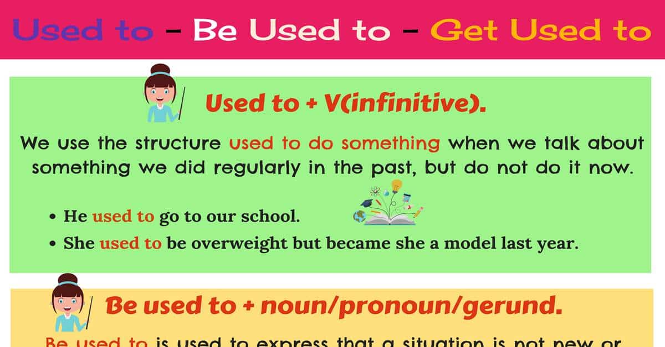



**Sentence structure**:

**Affirmative:** Subject + **used to + infinitive verb** + Object.

**Sentence:** He **used t**o go to London every summer.

**Negative sentence**: Subject + **didn’t use to + infinitive verb** + Object.

**Negative:** He did**n’t use to** go to London every summer.

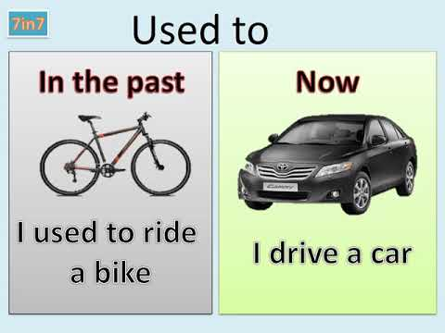

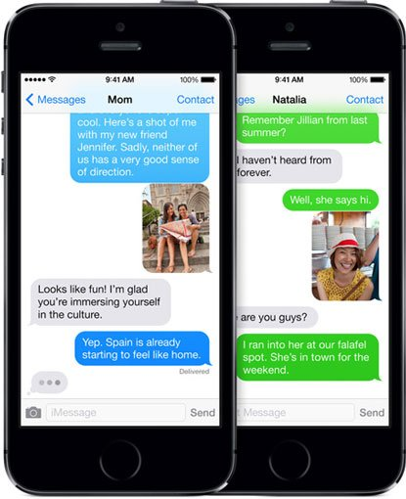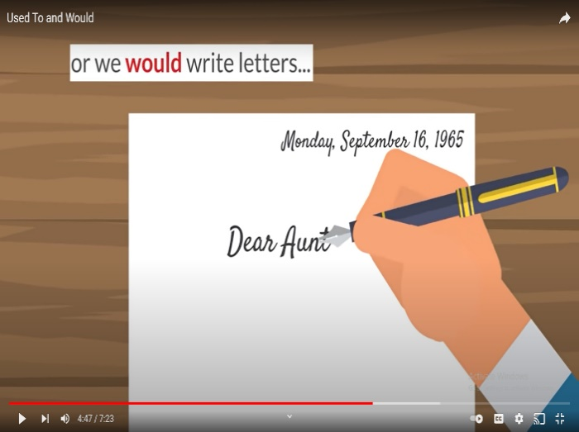

**EX: I used to write a letter to my friends, but now I use my phone to text them.**

**Q1) Choose the correct form for each sentence.**

1. I ------------------in Jordan when I was a child. **(used to** **live- lived)**

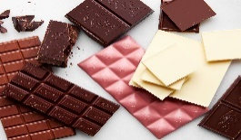2. She -----------------eating chocolate, but now she hates it. **(used to** **love- loved)**

3. He ------------------to the beach at 9:30 this morning. **(used to go -went)**

4. I -------------------tennis when I was at school.

**(used to play –played)**

**Q2) Choose the correct answer.**

1. **I ------------ to the beach every day last summer.**
2. used to b. used to go c. go
3. **Susan --------- drink milk when she was young.**
4. used to b. did use c. was
5. **Ancient People ------------- on horses.**
6. used to travel b. travelled c. travel
7. **Tom ------------ his new T-shirt this morning.**
8. wear b. wore c. used to wear
9. **Sally ----------------- her grandma every weekend.**
10. used to see b. saw c. see
11. **Tom --------------- his T.V show last night.**
12. used to watch b. watched c. watch

**Q3) Rewrite each sentence below using “used to”**

1. **Last year, I went to school on foot. Now I ride my bike.**

I used to go to school on foot, but now I ride my bike.

**2. Last year, I didn’t study. Now I study very hard.**

I didn’t use to study, but now I study very hard.

**Q4) Write 2 things that you used to do when you were a baby.**

1. I used to stuck my thumb.

2.I used to wear a diaper. 

Q5) Write sentences to answer the question, What did they use to do in the past ?. Use “ used to “.

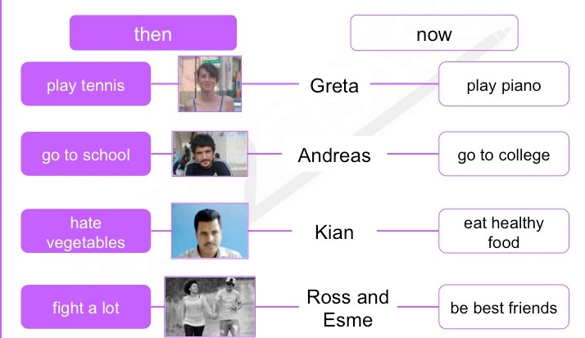

1.Greta used to play tennis, but now she plays piano.

2.Andreas used to go to school, but now he goes to college.

3.Kian used to hate vegetables, but now he eats healthy food.

4.Ross and Esme used to fight a lot, but now they are best friend.

Teacher: Raneem Haddad.

Coordinator’s Signature: ___________.