

Phrasal verbs with take/ Grade (4)

Name: Date: / /2023

|  |
| --- |
| **Objectives**: 1. To define the meaning of each phrasal verb with “take”.  2. To learn how to sort the phrasal verb with “take” in sentences.  3. To learn how to use the phrasal verb with “take” in sentences. |

**Phrasal verbs**

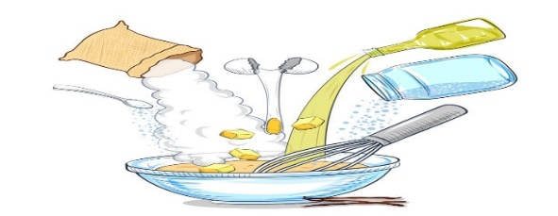**A phrasal verb is a combination of 2 words that create a different meaning.**

**Verbs**

**Prepositions**

**+**

|  |  |  |
| --- | --- | --- |
| **Phrasal verbs** | **Meaning** |  |
| **1.Take down** | **To remove** |  |
| **2.Take in** | **To realize or understand.** |  |
| **3.Take after** | **To look after or take care of something or someone.** |  |
| **4.Take over** | **To take resposibility or duty from someone else.** |  |
| **5.Take up** | **To start new hobby,job or activity.** |  |
| **6.Take apart** | **To separarte into pieces.** |  |
| **7.Take off** | **Remove clothing or things from someone’s body.** |  |

1. **Write the phrasal verbs in the box under the correct definition.**

|  |
| --- |
| **take in / take after/ take away / take up/ take apart**  **take down.** |

**To remove**

**Assume control of something**

**To realize or understand.**

**Start doing a new activity**

**1.take down 2. take in 3.take up 4. Take over**

**To separate things**

**To take care of someone.**

**5. take after 6. take apart**

**2) Match the beginnings (1-4) with the endings (A-I).**

**a) after you at all.**

**b) in everything that’s in a text.**

**c) up a job as a teacher.**

**d) over as managing director when Bill**

**retires.**

**1) Mary has taken**

**2) Your daughter doesn’t take**

**3) Alan will take**

**4) When the teacher reads quickly, Ann can’t take**

|  |
| --- |
| **1c 2 a 3 d 4 b** |

**3) Complete the sentences with the correct phrasal verb.**

**take in / take apart / take over /take up / take down/take after**

1. They take apart the engine to clean it.
2. He’s going to take up photography in his free time.
3. The company is expanding and taking in a new staff.
4. Miss Sara will take over the duties of Miss Susan during her absence.
5. Adam takes after his father because of his illness.
6. My mom made us took down all the stickers on the walls.

**4) Use any four phrasal verbs in sentences of your own.**

1. -------------------------------------------------------------.

2. -------------------------------------------------------------.

3. -------------------------------------------------------------.

4. -------------------------------------------------------------.

**English Department Teachers**