

**Grammar Worksheet**

Measure words

Grade ( 3 )

Name: Date: / /2023

|  |
| --- |
| **Objectives:**  1.**To learn how to measure uncountable nouns.**  **2.To practice using measure words.** |

The measure words are used to explain the quantity of something which is uncountable.

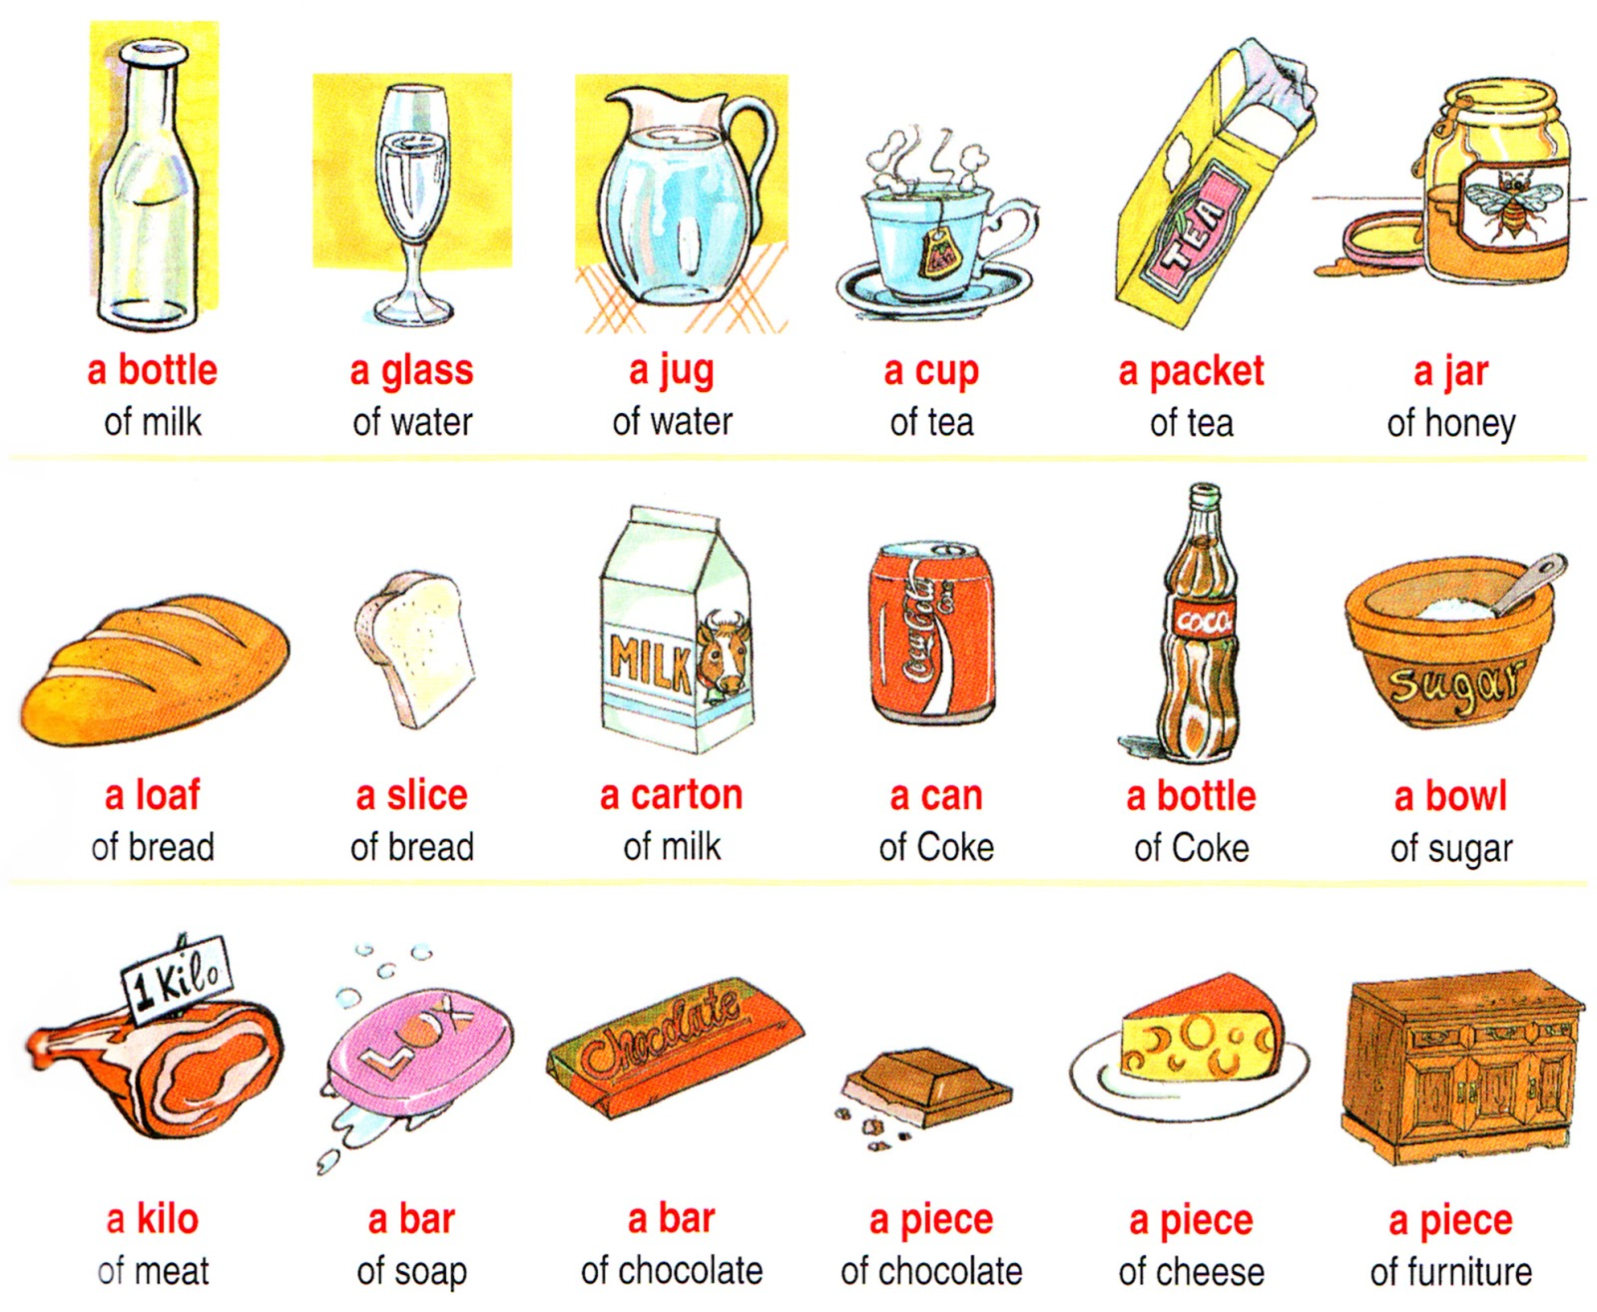

**Q1) Write the correct measure word under the picture with the correct noun.**

|  |
| --- |
| **a jug / a slice / a cup / a carton / a jar / a box / a bottle a bowl / a glass / a piece .** |
| **of cake / of tea / of cola / of strawberry milkshake / of milk / of jam / of soup / of juice / of meat / coffee** |

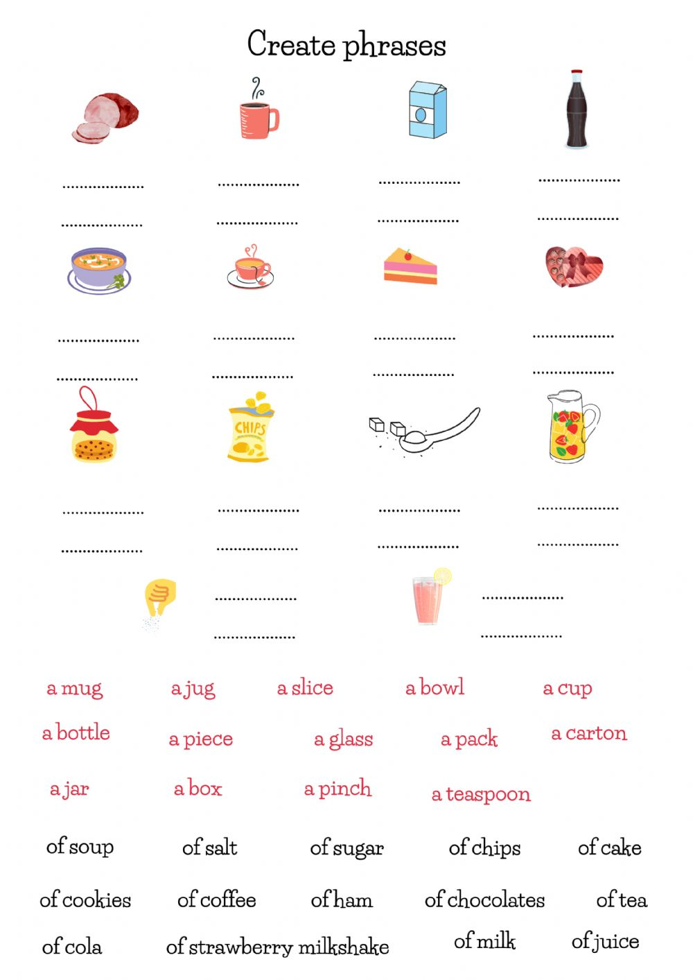

 

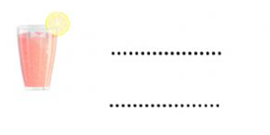

**Q2) Complete the sentences with the correct measure word from the box.**

|  |
| --- |
| cup of / dozens of / glass of / bowls of / bag of / loaf of /  kilograms of/ jars of/ carton of / piece of / slice of/bar of |

1. They have a cup of tea and a slice of pizza for breakfast.
2. I’m on a diet! I can’t eat even a bar of chocolate.
3. My father buys a loaf of bread every day.
4. There are three dozens of spoons at home.
5. There are many jars of honey here.
6. Please bring five kilograms of oranges.
7. I have to drink a carton of milk every night.
8. Can you put another piece of cake for me please.
9. It is very hot! Can you bring a glass of juice?
10. There are two bowls of rice there.

**Q3) Order the words to make meaningful sentences.**

1. always/ I/ water / of / in / my bag / carry /a bottle .

**I always carry a bottle of water in my bag.**

1. need / you/ Do/ a loaf/ bread / of /?

**Do you need a loaf of bread?**

**Q4)** **Choose the correct measure word.**

1. A **bag / bar** of chocolate a day helps keep stress a bay.
2. A **spoon / glass** of milk a day is very good for your bones.
3. I would like to buy a **bottle / box** of orange juice.
4. Let me cut a **loaf / slice** of toast for you.
5. My mum needs a **carton / bag** of flour.

Teacher : Raneem Haddad Coordinator’s Signature : _________.