

**Grammar Worksheet**

Countable and uncountable nouns

Grade ( 3 )

Name: Date: / /2023

|  |
| --- |
| **Objectives:**  1.To learn about countable and uncountable nouns.  2.To practice asking about quantity. |

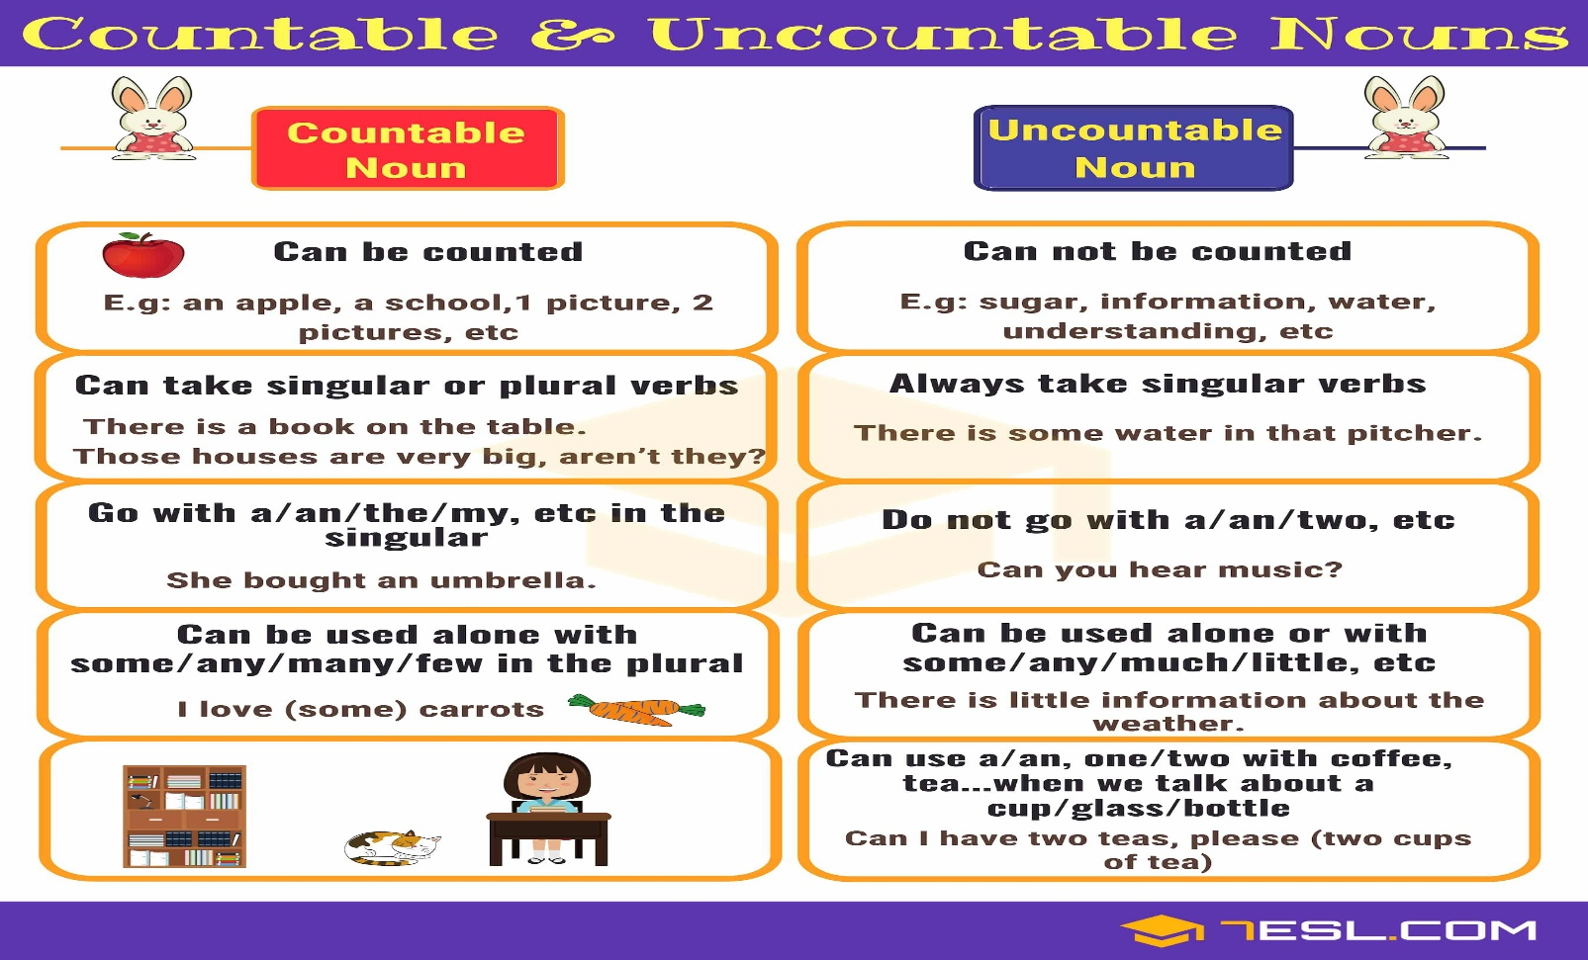

|  |  |
| --- | --- |
| **Countable nouns** | **Uncountable nouns** |
| **Table / Chair / apple / book / pen / dog / cat / student / banana/ egg / sandwich / cup / cookie / toy / watermelon.** | **Water / juice / soil / sand / coffee/ milk / sugar / salt/ rice / cheese/ meat/ bread/honey/flour/cotton / money / gas / tea / oil / time.** |

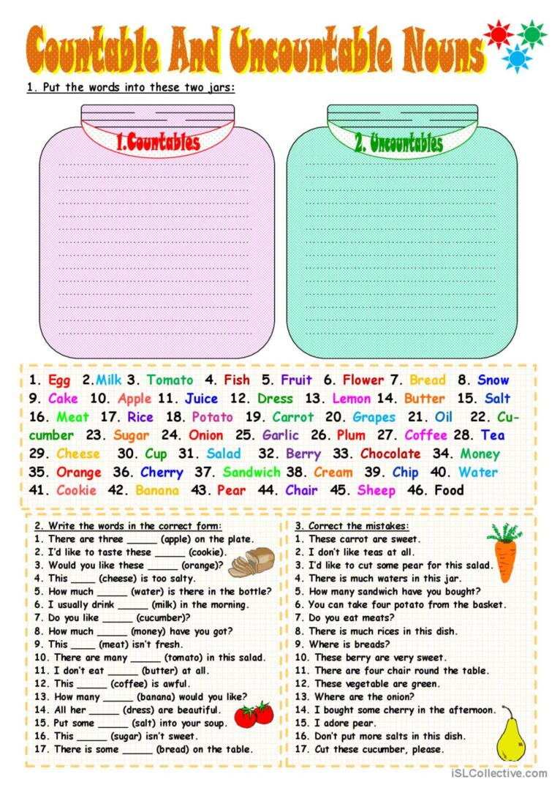

* **We use How much to ask about the quantity of uncountable nouns and How many to ask about the quantity of countable nouns.**
* **Examples:**

1. **How many** **brothers and sisters** do you have?
2. **How much** **milk** is in the fridge?

**Q2) Complete the sentences with many or much .**

**Example:** There are **many** students in th school. There is **much** rice in the bowl.

1. I’ve got ______ stories.
2. There isn’t _________ oil at home.
3. There are___________ flowers in the garden.
4. There are ________ desks in our class.
5. There isn’t __________ coffee in the cup.
6. There isn’t __________ flour at home.

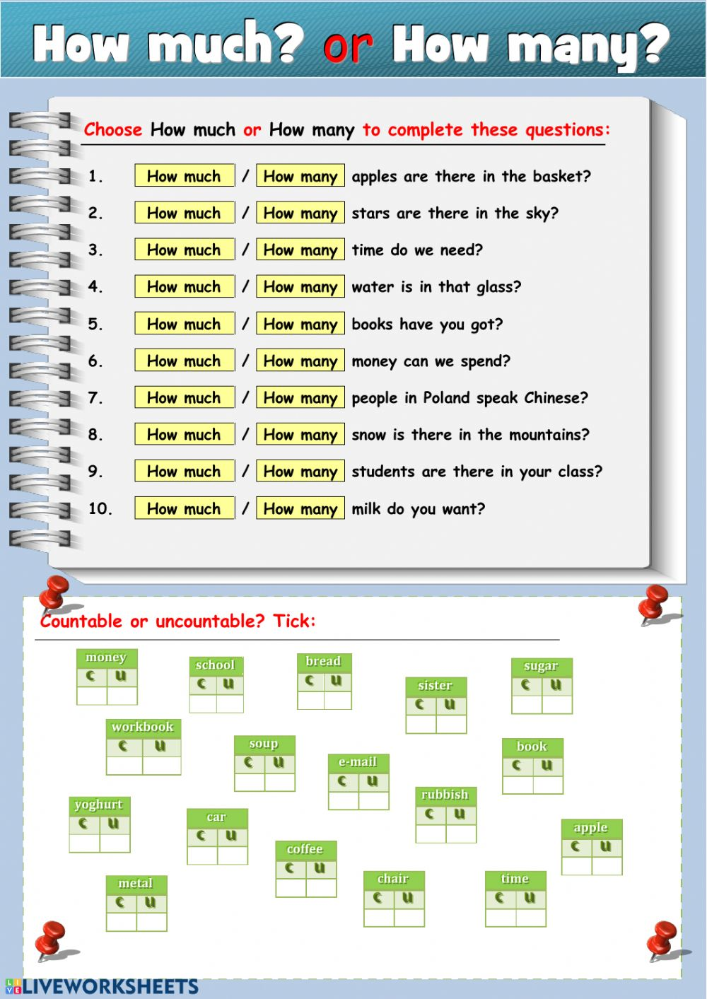

**Q3) Complete the questions with How many or How much.**

1. ________________tea do you drink?
2. ________________ people work in the office?
3. ________________colors are in the rainbow?
4. ________________ dogs do you have at home?

Q4) Write the correct word under each picture then divide them into countable and uncountable noun in the box.

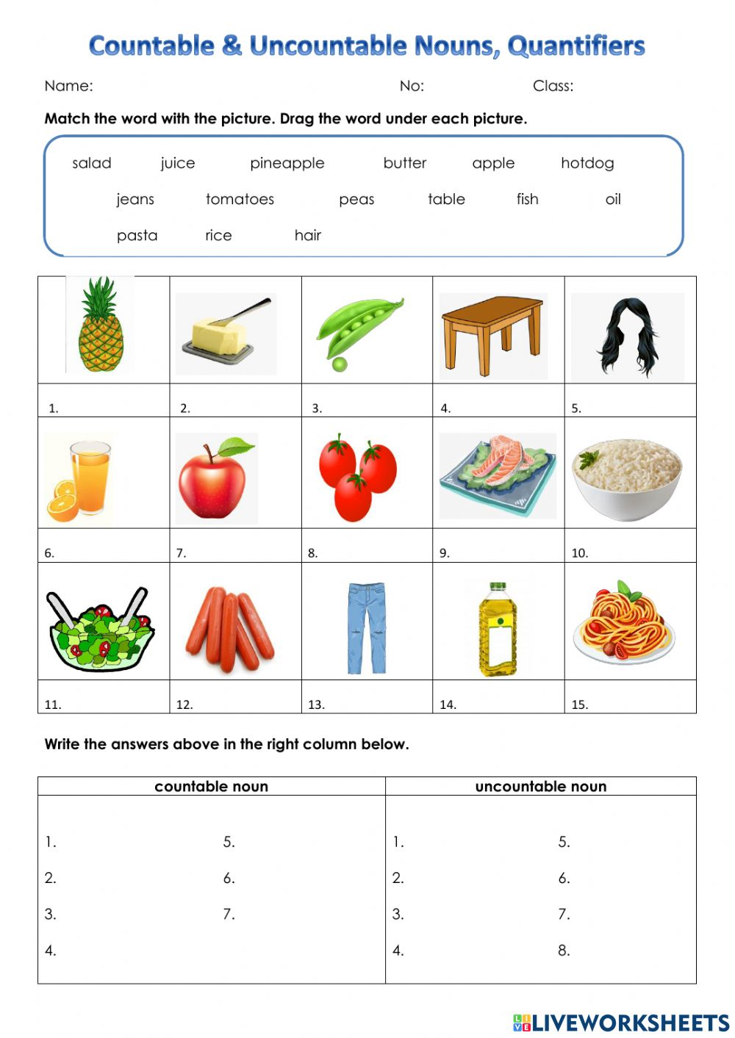

Teacher : Raneem Haddad Coordinator’s Signature : _________.