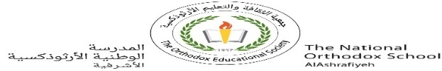

**Value*:*** “Respect yourself above all.”

The National Orthodox School

Science Worksheet

Name: Grade: 3(A+B)

Date: / /2023

***Planets of the Solar System***

Identify the planets and write their names.

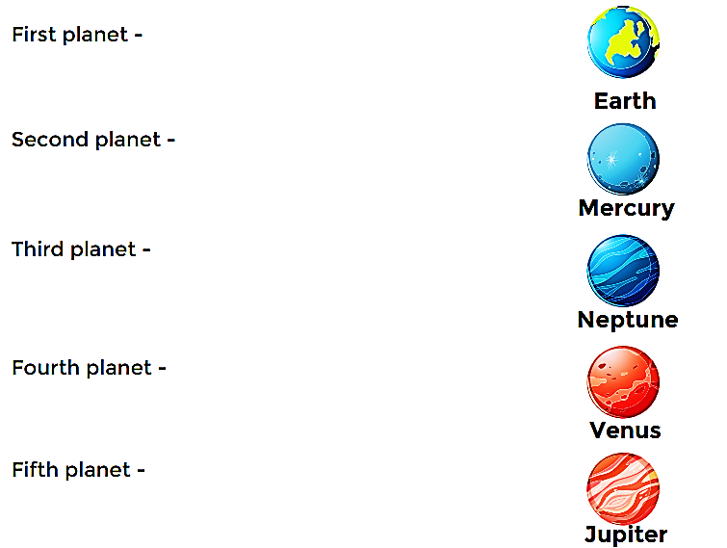

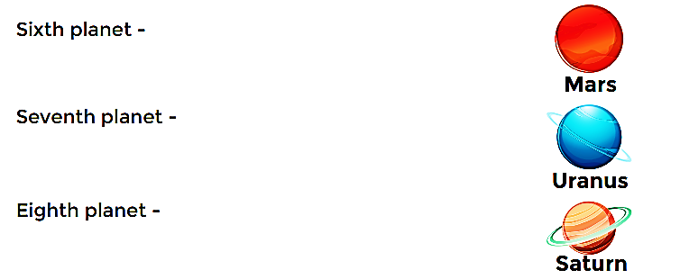

**Fill in the missing letters - Solar system**

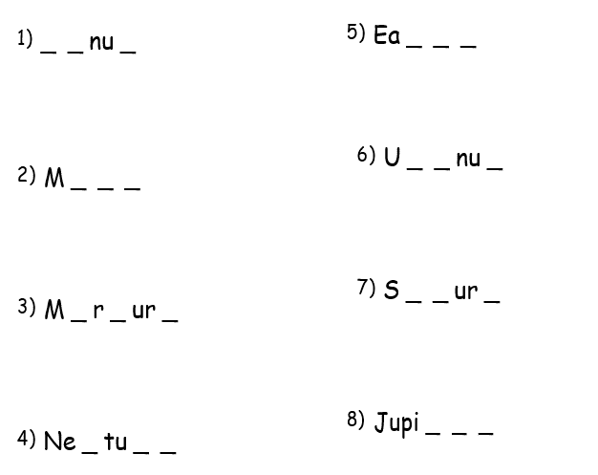

Which planet is your favorite? Why?

...................................................................................................................

..................................................................................................................