

Practice Paper /Ordering Adjective

Grade (4)

Name: Date: / /2023

|  |
| --- |
| **Objective**: To identify the types of adjective.  To practice ordering adjectives. |

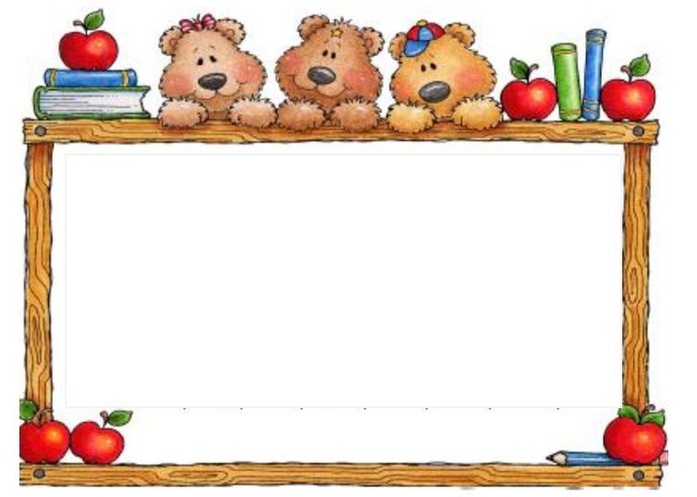 **Adjectives**: Words that describe nouns.

An adjective normally goes before a noun:

**Adj noun**

He has a **big car.**

**Adjectives like** good, bad, beautiful, etc. are “**opinion**” adjective. These adjectives describe what you think about something and go before adjective like **new, big**, etc. Which are “**fact**” adjective.

They have a **beautiful big house.**

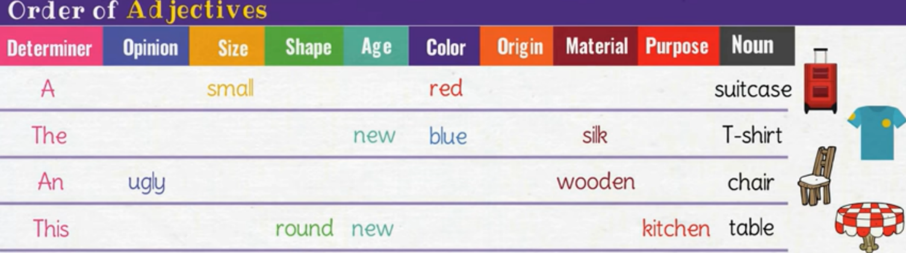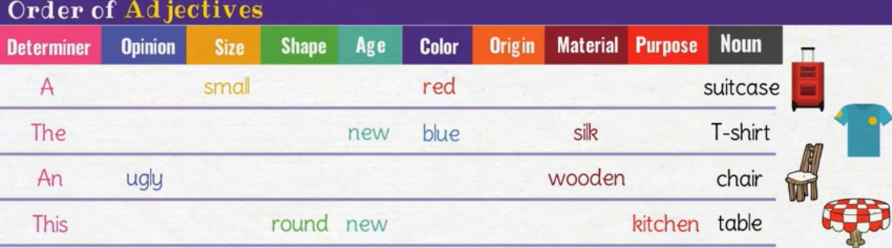**When there are two or more adjectives, they go in the following order:**

|  |  |  |  |  |  |  |  |  |
| --- | --- | --- | --- | --- | --- | --- | --- | --- |
| **Determiner** | **Opinion** | **Size** | **Age** | **shape** | **Color** | **Origin** | **Material** | **Nouns** |
| **A** |  | **Small** |  |  | **red** |  |  | **suitcase** |
| **An** | **comfy** |  | **new** |  | **blue** |  | **Silk** | **T-shit** |
| **This** |  |  | **old** | **round** |  |  | **kitchen** | **table** |

**Q1) Put the words given in each sentence in the correct order. Pay attention to the order of the adjectives in the chart above.**

1. I want to buy (**silk / green / an / amazing**) dress.

---------------------------------------

1. She drank (**Italian / black / hot**) coffee.

---------------------------------------

1. He has (**silver / old / beautiful / a**) ring.

-----------------------------------------.

1. We ate (**green / English / round / some**) apples.

---------------------------------------------.

1. I need (**computer / comfortable / a)** desk.

--------------------------------------------.

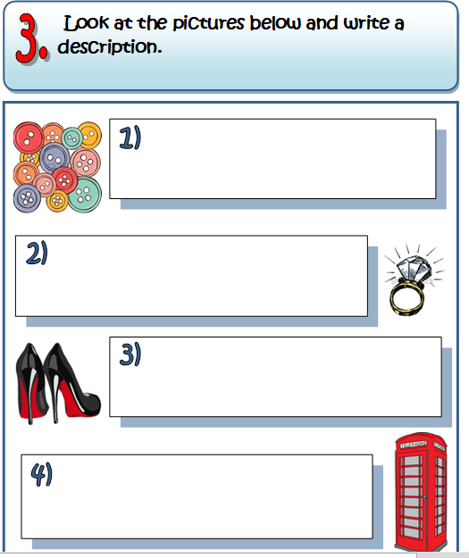**Q2) Look at the pictures below and describe them using more than one adjective.**

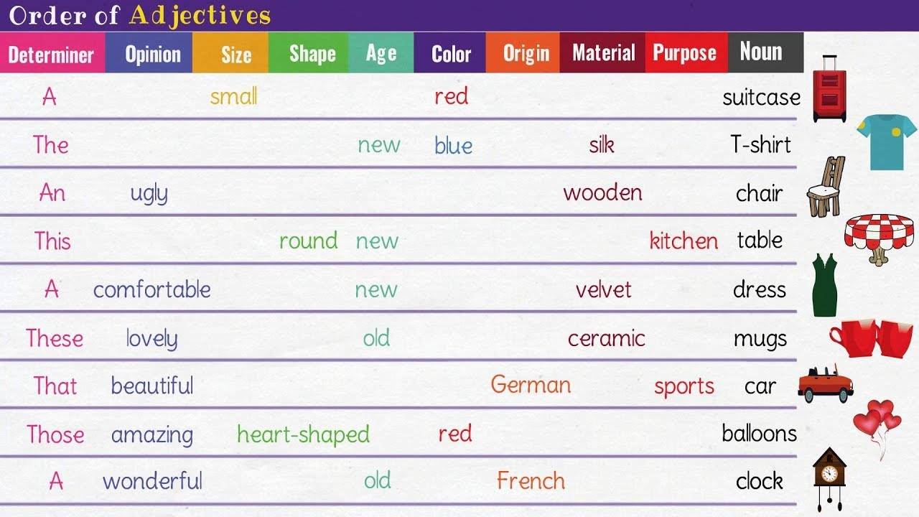**1.**I like these--------------- buttons.

**2.**What an ----------------------- Chinese cup.

**3.**It was a --------------------------------- shirt.

**4.** That -----------------------------car.

**Q3) Put the adjectives in the write column.**

**Enormous, tiny, gorgeous, table, delicious, door, silly, this, square, old, new, expensive, cotton, sliver, silk, round**

|  |  |  |  |  |  |  |  |  |
| --- | --- | --- | --- | --- | --- | --- | --- | --- |
| **Determiner** | **Opinion** | **Size** | **Age** | **shape** | **Color** | **Origin** | **Material** | **Nouns** |
|  |  |  |  |  |  |  |  |  |
|  |  |  |  |  |  |  |  |  |
|  |  |  |  |  |  |  |  |  |
|  |  |  |  |  |  |  |  |  |
|  |  |  |  |  |  |  |  |  |

**Q4) Write three sentences using more than two adjectives in the sentence.**

1. **---------------------------------------.**
2. **-------------------------------------.**
3. **--------------------------------------.**

**English department teachers**