

Antonyms /Grade (4)

Name: Date: / /2023

|  |
| --- |
| **Objectives**: To identify antonyms.  To practice using antonyms. |



**Antonyms:** Are words that have **opposite** meanings.

**Examples:**

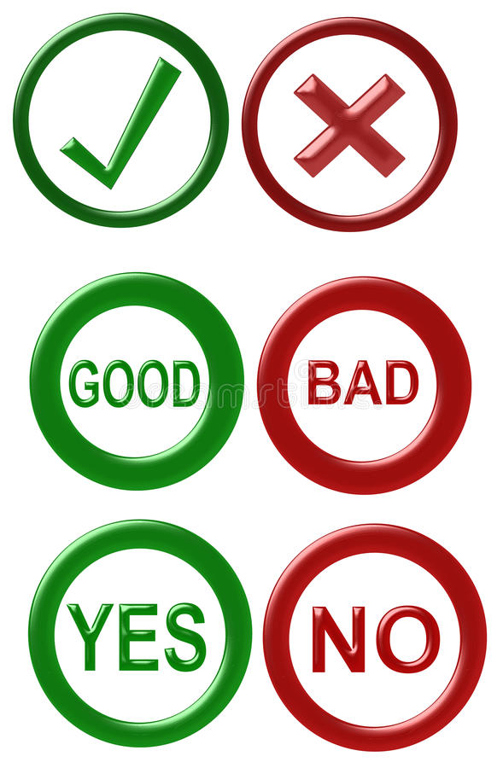

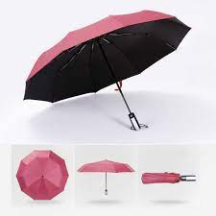

1. You can **expand** this compact umbrella to cover a large table.
2. You can **shrink** down this compact umbrella to put it in your bag.

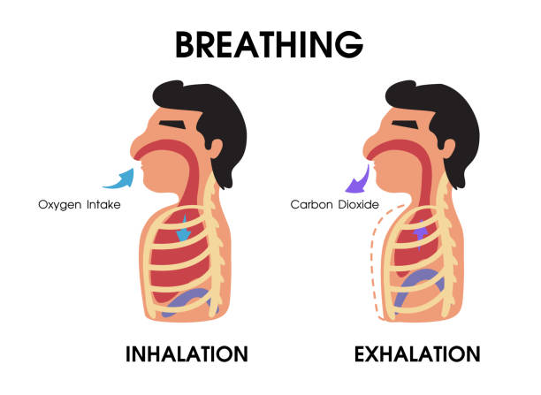

* On each breath, inhale and exhale a little more air.

**Q1) Write the best antonyms under each picture.**

|  |
| --- |
| **Down sad cold empty float small go tall** |

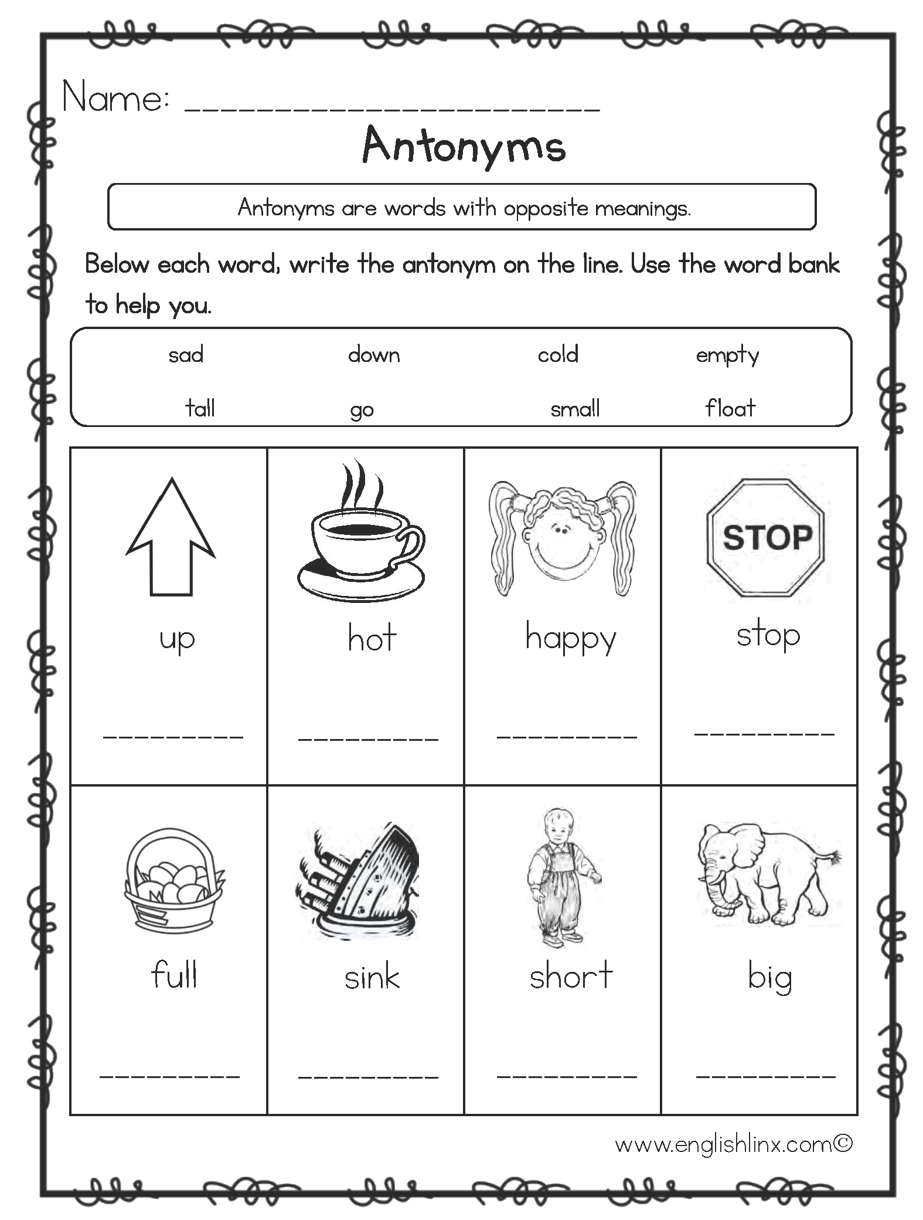

--Down cold sad go



Empty float tall small

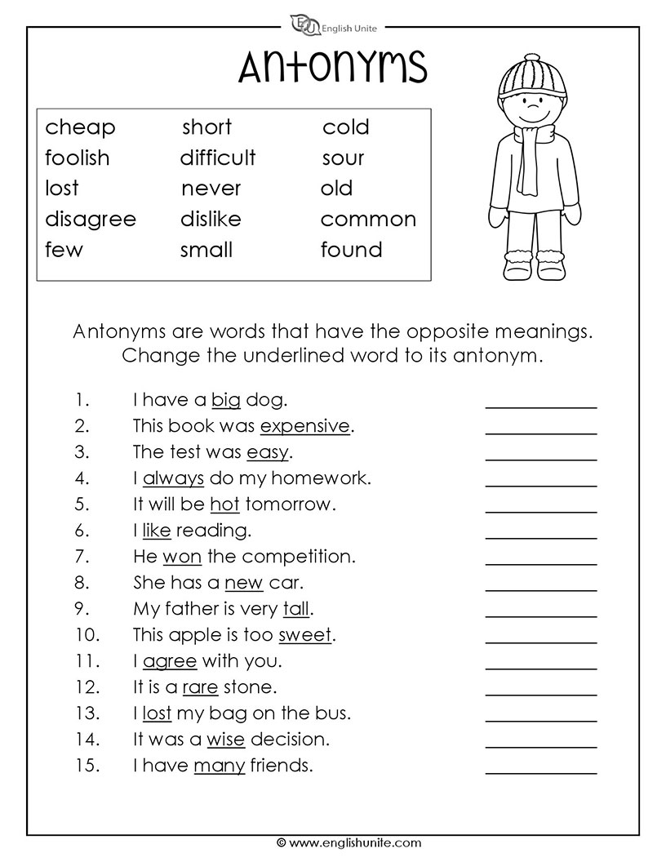**Q2) Change the underlined word in each sentence with its antonym from the box.**



|  |
| --- |
| **Cheap small**  **Disagree found**  **Old difficult**  **Sour dead** |

1. I have a big dog. small
2. This book was expensive. Cheap
3. The test was easy. difficult
4. I agree with you. disagree
5. She has a new car. old
6. This apple is too sweet. sour
7. I lost my bag on the bus. found
8. The skin’s top layer is made of live cells. dead

**Q3) Write sentences using antonyms.**

**1.-------------------------------------------------.**

**2.-------------------------------------------------.**

**3.-------------------------------------------------.**

**English department teachers**