

Practice Paper / Used to

Grade (4)

Name: Date: / /2023

|  |
| --- |
| **Objectives**:  1. To identify the verb “**used to”** and its use  2.To practice using “used to” in sentences. |

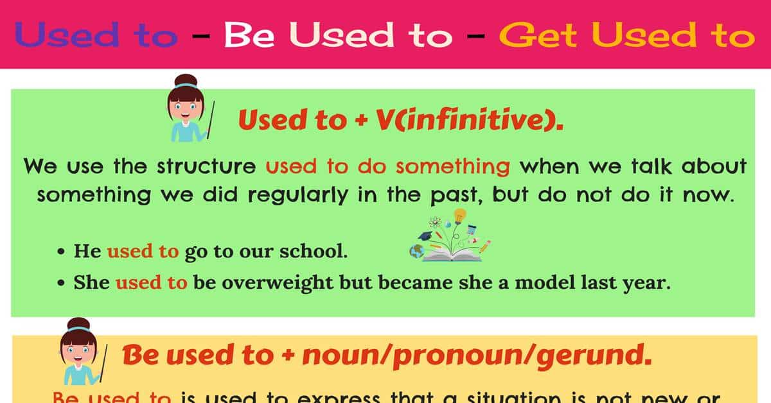



**Sentence structure**:

**Affirmative:** Subject + **used to + infinitive verb** + Object.

**Sentence:** He **used t**o go to London every summer.

**Negative sentence**: Subject + **didn’t use to + infinitive verb** + Object.

**Negative:** He did**n’t use to** go to London every summer.

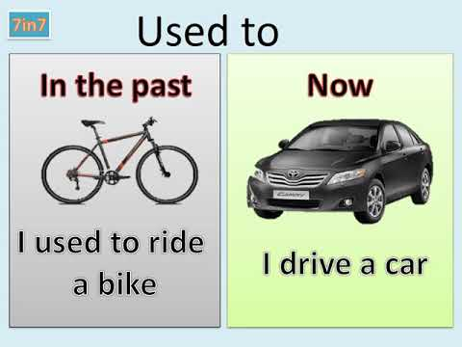

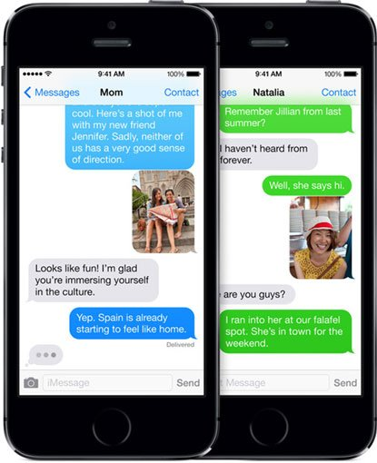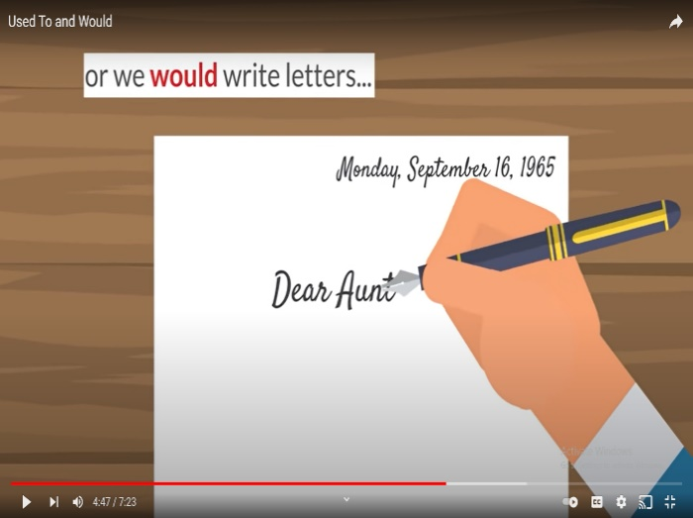

**EX: I used to write a letter to my friends, but now I use my phone to text them.**

**Q1) Choose the correct form for each sentence.**

1. I ------------------in Jordan when I was a child. **(used to** **live- lived)**

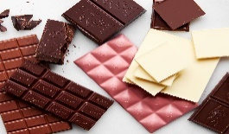2. She -----------------eating chocolate, but now she hates it. **(used to** **love- loved)**

3. He ------------------to the beach at 9:30 this morning. **(used to go -went)**

4. I -------------------tennis when I was at school.

**(used to play –played)**

**Q2) Choose the correct answer.**

1. **I ------------ to the beach every day last summer.**
2. used to b. used to go c. go
3. **Susan --------- drink milk when she was young.**
4. used to b. did use c. was
5. **Ancient People ------------- on horses.**
6. used to travel b. travelled c. travel
7. **Tom ------------ his new T-shirt this morning.**
8. wear b. wore c. used to wear
9. **Sally ----------------- her grandma every weekend.**
10. used to see b. saw c. see
11. **Tom --------------- his T.V show last night.**
12. used to watch b. watched c. watch

**Q3) Rewrite each sentences below using “ used to”**

1. **Last year, I went to school on foot. Now I ride my bike.**

**2. Last year, I didn’t study. Now I study very hard.**

**Q4) Write 2 things that you used to do when you were a baby.**

1.-----------------------------------------------------------------.

2.-----------------------------------------------------------------. 

Q5) Write sentences to answer the question, What did they use to do in the past ?. Use “ used to “.

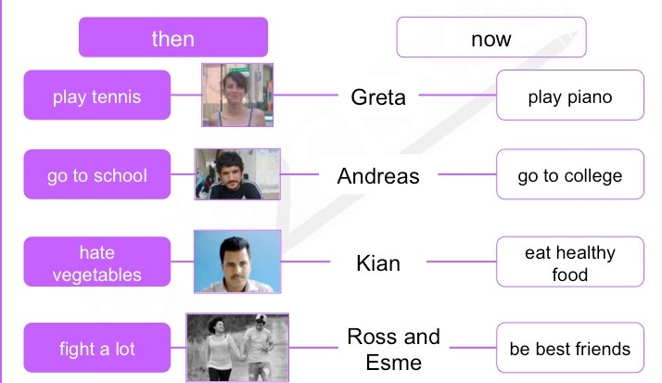

1.---------------------------------------------------------------------------

2.---------------------------------------------------------------------------

3.---------------------------------------------------------------------------

4.---------------------------------------------------------------------------

Teacher: Raneem Haddad.

Coordinator’s Signature: ___________.