

Conjunction / Grade (4)

Name: Date: / /2023

|  |
| --- |
| **Objective**: To identify **and, but or** as conjunctions.  To practice linking sentences together using conjunctions. |

**Conjunctions**: They are words that are used to join two sentences together.

**The conjunctions **and**  and  **but**  can be used to join two statements.

**And:** is used to connect **similar** ideas.

**But:** is used to connect **opposite** ideas.

**Or**: is used to talk about **options**.

You can have the blue pen **or** the red pen.

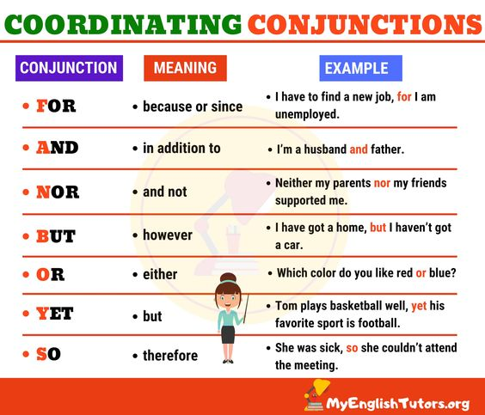







+ and + - and -

- but + + but -

**Q1) Choose the best conjunction to complete each sentence.**

1. I am hungry **(and / but/or)** I don’t have any money to buy lunch.

2. It’s late **(and / but/or**) I’m tired!

3. John likes funny movies **(and / but/or)** he doesn’t like scary movies.

4. We live in an apartment **(and / but/or)** we like it very much.

5. Can we have a holiday, **(and / but/or)** should we save our money?

6. Can we have a picnic, **(and / but/or)** is the weather too bad?

7. Which do you want to take the train **(and / but/or)** the bus?

8. Paris is a big city **(and / but/or)** it’s the capital of France.

**Q2) Write sentences using the coordinating conjunctions (or/but/and).**

1.And: ----------------------------------------------------

2.But: ----------------------------------------------------

3.Or: --------------------------------------------------------

4.But ---------------------------------------------------------

**English Department Teachers,**

  **Lesson _ Revision / Conjunctions**

**Grade (4) No. of classes (1)**

**Date: From ____ to ______**

**Objectives**:

* To revise the coordinating conjunctions (and, but, or). And their functions.

*To practice using these conjunctions correctly.

**Pre- learning:**

* Students will receive and watch a video about conjunctions (but-and). They will be asked to use 2 of them in sentences of their own.

|  |
| --- |
| Dear students,  Watch the video about conjunctions, use two of them in sentences and write them down in your notebook. <https://youtu.be/nNGiDfCX7PI> |

**Procedure:**

T. follows task1.

T. writes examples on the board and elicits what students remember about the function of conjunctions.

T. posts a link game to play about conjunctions. <https://wordwall.net/play/5146/614/7096>

T. uses a PowerPoint to give more explanation about the function of (but –and-or). By asking students to make a dialog while they are in at a café to ask for order and answer.

students go to the worksheet and do exercise 1.

**Attachment:**

<https://youtu.be/nNGiDfCX7PI>

<https://wordwall.net/play/5146/614/7096>