
Reading Comprehension (8)
Grade 2
Name: ------------ Date: /5/2023
*Objective: To read and understand the text and be able to answer the questions.
1)Read the text carefully then answer the questions below.
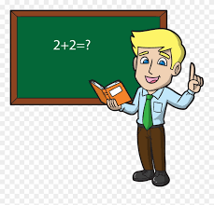
I love my father. His name is Omar. He is thirty years old.
He is very kind. He is a teacher. He is an active person.
He goes to his work early. He teaches Math for grade two.
1)How old is my father?
___________________________________________
2)What does Omar teach?
___________________________________________
3)Omar is a ______________.
doctor student teacher
4)Find out:
-A subject pronoun: _____________
-An adjective: ________________

