
Worksheet (5)
Grade Two
Name: Date: 11 /4/2023
Objectives: To identify the regular form of the past tense.
To practise using the past regular verbs in sentences.
We use the past simple to talk about things that happened in the past.

V1 means infinitive

*Rule (Affirmative): Subject + V2 (V1 +ed/d)
I | V1+ed
He, she, it | V1+ed
We, you, they | V1+ed

*Rule (Negative): Subject+ didn’t + V1
I | didn’t | play  work  Watch
He, she, it | didn’t | play  work  Watch
We, you, they | didn’t | play  work  Watch

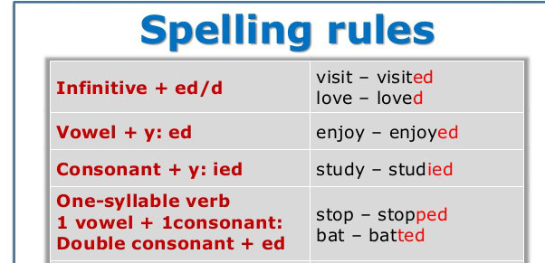
The key words for simple past tense:
Yesterday, last week, last night, last month, last year, -in 2003- long ago, …

1)Choose the correct answer:
- I ___________ my house yesterday.
clean cleaned cleand
- The sun ___________ off the sand.
dryed dryied dried
- She didn’t __________ her teeth yesterday.
brushed brush brushes

2)Complete the sentences using the past tense of the verbs in the brackets.

1.I needed (need) a pencil to write a letter.
2. You played (play) football last week.
3. He enjoyed (enjoy) his holidays in Syria.
4. We _didn’t chat (not/chat) last night
5. She studied (study) all night.
3)Write the past tense of these regular verbs:

watch watched step _stepped
talk_talked change_ changed
play played open opened
close closed use_used
turn on turned on finish finished
dance danced try tried
4) Use the past simple form of the following verbs in sentences.
- cook: _____________________________________________________
- watch: ____________________________________________________
T.Taghreed Alnimri

