
Worksheet (6)
Grade Two
Name: Date: 1 / 5/2023 _______________________________________________________________
Objective: To write the words in alphabetical order.
Alphabetical Order
A. Read through the alphabet.
a b c d e f g h i j k l m n o p q r s t u v w x y z

B. Underline the vowels.

C. The remaining letters are called _________________.

D. Complete the following letter sequences.

d |  | f | g |  | i
t | u |  |  | x
 | m | n |  |  | q

E. List the following words in alphabetical order.
1.
peach __________
banana __________
grapes __________
orange __________
apple __________

2.
bread ________
tea _________
coffee ________
sugar _________
jam _________

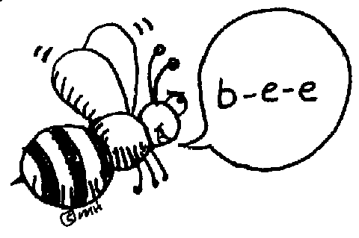

T.Taghreed Alnimri Coordinator’s Signature:

