**The National Orthodox School / Shmaisani**

**Subject: Biology Classification - practice paper**

**Name:**

**Date:** **Gra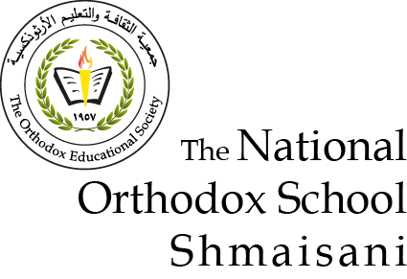de 9IB**

**Circle the correct answer**

1. **An ornithologist has identified a bird as, "Regulus regulus", commonly known as a "goldcrest"**

Which of the following options shows the correct classification of this bird.

option Domain Class Genus

A Eukaryote Chordate Aves (Birds)

B Eukaryote Aves (Birds) Regulus

C Animalia Chordate Aves (Birds)

D Chordate Aves (Birds) Regulus

1. **Which of the following characteristics are found in the classification group Cnidaria?**

A. Radial symmetry

B. Feathers

C. Mouth and anus

D. Scales

**3. Which group of animals have the following features:**

Bilateral symmetry

A muscular foot and a mantle

A mouth and an anus?

A. Chordata

B. Arthropoda

C. Cnidaria

D. Mollusca

1. **The diagram below shows an animal found in some water in East Asia.**

**Which of the following is the best classification of this animal.**

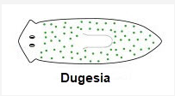A. Molusca because of it's mouth and it's muscular foot

B. Platyhelminth because it has bilateral symmetry and a flattened body shape

C. Annelida because of its bilateral symmetry and body segments

D. Arthropoda because of it's bilateral symmetry and it's eyes

1. **The diagram shown illustrates the animal phyla.**

Which of the phyla shown have radial symmetry?

A. Poriphera and Cnidaria

B. Annelida, Mollusca and Poriphera

C. Poriphera only

D. Cnidaria only

1. **The diagram shown illustrates the animal phyla.**

Which of the phyla shown could contain animals with both a mouth and an anus?

A. Mollusca, Annelida and Chordata

B. Annelida, Mollusca, Arthropoda and Poriphera

C. Annelida, Chordata, Mollusca, and Arthropoda

D. Poriphera, Cnidaria and Platyhelmintha

1. **There are three domains in the classification of living things. They are called Archaea, Eubacteria and Eukaryotae.**

**Which of these domains will have organisms that contain mitochondria?**

A. Eukaryotes

B. Eubacteria and Eukaryotes

C. Archae and Eubacteria

D. Eubacteria

1. **Which feature in the list below is characteristic of reptiles but not birds?**

A. They feed their offspring on milk

B. They have bilateral symmetry

C. They are cold blooded

D. They lay eggs out of water

1. **The image shows a fossilized animal found in the Araripe Basin, northeastern Brazil.**

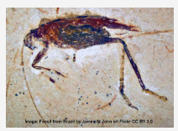Study the image and decide which is the most appropriate classification group for this animal.

A: Mollusca

B: Platyhelmintha

C: Arthropoda

D: Chordata