Answer key
1a. [2 marks]
The graphs show how the global mean surface temperature changed from 1978 to 2018, as well as the amount of energy reaching the surface of the Earth from the Sun.
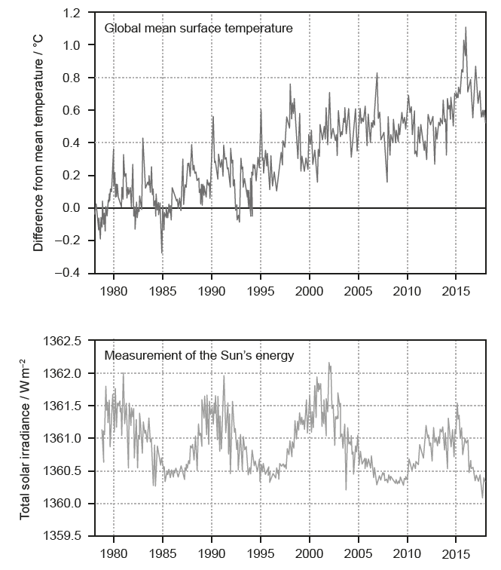
It has been argued that variation in the global mean surface temperature has been caused by variation in energy from the Sun. Analyse whether evidence from the graphs supports this argument.

Markscheme
(Evidence does not support this argument because:)
- overall increase in surface temperature but no overall increase/slight decrease in solar irradiance;
- peaks and troughs in solar irradiance do not correspond with fluctuations in surface temperature;
Do not award marks for claims that the evidence supports the argument, for example, claims that the fluctuations coincide.
1b. [3 marks]
Explain how increased levels of atmospheric carbon dioxide contribute to global warming.

Markscheme
- carbon dioxide absorbs/traps long wavelength/infra-red radiation;
- more heat trapped in/less heat escapes from atmosphere with more carbon dioxide;
- short wave/UV radiation from the sun passes through the atmosphere/reaches the Earth’s surface;
- radiation from the sun/sunlight warms the (surface of the) Earth;
- long wavelength/infra-red radiated from the (warmed) Earth’s surface;
Do not accept answers relating to ozone in the atmosphere because the question refers to carbon dioxide.
For mpa do not accept heat instead of LW/IR radiation.
1c. [1 mark]
State one other gas that contributes to global warming.

Markscheme
methane/nitrous oxide/water vapour/ozone/CFCs/other halogenated gases;
2. [1 mark]
Which activity directly contributes the most to recent increases in atmospheric CO₂ concentrations?
A. Landfills
B. Planting trees
C. Cattle rearing
D. Burning of fossil fuels

Markscheme
D
3. [1 mark]
The table shows features of greenhouse gases in the atmosphere.
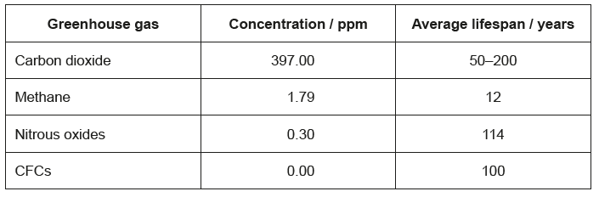
According to the data in the table, which greenhouse gas contributes the most to climate change?
A. Carbon dioxide because it is the most abundant greenhouse gas
B. Methane because it has the shortest lifespan
C. Nitrous oxides because they absorb the greatest amount of shortwave radiation
D. CFCs because they destroy the ozone layer

Markscheme
A
4. [1 mark]
How do greenhouse gases contribute to global warming?
A. They destroy the ozone layer, allowing radiation to reach the Earth’s surface.
B. They prevent radiation from the Earth escaping into space.
C. They trap short wavelength radiation in the atmosphere.
D. They are a product of combustion, which generates heat.

Markscheme
B
5. [1 mark]
Which gases have made the most significant contributions to global warming?
A. Water and carbon dioxide
B. Carbon dioxide and methane
C. Methane and nitrous oxide
D. Carbon dioxide and ozone

Markscheme
A

6b. [4 marks]
Outline how plants make use of the different wavelengths of light.

Markscheme
a. light used in photosynthesis/light-dependent reactions/photolysis/photosystems/photophosphorylation/excitation of electrons/switch to flowering
b. chlorophyll absorbs red AND blue light (more)
c. chlorophyll/leaf/plant reflects/does not absorb/does not use green light
d. absorption spectrum of chlorophyll has peaks in the red and blue/sketch graph to show this
e. action spectrum shows which wavelengths plants use in photosynthesis/sketch graph of action spectrum showing peaks in the blue and red
f. accessory/other (named) photosynthetic pigments absorb different wavelengths/colours
g. violet is the shortest wavelength and red the longest
h. red light and far red/infra-red absorbed to measure length of light/dark periods

7. [1 mark]
Which characteristic of water vapour classifies it as a greenhouse gas?
A. It absorbs and then re-emits some of the long wave radiation emitted by the Earth’s surface.
B. It prevents short wave radiation from reaching the Earth’s surface.
C. It absorbs UV radiation but does not re-emit it.
D. It absorbs infra-red radiation but does not re-emit it.

Markscheme
A
9a. [2 marks]
The diagram shows the greenhouse effect.
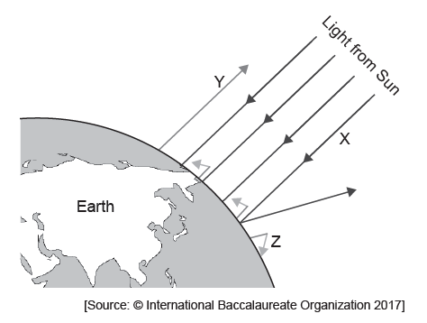
State the type of wavelength of the radiation labelled X and Y.
X:
Y:

Markscheme
X: short-/ultraviolet/UV/visible/EMR/electromagnetic radiation
Y: long-/infrared/IR
9b. [2 marks]
Outline reasons for the change occurring at Z.

Markscheme
a. greenhouse gases present (at Z)
b. greenhouse gases «CO₂, methane, nitrous oxide, water vapour» absorb long-wavelengths/infrared
OR
long wavelengths/infrared waves blocked from leaving the atmosphere
c. (long-wavelengths/infrared absorbed and) reradiated/re-emitted (heat Earth)
9c. [1 mark]
The short-tailed albatross (Phoebastria albatrus) nests and breeds on remote low-lying coral islands in the Pacific Ocean. Predict how global warming may threaten the survival of such an ocean bird.

Markscheme
a. rising ocean levels/more extreme weather «due to global warming» may destroy breeding/nesting sites
OR
rising sea level may put island underwater causing young birds/chicks to drown
b. populations may not find/adapt to new colony sites
c. warming seas may affect the food supply

