

**Web Design –Expression Web 4**

**Worksheet #2 (Practical)**

**Name ………………………………. 6th Grade, Section …………**

**Date…………………………………. 2nd Semester 2022 - 2023**

**Start Microsoft Expression Web 4**

Start 🡪 Programs 🡪 Microsoft **Expression Web 4**

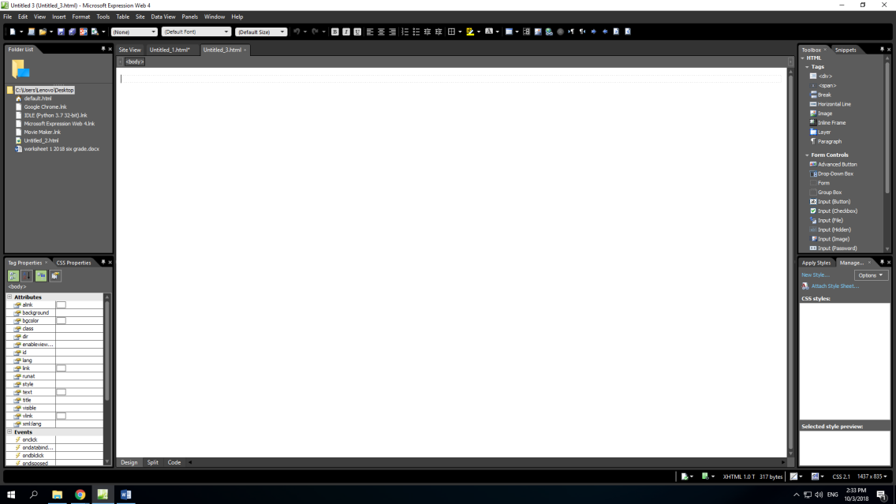

**Create new page**

1. Create a new web page

File 🡪 New 🡪 Page

1. Save this page using the name: **Endangered Animals**.
2. Change the back-ground color to light green

Format 🡪 background: light green

1. At the top of the page enter the heading: Endangered Animals
   * Change the Font color: Dark Green
   * Font Name: Times New Roman
   * Font Size: 50 pt.
   * Font Type: Bold /center align

1. 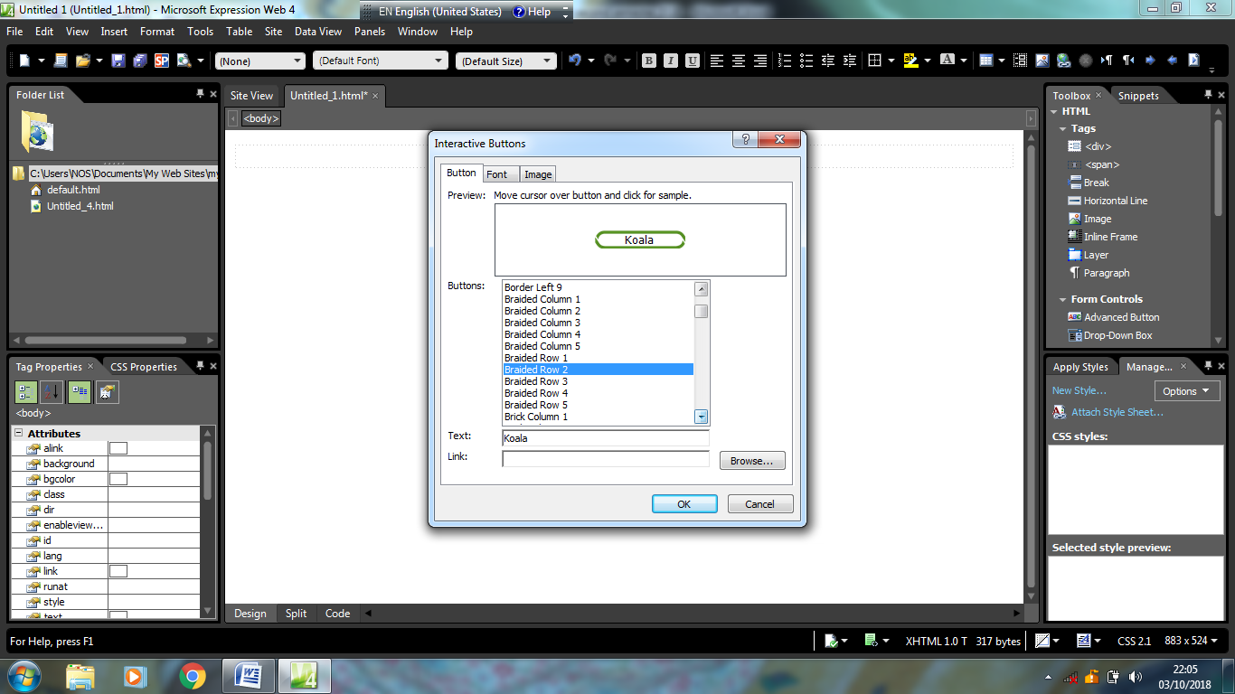In a new line, insert 3 interactive buttons
   * Insert 🡪 interactive button 🡪 Braided Row 2.

You can change the button type.

* + In the text of the first button type: Koala.
  + Press ok.

Repeat the above steps to get the two buttons :

* + White Lion
  + Panda

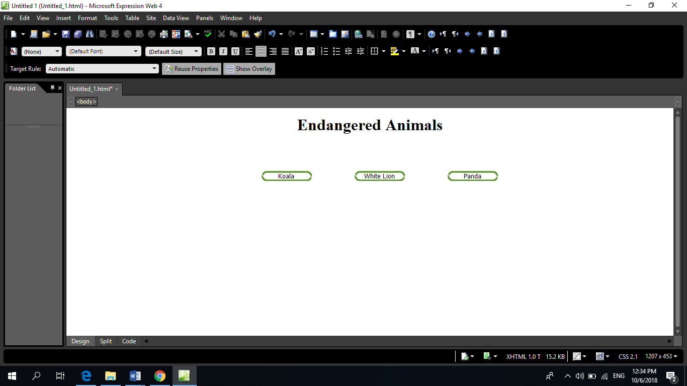

1. Bellow the buttons:
   * Insert the picture [Endangered Animals.jpg].
   * Change the width of the picture to be: 400 pixels and the height to 400 pixels.
2. Save the page

*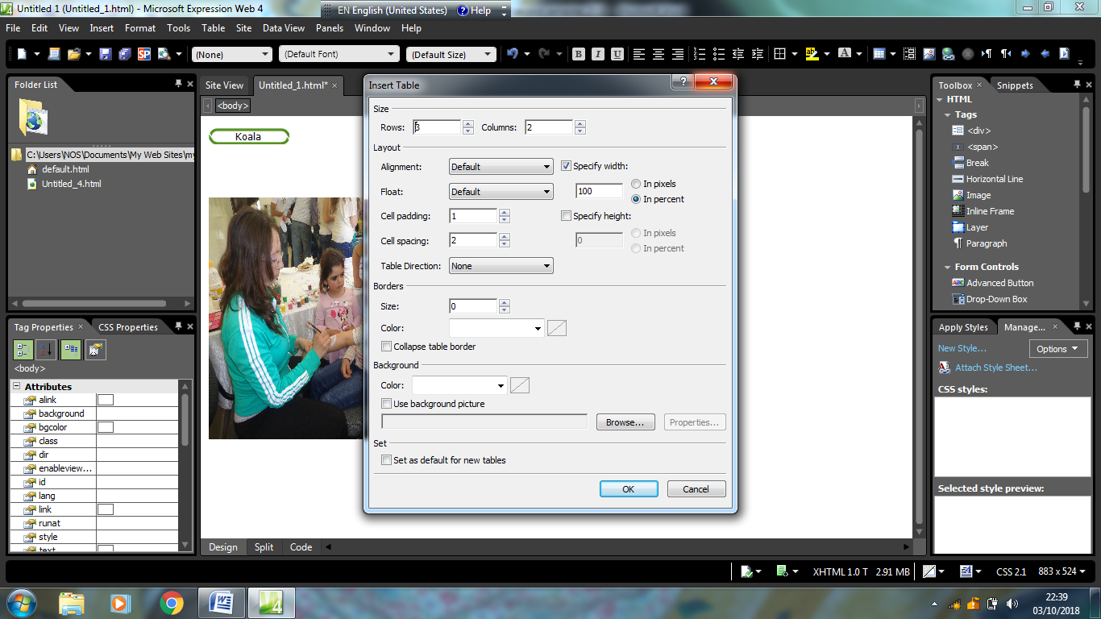***Create new page [Koala.htm]**

1. Background: light blue.
2. Insert the title Koala in the header.
3. Change the text to be Font to Arial Black, font size to 36.
4. Insert a table:
   * Number of rows: 3, Number of Column: 2
   * Border size: 2
   * Border color: Dark Blue
   * Table Width: 90%
5. Merge the cells to create the table as shown below.

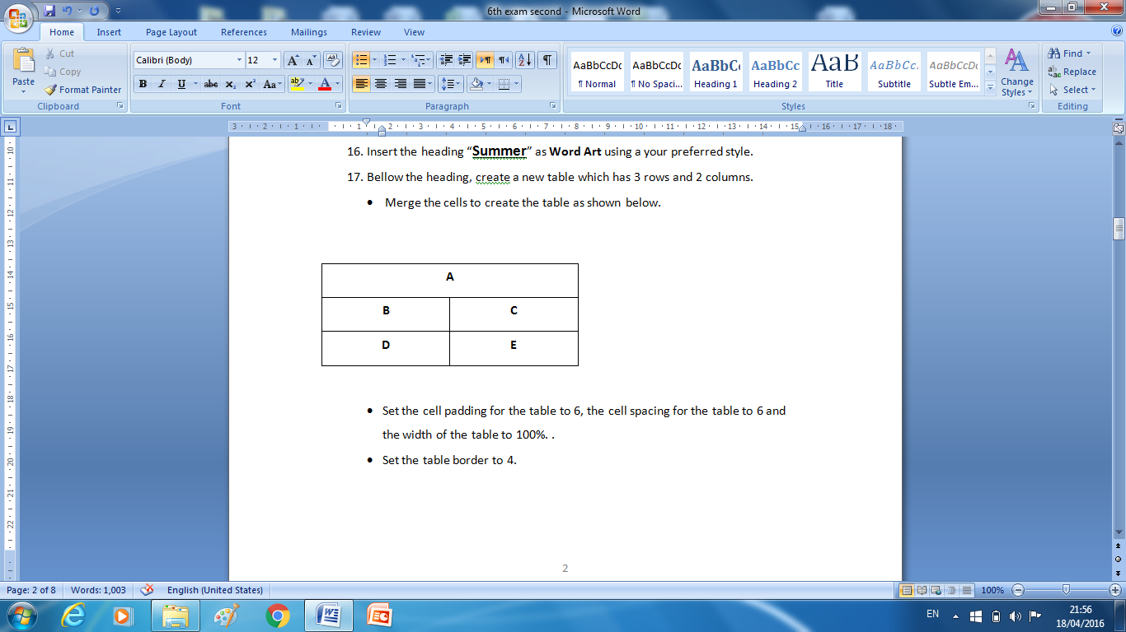

1. Using the file **animals,** Copy the data about the **Koala** in cell A.

Edit the text so that:

* + Font-Times New Roman
  + size- 14
  + Font Color: Orange
  + Alignment: Justify.

1. Below the paragraph in cell A, type the text “Homepage”.
2. Create a Hyperlink from the word [Homepage] to the page [**Endangered Animals**].
3. In cells [B, C, D, and E] insert a **Koala** pictures (Koala1, Koala2, Koala3, Koala4).
4. Change the **Height** of each picture to **200** **pixels**, and keep the aspect ratio.
5. Save the page.

**Create 2-pages [White Lion & Panda]**

1. Use the steps 8- 18 to create new two pages about two endangered animals White Lion & Panda.

**Create Hyperlinks**

1. Return to the page **Endangered animals.htm** and:
   * Create a Hyperlink from the buttons [Panda] to the page [Panda.htm]
   * Create a Hyperlink from the buttons [Koala] to the page [Koala.htm]
   * Create a Hyperlink from the buttons [White lion] to the page [White lion.htm]