

**Our value: Alone we can do so little; together we can do so much.**

Zero and First Conditionals

Grade 7 (A + B)

Name: Date: / /

Objectives: To learn about the different types of sentences.

To practise identifying types of sentences.

To learn the forms and uses of zero and first conditionals.

To practise using the zero and first conditionals correctly.

Types of Sentences

There are four types of sentences: simple, compound, complex, and compound-complex. A sentence contains one or more clauses, and you can classify a sentence as one of the four types by assessing the number and types of clauses it contains.

**Simple Sentences**

A simple sentence contains a single independent clause—that is, a subject and a predicate that form a complete thought:

**-It is an ice cream cone.**

**-The girl bought an ice cream cone.**

**Compound Sentences**

A compound sentence contains two or more independent clauses joined by a coordinating conjunction, fanboys, (for, and, nor, but, or, yet, so).

**Independent Independent**

**-The girl bought an ice cream cone, but she dropped it in the park.**

**-The girl bought an ice cream cone yet, she dropped it in the park.**

**-The girl bought an ice cream cone and she dropped it in the park.**

**Complex Sentences**

A complex sentence contains one dependent clauses attached to an independent clause. The dependent clauses are connected to the independent clause through subordinating conjunctions (e.g., because, after, when , if)

Dependent Independent

**-After she bought an ice cream cone, the girl went to the park.**

Independent Dependent

**-The girl dropped her ice cream cone because a large dog knocked her over.**

**\*\*Practice:**

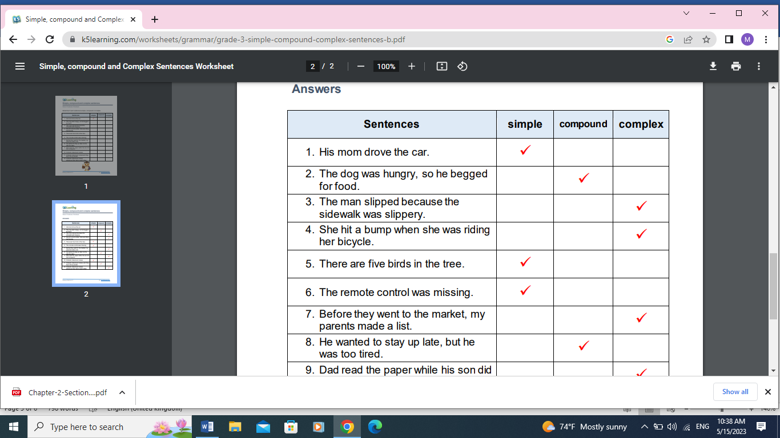

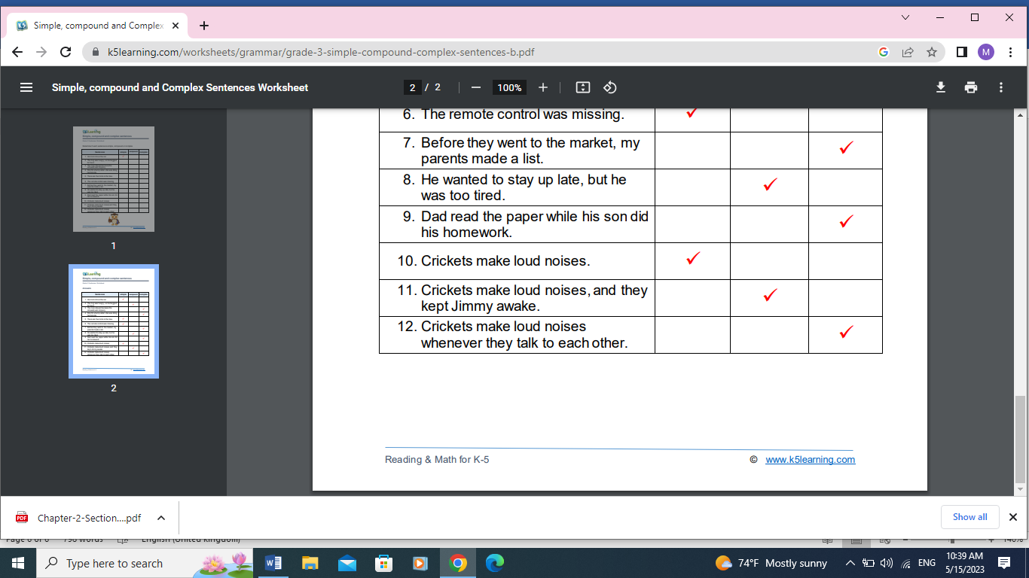

**Zero Conditional**

* If + present simple, .... present simple.

This conditional is used when the result will always happen. So**, if water reaches 100 degrees, it always boils**. It's a fact. I'm talking in general, not about one particular situation. The result of the 'if clause' is always the main clause.

The 'if' in this conditional can usually be replaced by 'when' without changing the meaning.

**For example:**

**Dependent Independent**

If water reaches 100 degrees, it boils. (It is always true, there can't be a different result sometimes).

If I eat peanuts, I am sick. (This is true only for me, maybe, not for everyone, but it's still true that I'm sick every time I eat peanuts)

Here are some more examples:

|  |
| --- |
| * If people **eat** too much, they **get** fat. * If you **touch** a fire, you **get** burned. * People **die** if they **don't eat**. * You **get** water if you **mix** hydrogen and oxygen. * Snakes **bite** if they **are** scared * If babies **are** hungry, they **cry.**   **First Conditional**  if + present simple, ... will + infinitive  The first conditional has the present simple after 'if', then the future simple in the other clause:  It's used to talk about things which might happen in the future. Of course, we can't know what will happen in the future, but this describes possible things, which could easily come true.  **Dependent Independent**  If it **rains**, I **won't go** to the park.  If I **study** today, I'**ll go** to the party tonight.  If I **have** enough money, I'**ll buy** some new shoes.  She**'ll be** late if the train **is** delayed.  She'**ll miss** the bus if she **doesn't leave** soon.  If I **see** her, I'**ll tell** her.  **Practice:**  Put the verbs between brackets into the correct form.   1. If you don’t tell her the truth, she will be **(be)** angry with you!(F) 2. Soap dissolves if you leave **(leave)** it in water. (Z) 3. If he rings the bell, the receptionist will come **(come). (F)** 4. If I study more, I will pass **(pass)** the exam.(F) 5. Plants die **(die)** if you don’t water them. (Z) 6. He will understand **(understand)** it if she explains him the situation.(F) 7. Milk goes **(go)** off if you don’t keep it in a cool place.(Z) 8. If they offer me a job, I will take **(take)** it.(F) 9. I will have **(have)** to invite Bob if I invite Linda.(F) 10. If Jack meets Tom, he will tell (**tell)** him the truth.(F) 11. If Ella has enough money she will buy **(buy)** a new car.(F) 12. The heater comes **(come)** on if you press this switch.(Z) 13. If you want to understand the text, you will have **(have)** to study the new words.(F) 14. My parents will get **(get)** angry if I don’t do everything right now.(F) 15. We’ll go to the beach if it doesn’t rain **(not/rain)** .(F) |

Choose the correct answer

1. If you heat water to 100 C, it ...

a. boils b. boil c. will boil

1. My mother will buy me a new computer if she ... enough money.
2. is having b. has c. will have
3. Ice ... if you heat it.
4. is melting b. will melt c. melts

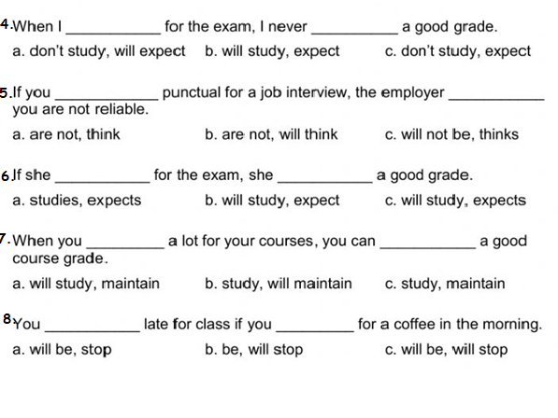

Teacher: Mirna Nawaf Al- Sahawneh.

Coordinator’s Signature: -----------------