

**Value*:*** “Respect yourself above all.”

The National Orthodox School

Science Worksheet /**Unit 6**

Name: Grade: 5(A+B)

Date: / /2023

***Potential and Kinetic Energy***

**Potential Energy :**Energy stored in an object due to its position ·

**Kinetic Energy :**Energy that a moving object has due to its motion.



The apple on the table has...potential...........energy.

The apple falling from the table is........ **kinetic** ........energy.



If the rock falls from the hill, it is..... **kinetic** ....energy.

If the rock is still, it has potential...energy.

**1) Read each question carefully and decide if the activity refer to potential or kinetic energy**.

Riding a bike: ...kinetic.... Holding a ball in your hand: ...... potential.......

A bird flying: .......kinetic A rock at the top of a hill: .... potential...

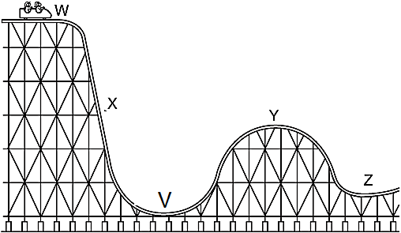2)

Using the track above, at which point does a train on this roller coaster:

a. Have the highest POTENTIAL energy? W

b. Have the highest KINETIC energy? V

c. Have BOTH kinetic and potential energy? X

d. How does the potential energy at point **W** compare to potential energy at point **Y**.

Potential energy at W is higher than potential energy at Y>

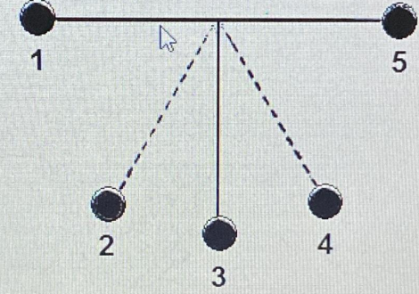**3) The diagram below shows a pendulum in motion.**

a- At which point(s) the pendulum has highest potential energy?

1, 5

b- At which point does the pendulum have maximum kinetic energy?

3

c- At which point does the pendulum have maximum speed?

3

d- At which point(s) does the pendulum have both kinetic and potential energy?

2,3