The National Orthodox School

Science Worksheet

**Energy changes**

Name : Grade: 5

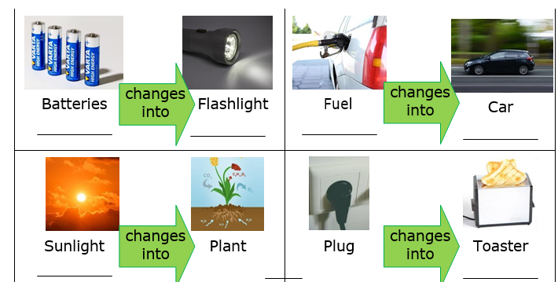Write the type of energy that is transformed in these examples.

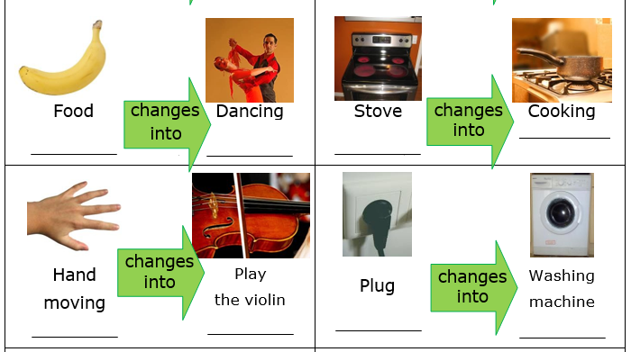

kinetic, heat, sound, light energy

electrical energy

kinetic energy

sound energy

heat energy

chemical energy

kinetic energy

chemical energy

heat energy

electrical energy

chemical energy

light , heat energy

kinetic, light, sound,and heat energy

chemical energy

light energy

chemical energy