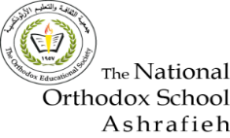

The National Orthodox School/AL-Ashrafieh

Science Worksheet

**Unit 7: Magnets and Magnetism**

Grade: 4(A+B) Date: / /2023

Name:

***Q1*. Fill the blanks with the correct word to complete the statements.**

1. All magnets have two poles.
2. Same poles of two magnets will repel each other.
3. Opposite poles of two magnets will attract each other.

4. The force which holds objects to a magnet is called magnetic force

5. A magnet that is powered by electric current is called a/anelectromagnet

***Q2*. Write True or False**

F 1. An electromagnet is an example of a permanent magnet.

T 2. You can increase the power of an electromagnet by adding more power source.

F 3. Cotton and paper are magnetic materials.

F 4. Coiling the wires more will decrease the power of electromagnets.

F 5. Opposite poles of a magnet will repel each other.

***Q3*. State whether theses magnets would attract or repel.**

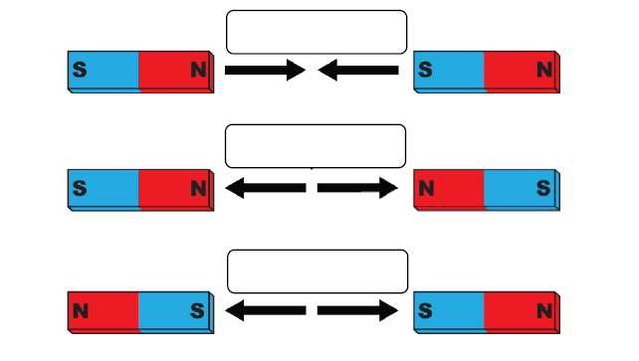

attract

repel

repel

***Q4*. Label the electromagnet.**

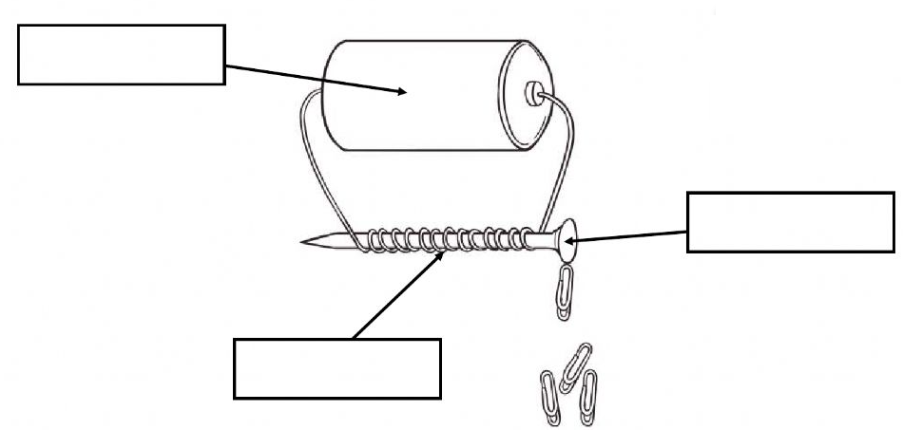

Battery (power supply

Nail ( iron rod)

Coils of wire

*Teacher: Diala Al-azrai*