** Defining Relative Clauses**

**Our value: Alone we can do so little; together we can do so much.**

**Name ………………… Grade (6)**

|  |
| --- |
| **Objectives**  1. To identify the defining relative pronouns and their uses.  2. To use the correct relative pronouns in sentences.  3. To practice joining sentences using relative pronouns**.** |

* We use a defining relative clause to join two ideas with a **relative pronoun**.
* It gives **essential (important) information** about the noun it is describing.
* The essential information can define: **people, things, places, times** and **possessions**.

|  |  |  |
| --- | --- | --- |
|  | **RELATIVE PRONOUN** | **EXAMPLE** |
| PEOPLE | WHO/THAT | My friend **who** is a doctor works in London. |
| THINGS | WHICH/THAT | The bicycle **which** is in the corridor is old. |
| TIME | WHEN | Let´s meet on a day **when** I´m not working. |
| PLACE | WHERE | The city **where** I went to university is a great destination to visit. |
| POSSESSION | WHOSE | My neighbour **whose** father is a lawyer also wants to study law. |

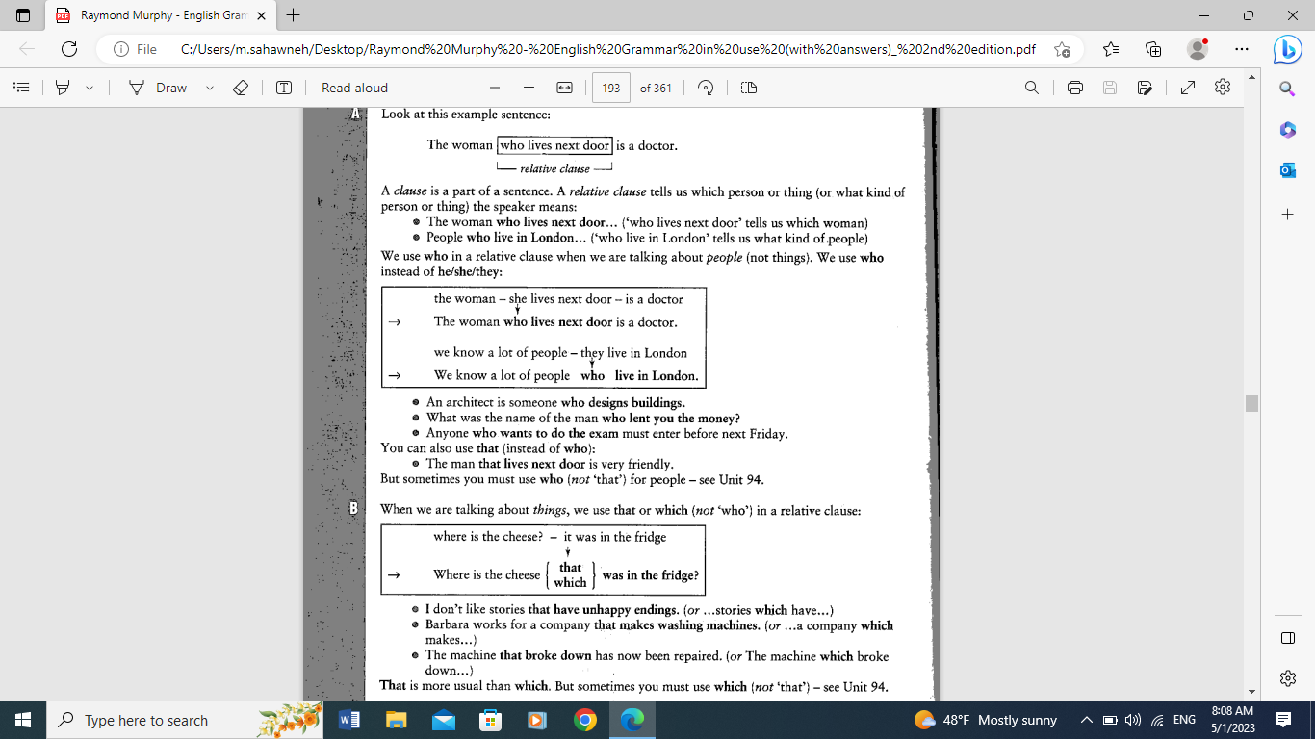

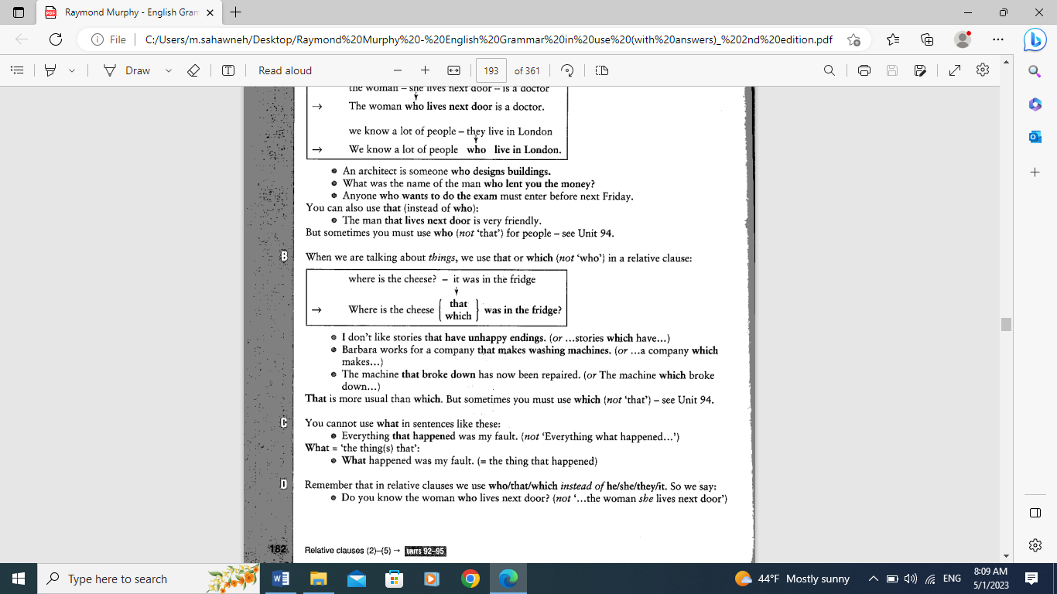

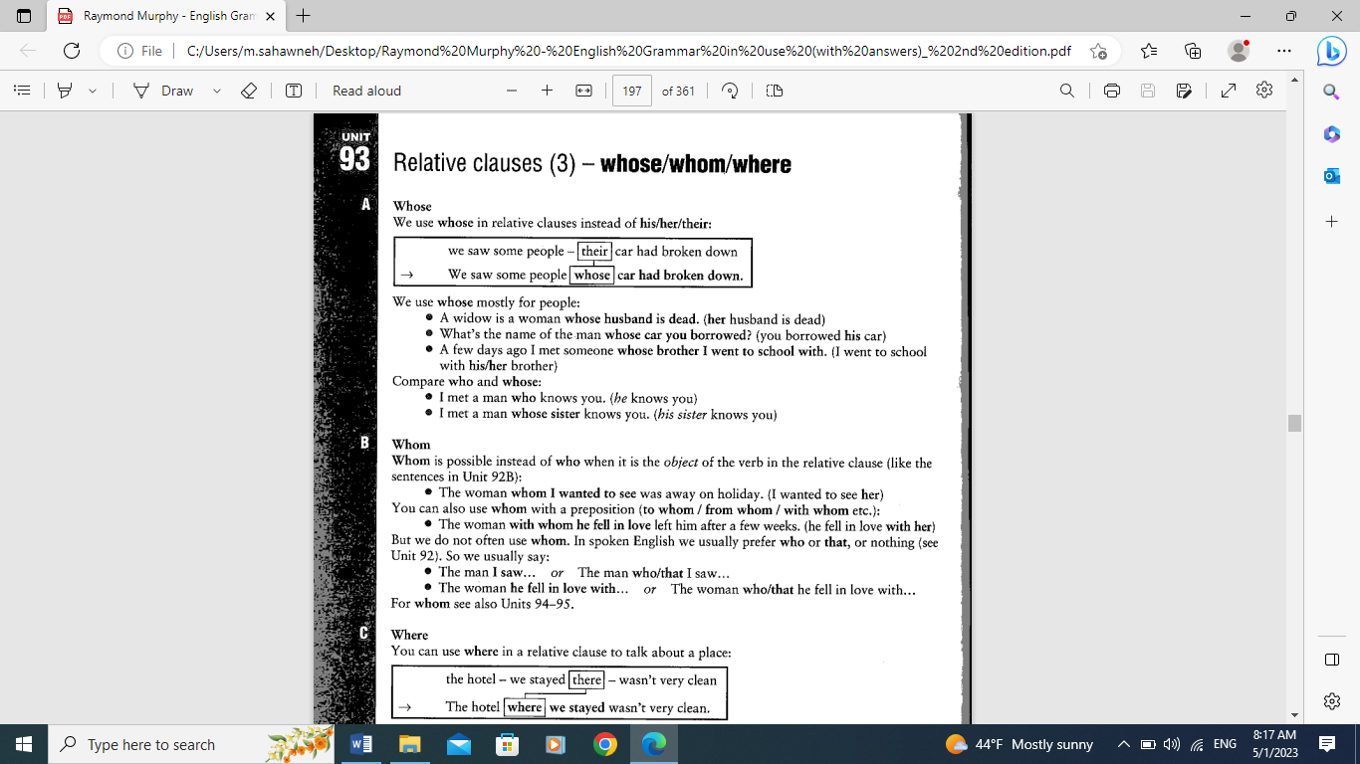

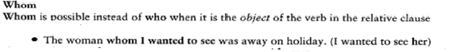

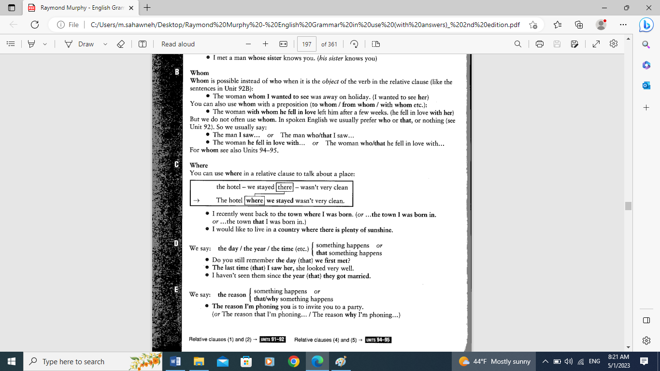

**A) Circle the relative pronoun and underline the relative clause in these sentences.**

1. The artist whose paintings are amazing is very creative.

2. The old lady who moved in next door is a nice neighbor.

3. This is the girl whose dog bit me.

4. These are the shops which I always go to.

5. This is the house where I spent the summers when I was little.

6. That is the building where they shot the film 'Vanilla Sky'.

**B) Complete the sentences using relative pronouns.**

1. The city _where_______ I was born, has beautiful buildings in the center.

2. These are the shoes __which/that_______ I want to wear for my birthday party.

3.That´s the girl ______whose____ project won the contest.

4. Jeremy´s favorite book is the one ____which/that_____ has his name written on the cover.

5.That´s the place ____where_____ I took my driving test.

6.My friends __whose______ belongings were stolen filed a report with the police.

7. The student __who/that______ plays the piano has performed in front of a large audience.

8. Amelia was playing basketball ___when______ she fell and sprained her ankle.

9. This is the song __which/that____ I like the most in the new album.

10. The thief __who/that____ stole my bag was caught by the police.

**C) Join the sentences. use relative pronouns.**

1. I know a chef. He makes 100 types of pasta.

I know a chef who/that makes 100 types of pasta.

2. I read a book. It explained how to make films.

I read a book which/that explained how to make films.

3. This is the garden. He usually walks his dog here.

This is the garden where he usually walks his dog.

4. Here is the boy. His mother is my math teacher.

Here is the boy whose mother is my math teacher.

5. I remember the day. I had a surprise party then.

I remember the day when I had a surprise party.

6. Pass me the dictionary. I put it on the shelf.

Pass me the dictionary which/that I put on the shelf.

7. They sent me a postcard of the hotel. They stayed there on holiday.

They sent me a postcard of the hotel where they stayed on holiday.

8. We last saw Mary on Christmas Day. She came to our party then.

We last saw Mary on Christmas Day when she came to our party.