**The Internet of Things**



**A. What is the internet of things?**



Everyone knows that the Internet connects people, but now **it** does more than that – it connects objects, too. These days, computers often communicate with each other; for example, your TV automatically downloads your favourite TV show, or your ‘sat nav’ system tells you where you are. This is known as the ‘Internet of Things’, and there’s a lot more to come.



**B. An easy life**



In just a few years’ time, experts say that billions of machines will be connected to each other and to the Internet. As a consequence, computers will increasingly run our lives for us. For example, your fridge will know when you need more milk and add it to your online shopping list; your windows will close if it is likely to rain; your watch will record your heart rate and email your doctor; and your sofa will tell you when you need to stand up and get some exercise!

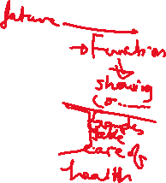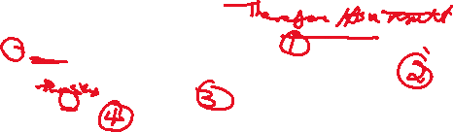

**C. An unknown future (frightening future)**



Many people are excited about the ‘Internet of Things’. For them, a dream is coming true. They say that our lives will be easier and more comfortable. However, others are not so sure. They want to keep control of their own lives and their own things. In addition, they wonder what would happen if criminals managed to access their passwords and security settings. The dream could easily become a nightmare!

