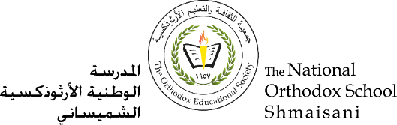

**The Primary Stage of Grades (4-5)**

**School Year 2022 - 2023**

**Name**: ____key____ **Subject**: Comprehension Practice

**Date: / / Class: Grade 4 CP (All Sections)**

**______________________________________________________________________**

**Objective/s :** To read a text and answer comprehension questions.

To practise some grammatical concepts covered.

**Read the text below. Then use the information in the text to answer the questions:**

**The very Naughty Leprechaun**

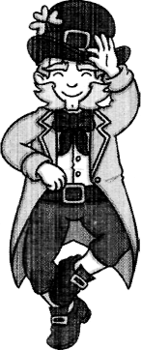

Niall was a very naughty leprechaun. He lived by himself in the woods and loved playing tricks on all the animals.

It was Niall's birthday and it was going to be the best birthday ever. He was looking forward to his birthday cake but first he wanted to play his favourite trick on the animals.

5

Niall made himself invisible and waited in the bushes. Before long, Rosa Rabbit came hopping by with a bag of carrots.

"It's my birthday!" Niall shouted, when she was very close.

"Aaahhh!" Rosa screamed, throwing the carrots in the air. The carrots landed on **her** head with a clump! Clump! CLUMP!

1000

"You naughty leprechaun!" she shouted and angrily hopped away.

After Niall had stopped laughing, he settled down in the bushes once more.

Before long, Barry Badger came trotting by with a bag of flour.

"It's my birthday!" Niall shouted, when he was very close.

"Aaahhh!" Barry screamed, throwing the flour in the air.

1500

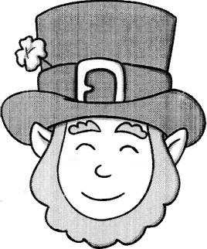The flour landed on **his** head with a flump! Flump! FLUMP!

"You naughty leprechaun!" he growled and angrily trotted away.

After Niall had stopped laughing, he settled down in the bushes yet again.

2000

Before long, Hannah Hen came bobbing by with a box of eggs.

"It's my birthday!" Niall shouted, when she was very close.

"Aaahhh!" Hannah screamed, throwing the eggs in the air. The eggs landed on her head with a smash! Smash! SMASH! "You naughty leprechaun!" **she** clucked and quickly bobbed away.

2500

After Niall had stopped laughing, he walked back to his house in the old oak tree.

When he got there, the animals were waiting for him. Rosa had a big bruise on her head, Barry was completely white and Hannah had egg yolk dripping from her beak.

"Hello," Niall giggled.

3000

"We made you a carrot cake," Barry said, brushing the flour from his eyes.

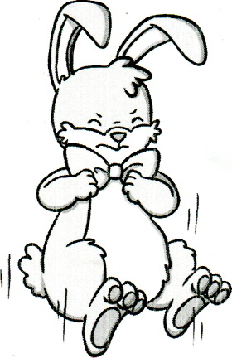"You remembered my birthday?" Niall squealed rather happily. "Yes," Hannah clucked. She gave Niall the cake.

Niall looked down at what was supposed to be a freshly baked birthday cake, but instead of the cake, it was a plate full of bashed carrots, smashed egg shells and powdery flour.

3500

"Someone ruined all of our ingredients," Rosa said. "Happy birthday."

"Oh," Niall said very sadly. "Thank you."

It was the worst birthday ever...

4000

1. Who did Niall live with?

He lived by himself.

1. What did Nail do after he became invisible?
2. laughed

√

1. waited in the bush
2. shouted
3. Why do you think Rosa screamed and threw her carrots in the air?

Because she was frightened / shocked/ He made her jump .

1. Find and copy what the animals shouted at Niall after they threw their food in the air:

“You naughty Leprechaun.”

1. "Someone ruined all our ingredients," Rosa said. "Happy birthday." Who is the 'someone' Rosa is talking about?

Rosa is talking about Niall.

1. 'Niall looked down. Instead of the cake, it was a plate full of...'

Find and copy one thing on the plate instead of the cake:

Bashed carrots, smashed egg shells and powdery flour.

1. Number the events below to show the order in which they happen in the story.

The animals give Niall a plateful of raw ingredients.

4

Niall meets the animals by the old oak tree.

3

Niall thinks it's going to be the best birthday ever.

1

Flump! Flour lands on Barry's head.

2

Niall thinks it's the worst birthday ever.

5

1. "Oh," Niall said, sadly (line 39).

Why do you think Niall was sad at this point in the story?

Niall was sad because he realized it was his fault that his birthday (birthday cake) was ruined. He should have been kinder to the animals as they wanted to celebrate his birthday by baking him a cake.

1. Find a word between lines (26-28) that means “**injury**” bruise
2. Find a word between lines (26-28) that means “**trickling**” dripping
3. Find a word between lines (34-36) that means “**damaged**” bashed/ smashed
4. Find three examples of **onomatopoeia** in the text.

Clump, flump, smash, clucked.

1. The writer named the characters **Rosa Rabbit, Barry Badger and Hannah Hen.** Which technique did the writer use?

Alliteration

1. Which **verbs** did the writer use to show how the three animals moved?

Rabbit: hopping / Badger: trotting Hen: bobbing

1. Underline the **main clause** in the following sentences:
2. Before long, Rosa Rabbit came hopping by with a bag of carrots.
3. After Niall had stopped laughing, he settled down in the bushes once more.
4. The underlined pronouns refer to:
5. her Rosa Rabbit
6. his Barry Badger
7. she Hannah Hen
8. Add the missing apostrophes.

* It was Niall’s birthday and he wanted to celebrate.

“ It’s a great day,” he said.

* The cake’s ingredients were ruined so his friends’ surprise was ruined too.

1. Add commas to the following sentences:
2. “We can make him a carrot cake,” Rosa Rabbit suggested.
3. After Niall had stopped laughing, he walked back to his house in the old oak tree.
4. Underline the prepositional phrases in the following sentences.
5. Niall made himself invisible and waited with great patience in the bushes.
6. "Aaahhh!" Rosa screamed, throwing the carrots in the air.
7. Underline the adverbial phrases in the following sentences.
8. "You remembered my birthday?" Niall squealed rather happily.
9. "Oh," Niall said very sadly. "Thank you."
10. Niall made himself invisible and waited with great patience.