I | n | i | t | i | a | l | t | e | s | t

- Tick the word that is different. (1 mark each)

1 | track | Rugby
 | court | Pitch
2 | journalist | Clerk
 | playwright | Rink
3 | confident | Tense
 | upset | Worried
4 | oars | Poet
 | bat | Goggles
5 | muscle | Eyelids
 | skates | heartbeat
6 | wind | Coal
 | gas | Paper
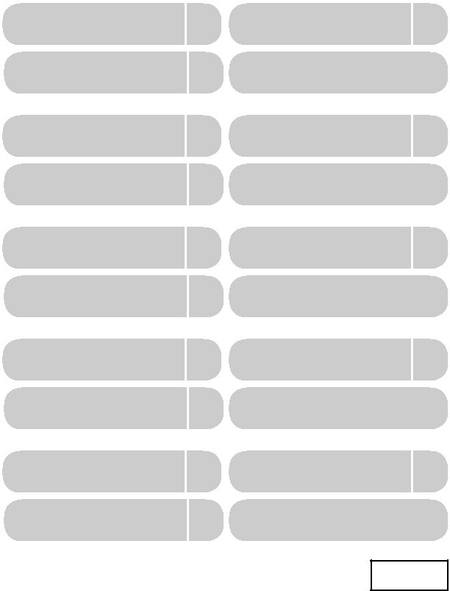
6

- Add one word from box A and one word from box B to complete each sentence. (1 mark each)

- B

get | Around
look | Down
meet | Place
settle | Started
take | Up
wake | Up

1 Tell me about the novel you’re reading. Where does the story take place

?


2 I’m sorry I’m late. I didn’t
wake up early enough.

3 When I graduate from university, I would like to buy a house and
settle down

4 If you’re free at the weekend, let’s
meet up and go

shopping together.

5 I’ve never visited that museum. I’d like to go in and look around

.

6 I’ve got a lot of homework, so I think I should get started

right now!
- Report the following statements. (2 marks each)

¹ I have some questions for you, Muna.

Nour told Muna that she had some questions for her. .

- I’ve lived in Amman for six years.

Sami said that he had lived in Amman for six years. .

- Yesterday I bought all the ingredients for a chocolate cake.
Huda told me that she had bought all the ingredients for a chocolate cake the day before.
- I really enjoyed the book that i finished this morning.
Tareq said that he had really enjoyed the book that he had finished that morning.
- My favourite subject this year is Chemistry.
Hussein told me that his favourite subject that year was chemistry. .

10

- Find six natural sources of power. Circle them and write them down. (1 mark each)

qklfossilfuelsamsiwindplfwaterqkld

woodghelwavessmfysolarenergybch

- fossil fuels
- wind

- water

- wood

- waves

- solar energy

6

- Complete the sentences with words from the box. One word is not needed.

(1 mark each)

energy grateful headlines helmet lawyer likely navy

1 I am studying hard because I want to be

a | lawyer |  | .
2 When you ride a bike, you should
always wear a |  | Helmet |  | .

3 Thank you so much! We are very

grateful.

4 Do you think it is likely to rain tomorrow?

5 I always look at the newspaper

headlines, but I don’t always

read the articles.

6 Solar panels generate energy from the sun.

6
6 Circle the correct words. (1 mark each)

1 We’re going to Aqaba again in / on the summer. I have / had been looking forward to it since last year.

2 We had the computer repaired / repairing because it had stopped to work / working.

3 Mahmoud was walking home when the rain was starting / started. It was very heavy, so he must / can’t have got very wet.

4 In the past, most letters wrote / were written by hand, but these days they are usually typed / typing.

8

- Complete the sentences with the cooking verbs in the box. One verb is not needed. (1 mark each)
 |  |  | boil | fry grill melt |  |  |  |  |  | mix
 |  |  | roast | season slice sprinkle
1 | When you heat cheese, it
2 |  |  | melt |  |  | s.
2 | Put some flour and sugar in a bowl and
3 |  |  | mix |  |  |  | them together.
3 | You need a sharp knife to
4 |  |  | slice |  |  |  | the bread.
4 | Heat the water until it |  |  |  |  |  |  |  |  | boil |  | s.
5 | Put the eggs in oil or butter to
6 |  |  | fry |  |  |  | them.
6 |  |  | Sprinkle |  |  |  | some salt and pepper
 |  | over the potatoes to season
 |  |  | them.

- Roast the meat in the oven.

 |  | 8
Total |  | 50

5


Module 1 Technology
 |  |  | t | 1 | I | n | f | o | r | m | a | t | i | o | n
 |  | i
 | n
U

t

e

c

h

n

o

l

o

g

y

Vocabulary |  |  |  | 2 Choose the correct word.
1 Match the descriptions with the pictures |  |  |  | 1 Modern computers can run a lot of
and the words in the box. One word is |  |  |  | programs / models at the same time.
not needed. The fi rst one is done for you. |  |  |  | 2 You can move around the computer
computer chip |  | calculation |  | screen using a tablet / mouse.
floppy disk | smartphone |  | program | 3 From 1990 CE to 2000 CE was a decade /
PC | World Wide Web |  |  | generation.
a | b |  |  | 4 A laptop / tablet doesn’t need a
 |  |  |  | keyboard.
 |  |  |  | 5 The television was first invented /
c | d |  |  | developed by John Logie Baird.
c | d |  |  | 3 Complete the sentences. Use words from
 |  |  |  | exercises 1 and 2.
e | f |  |  | 1 Although they are pocket-sized,
 |  |  |  | __smartphones are powerful computers as well as phones.
 |  |  |  | 2 My brother is learning how to write
 |  |  | smartphone: d | Computer programs .
 |  |  | computer chip:b | 3 I need to make a few calculations before
 |  |  | computer chip:b | I decide how much to spend.
 |  |  |  | 4 Mobile phones used to be huge. Early
 |  |  |  | __models were as big as bricks!
 |  |  | floppy disk: f | 5 I can close the lid of my laptop
 |  |  |  | and then put it in my bag.
 |  |  | PC:e
 |  |  | Calculation:c
 |  |  | __World Wide Web :a __

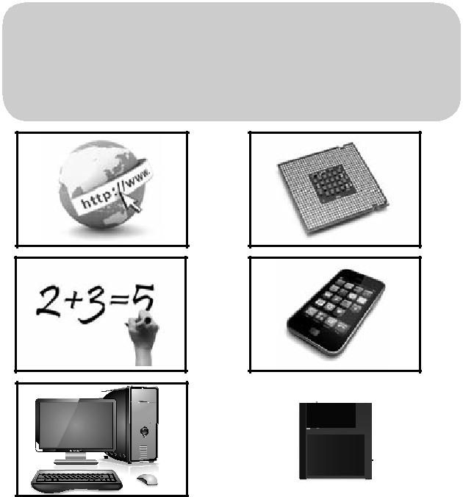

6


Grammar

- Complete the text with the correct form of the verbs in brackets. The first one is done for you.

In 1943 CE, the chairman of a ‘business

machines’ company (1) said (say) that the world only (2) needed (need) two or three computers. He

- was(be) wrong! Since

then, there (4) has been (be) a technological revolution. These days, millions of families (5) have

(have) at least one computer at home, and many people (6) carry

(carry) smartphones and tablets with them everywhere. A few people even

(7) wear (wear) them – either on their wrists, round their necks or on their belts. There’s even more: experts say that one day soon we (8) will attach

(attach) them to our skin!

- Choose the correct form of the verbs below. The fi rst one is done for you.

1 Children often use / are using computers better than their parents.

2 I usually will play/ play computer games every day, but only for one hour.

3 I want to get / getting a tablet, but I can’t afford to buy / buying one at the moment.

4 Look at the black sky! It’s raining / going to rain soon!

5 I’m coming / come from Ajloun, but I’m staying / stay in Irbid for a few months. I will return to Ajloun in the spring.

6 Nadia has been doing / done her homework for two hours! She is / will be very tired when she finishes.

7 If Ali had / has his own computer, he wouldn’t / doesn’t need to use his friend’s computer.

8 I was writing / wrote an email when my laptop was switching / switched itself off.
- Rewrite the sentences with the words in brackets. The first one is done for you.

1 Perhaps Issa’s phone is broken. (might)

Issa’s phone might be broken.

2 Somebody has found my missing laptop.
(been)
My | missing laptop has been found. |  |  | .
3 I asked someone to fi x my computer.
(had)
I |  | had my laptop fixed | .

4 It isn’t necessary to switch off the screen.

(have)
You |  |  |  |  | don’t have to switch off the screen. |  |  |  |  |  | .
5 You are not allowed to touch this
machine. (must)
You |  |  |  |  | mustn’t touch this machine, |  |  |  |  |  | .
6 I think you should send a text message.
(would)
If | I |  |  |  | were you, I would send a text message. |  |  |  |  |  | .
7 Press that button to make the picture
move. (moves)
If you |  |  |  | press the button, the picture moves. |  |  | .
8 Mohammad checked his emails, and
then he started work. (before)
Mohammad had |  |  |  | had checked his emails before he started work. |  | .

Vocabulary

- Answer the following questions.

1 Which of these is an invention – the TV or gravity? Explain your answer.
The TV: it is a product that is man-made.
2 What is the difference between a smartphone and an ordinary mobile phone?
A smart phone has internet access.
3 If you need to make a calculation, what do you usually use?
A calculator
4 Which would you rather have – a PC, a tablet or a laptop? Why?

5 Do you usually use a floppy disk? If not, what do you use?
A flash memory



Reading

- Think of two examples of how technology can keep us fit.1. Smartphone apps can be used to monitor how much exercise you do. Apps can track your workout time, heart rate and how many calories you burn.
2.Interactive video games can also be used to help us to keep fit. They are used indoors and provide a healthy, active alternative to watching TV.
- Read the article below quickly, and circle the correct words.

1 The article is about how the Internet has developed / is developing.

2 The writer says what he thinks / gives different opinions.

10 Read the article again and match the headings with the correct paragraphs. You do not need one of the headings.

1 An easy life!

2 An unknown future

3 What is the ‘Internet of Things’?

4 When will it end?
The Internet of Things?
- What is the ‘Internet of Things’?

Everyone knows that the Internet connects people, but now it does more than
that – it connects objects, too. These days,

- computers often communicate with each other; for example, your TV automatically downloads your favourite TV show, or your ‘sat nav’ system tells you where you are. This is known as the ‘Internet of Things’,

- and there’s a lot more to come.

- An easy life

In just a few years’ time, experts say that billions of machines will be connected to each other and to the Internet. As a

- consequence, computers will increasingly run our lives for us. For example, 1. your fridge will know when you need more milk and add it to your online shopping list; your windows will close if it is likely to rain;

- your watch will record your heart rate and email your doctor; and your sofa will tell you when you need to stand up and get some exercise!

C. An unknown future
- Many people are excited about the ‘Internet of Things’. For them, a dream is coming true. They say that our lives will be easier and more comfortable. However,
others are not so sure. They want to

- keep control of their own lives and their own things. In addition, they wonder what would happen if criminals managed

to access their passwords and security settings. The dream could easily become a
35 nightmare!

11 Read the article once more, then answer the questions.

1 What does the ‘Internet of Things’ mean? Give an example from the text.
It means the connection between different computers. Examples from the text are TV downloads and sat nav.
2 Find a word in the first paragraph which has the same meaning as ‘speak to’.
Communicate
3 How will the ‘Internet of Things’ help you to keep fit, according to the text?
The sofa will tell you when to get some exercise.

4 What does the word ‘others’ in bold in the third paragraph refer to?
other people with a different opinion (not sure, worried)
5 According to the text, why are some people excited about the future? Why are others worried?
Some people are excited because they think their lives will be made easier and more comfortable. Others are worried because they want to keep control of their own lives and their own things
6 In your opinion, is the ‘Internet of Things’ exciting or worrying? Why?
I think the internet of things is exciting for many reasons such as making life easier, keeping in touch with others and saving time and efforts. On the other hand, the internet is worrying for many because 1. criminals access our passwords and security setting 2. making us lazier and 3. making life more boring.



Writing

12 What are the advantages and disadvantages of the ‘Internet of Things’? Read the lists and add your own ideas.
 |  |  | Advantages |  |  |  |  |  |  |  |  |  |  |  | Disadvantages
 |  | health: monitor health and activity; fridges |  |  |  |  |  |  |  |  |  |  | privacy: everything you do is tracked;
advise on healthy eating; more time to relax;
 |  |  |  |  |  |  |  |  |  |  |  |  | security: criminals could get control of your
 |  |  |  |  |  |  |  |  |  |  |  |  | personal information; criminals could take
transport: driverless cars – automatically |  |  |  |  |  |  |  |  |  |  |  |  | over the whole system;
avoid crashes; traffic controlled more
efficiently – no more traffic jams;
 |  |  |  |  |  |  |  |  |  |  |  |  | safety: computers sometimes fail –
 |  |  |  |  |  |  |  |  |  |  |  |  | consequences could be terrible;
at home: control washing machines,
cookers, etc. with your phone; lights and
 |  |  |  |  |  |  |  |  |  |  |  |  | employment: many thousands of jobs are
heating go on and off automatically (saving
 |  |  |  |  |  |  |  |  |  |  |  |  | lost;
energy);
leisure: smart TV automatically downloads
your favourite shows; music systems play
music to suit your mood;

13 Look at the sentences below, then write a paragraph about the advantages and disadvantages of the ‘Internet of Things’. Use some of the expressions in bold below and ideas from exercise 12.

- Lights will go off automatically. In this way,/Therefore,/Consequently,/As a result, we will save energy.
- On the one hand, life would be easier. On the other hand, we would have less privacy.

- Driverless cars would make travelling simple. However, if they went wrong, they could be very dangerous.
- Although the ‘Internet of Things’ sounds exciting, we should be careful.

