The History of Computers



When **you** are using a computer, think about the technology **that** is needed for **it** to work. People have been using types of computers for thousands of years. A metal machine was found on the seabed in Greece **that** was more than 2,000 years old. **It** is believed that **this** was the first ever computer.



In the 1940s, technology had developed enough for inventors to make the first generation of modern computers. **One such model** was so **large that it needed a room that was 167 square** metres to accommodate **it.** During **that decade**, scientists in England developed the first computer program**. It** took 25 minutes to complete one calculation. In 1958 CE, the computer chip was developed.



The first computer game was produced in 1962 CE, followed two years later by the computer mouse. In 1971 CE, the floppy disk was invented, **which** meant that information could be shared



**6**



between computers. The first PC (personal

computer) was produced in 1974 CE, so people



could buy computers to use at home.



In 1983 CE, people could buy a laptop for the first time. Then, in 1990 CE, the British scientist Tim Berners-Lee developed the World Wide Web. It was not until 2007 CE that the first smartphones appeared. Today, **most people** use

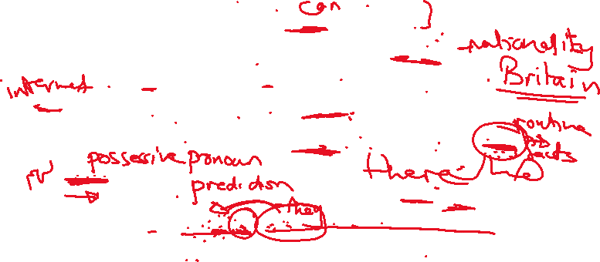

**their** mobile phones every day.

What will happen in the future? **You** can already buy watches **which** can do the same as mobile phones. Scientists have also developed glasses **that** are capable of doing even more than this.



Life in the future is going to see further changes



in computer technology. **It** is likely that all aspects of everyday life will rely on a computer program, from



how we travel to how our homes are heated.

