**The National Orthodox School / Shmaisani**

**Subject: Biology Using keys**

**Name:**

**Date:** **Grade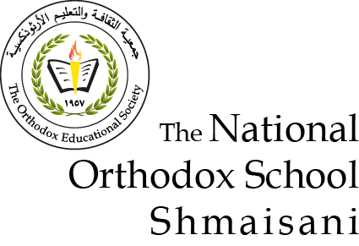 8 – all sections**

**Dichotomous Keys**

Keys are used to identify organisms based on a series of questions about their features , Dichotomous means ‘branching into two’ and it leads the user through to the name of the organism by giving two descriptions at a time and asking them to choose.

Each choice leads the user onto another two descriptions.

In order to successfully navigate a key, you need to pick a single organism to start with and follow the statements from the beginning until you ﬁnd the name.

You then pick another organism and start at the beginning of the key again, repeating until all organisms are named.

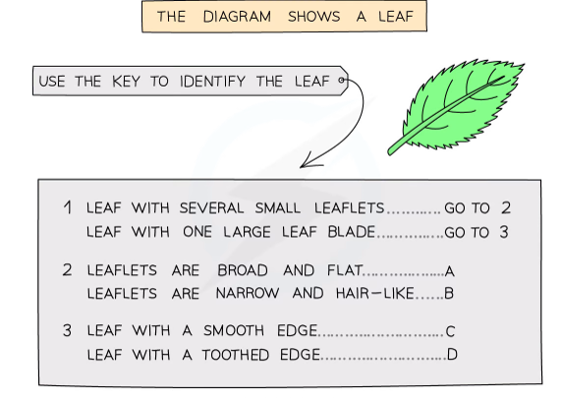

**Write the correct letter in the box**

**Question 1 :**

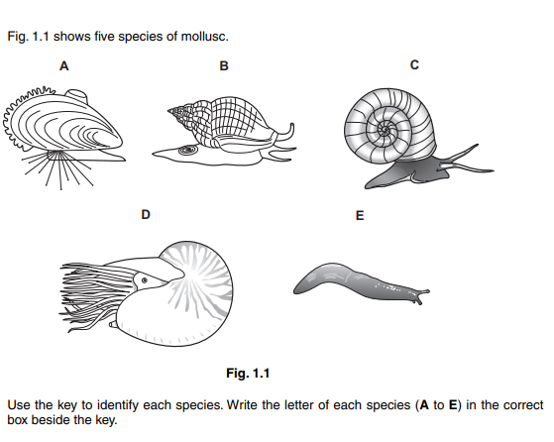

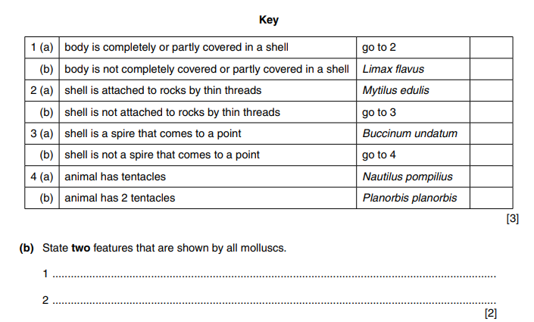

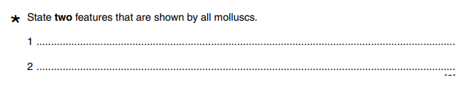

**Question 2 :**



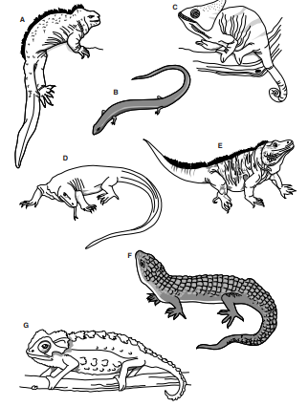

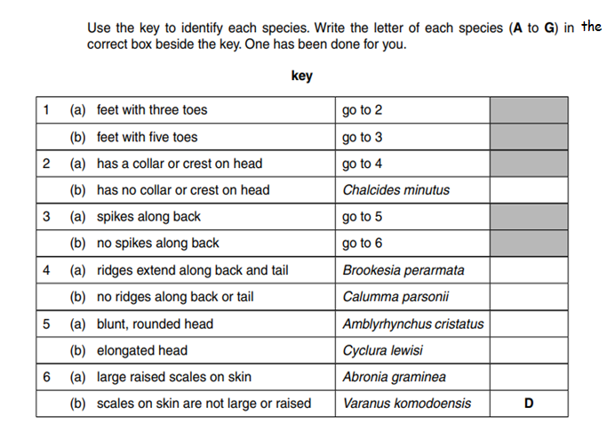

**Question 3 :**



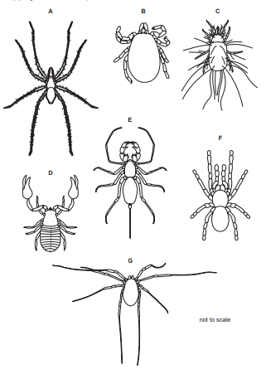

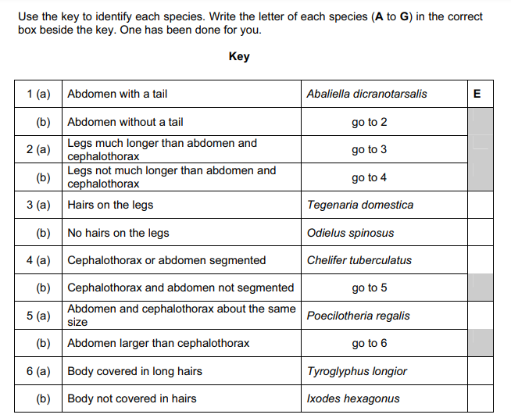

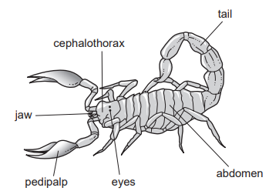 ***The diagram below helps you to identify the body parts of the species mentioned in the key above .***

**Question 4:**

