**The Primary Stage (4-5)**

**Name:** ____________ **Subject: ICT**

**Class: Grade 5 ( )**

**Network Study sheet**

-----------------------------------------------

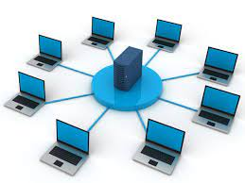**What is a Network?**

A network consists of two or more computers (devices) that are linked in order to share resources (such as printers and scanners), exchange files, or allow electronic communications. The computers on a network may be linked through cables, telephone lines, radio waves, satellites, or infrared light beams.

Two very common types of networks include:

* [Local Area Network (LAN)](https://fcit.usf.edu/network/chap1/chap1.htm#LocalAreaNetwork)
* [Wide Area Network (WAN)](https://fcit.usf.edu/network/chap1/chap1.htm#WideAreaNetwork)

Local Area Network (LAN) joins computers in a single building. A school network is a LAN.

Wide Area Network (WAN) joins computers that are far apart. An organization with offices in different cities or countries uses a WAN, **the internet is a WAN.**

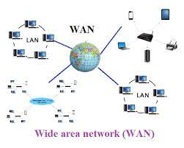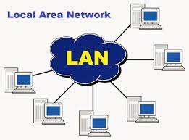

**The advantages of a network:**

* Communicating
* Sharing files
* Sharing resources

**What makes a network:**

* Network devices
* Cables
* Network Software

**Connecting to a network**

* **Wired connection**
* **Wireless (Wi-Fi) connection**

Networks use a device called a **wireless access point (WAP)** to provide a wireless connection. A place where a wireless connection is available is called a **hotspot.**

Laptop and tablet computers usually use a wireless connection to a network. Desktop computers are usually connected to a network with a cable.

**Using a network login**

To use a network, you must have a **login**. A login is made up of

* User name
* password

you must keep your password safe to protect your information and work by:

* Never tell anyone your password
* Change your password regularly
* Choose a strong password

**A strong password**

A strong password is difficult for another person to guess. You can use the passphrase method to make a strong password.

1. Think of a short phrase that you can remember. Use two or three short words with eight to twelve characters in total.

For example, **‘Ginger cats’**

1. Remove the spaces between the words: **Gingercats**
2. Replace some of the letters with other characters that look similar.

**For example : a @, e 3, s $**

1. This is your new strong password: **Ging3rc@t$**

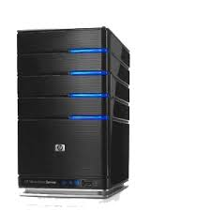**Devices in a network**

|  |  |  |
| --- | --- | --- |
| **Server** | **Switches and hubs** | **Routers** |
| A server is a powerful computer | A device used to connect computers together | A router connects a network to the internet. |
|  | What is the difference between the switch, router, and hub | **C:\Users\r.massoud\AppData\Local\Microsoft\Windows\INetCache\Content.MSO\828827AB.tmp** |

**What happens when you send an email from your school to your home?**

The email server sends the email to the **router**

The switch sends the email to the **email server**

Your computer sends the email to a **switch**

The router sends the email to the **internet**

**Where are network devices stored?**

Network devices are usually stored in a locked room called a **server room**. They are stored in metal cabinets.

**The internet**

What is the internet?

The internet is a wide area network (WAN) that connects computers across the world. It is the biggest network in the world.

The internet is not owned or controlled by a single person or organization.

**People use the internet to:**

* Communicate
* Share things
* Helps people to learn and work together
* Online shopping

**Internet services**

**The world Wide Web** (WWW): made up of all the web pages in the world.

**Email and chat**: Ways of sending messages

**Video conferencing**: people across the world can meet as if they were in the same room.

**Streaming**: games, music and videos can be played on your local device

**Web Browser**

We use a **web browser** to look at web pages on the web.

An example of web browser (Google Chrome)

**Search Engine**

We use **search engine** to search information on the web.

**Hyperlinks**

The links on web pages are called **hyperlinks**.