

**Our value: Alone we can do so little; together we can do so much.**

Adjectives and Adverbs

Grade 5 (A + B)

Name: Date: / /

Objectives: To review adjectives and adverbs.

To practise using adjectives and adverbs correctly.

* An adjective is a word or set of words that modifies (i.e., describes) a noun or pronoun. Adjectives may come before the word they modify.

*Examples:*  
*That is a****cute***puppy. *She likes a****high***school*senior.*

Adjectives may also follow the word they modify:

*Examples:*  
*That* ***puppy*** *looks cute.*

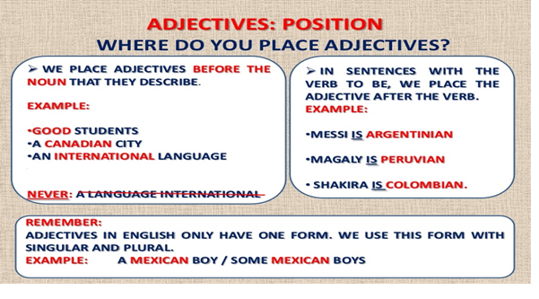

* An adverb is a word or set of words that modifies verbs, adjectives, or other adverbs. Adverbs answer *how*, *when*, *where*, *why*, or *to what extent*—*how often* or *how much* (e.g., *daily*, *completely*).

*Examples:*  
*He speaks****slowly***.(tells *how*)  
*He speaks****very****slowly.* (the adverb *very* tells *how* slowly)  
*She arrived****today***.(tells *when*)  
*Let's go****outside.*** (tells *where*)

*Jorge works out****strenuously.*** (tells *to what extent*)

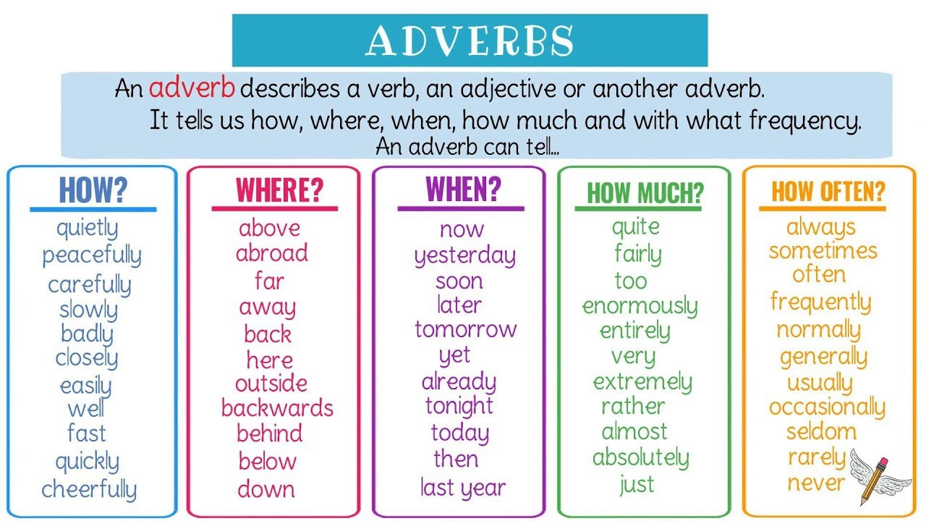

Adv of manner /adv of place/adv of time/adv of degree (intensity)/

adv of frequency

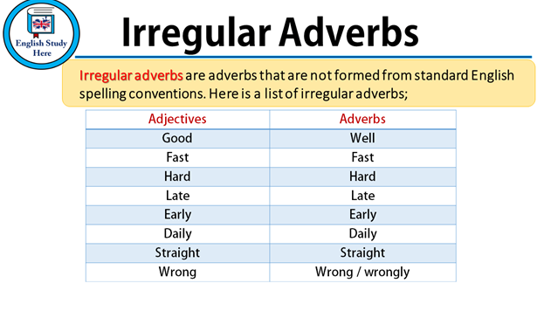

Top of Form

Write down the correct form of the word in brackets (adjective or adverb).

1. Tom is a (slow) slow worker. He works slowly.
2. Sue is a (careful) careful girl. She climbed up the ladder carefully.
3. The dog is (angry) angry. It barks angrily.
4. He acted (excellent) excellently. He's an excellent actor.
5. They learn English (easy) easily. They think English is an easy language.
6. Max is a (good) good singer. He sings well.
7. It’s (awful) awfully cold today. The cold wind is awful.
8. If that is true, why does dog food smell so (terrible) terrible?
9. The little boy looked (sad) sad. I went over to comfort him and he looked at me sadly.
10. I tasted the soup (careful) carefully but it tasted (wonderful) wonderful.

Choose the correct answer.

1) John held the plate ------------- **(careful / carefully)**

2) Julia is a -------------- person. **(careful / carefully)**

3) I ran --------------- to the station. **(quick / quickly)**

4) The journey was ------------- **(quick / quickly)**

5) You look ------------. Didn't you sleep well? **(tired / tiredly)**

6) The baby rubbed her eyes ---------------. **(tired / tiredly)**

7) She sang ----------------. **(happy / happily)**

8) You sound ---------------. **(happy / happily)**

9) I speak English ----------------. **(well / good)**

10) Her English is ------------------. **(well / good)**

11) She cooks -------------. **(terrible / terribly)**

12) He is a ---------------- cook. **(terrible / terribly)**

13) The music was ----------------. **(beautiful / beautifully)**

14) She plays the piano ------------------. **(beautiful / beautifully)**

15) That was a -------------- answer. **(clever / cleverly)**

16) She answered ------------------. **(clever / cleverly)**

17) Your flat seems ----------------today. **(tidy / tidily)**

18) He put the dishes away ----------------. **(tidy / tidily)**

19) He spoke ----------------. **(warm / warmly)**

20) She is a very -------------------person. **(warm / warmly)**

Bottom of Form

Teacher: Mirna Nawaf Al- Sahawneh.