

**Our value: Self – belief and hard work will always earn you success**

**Vocabulary _ Unit 13**

**(The Sound of Money and the Smell of Soup)**

**Name ………………… Grade (5)**

|  |
| --- |
| **Objectives**  **1. Identify the meaning of the new words.**  **2. Identify the synonyms of the new words.**  **3. Practice using the new words in sentences.** |

**Verbs**

|  |  |  |
| --- | --- | --- |
| **Word** | **Synonym** | **Meaning** |
| Growl | Bark | To make a low noise in the throat to show anger or to give a warning.  **Example**: Once the dog was cornered, he began to **growl**. |
| Stir | Whisk | To move a liquid or substance around, using a spoon or something similar.  **Example**: Don't **stir** the milk until it creams. |
| Stare | Gaze | To look at someone or something for a long time.  **Example**:  It's impolite to **stare** at a girl. |

**Adjectives**

|  |  |  |
| --- | --- | --- |
| **Word** | **Synonym** | **Meaning** |
| Terrifying | Frightening | Making you feel frightened.  **Example**: A **terrifying** scream in the blackness of the night made my blood run cold. |
| Fierce | Violent | Angry and aggressive / very strong.  **Example**: He may look **fierce**, but he means no harm. |
| Delicate | Fine | Fine or thin; easy to damage or break.  **Example**: Everything you see exists together in a **delicate** balance. |
| Greedy | Selfish | Wanting more food, money, power, etc. than you really need.  **Example**: The **greedy** boss stopped at nothing to gain profit. |
| Wise | Knowing | Having or showing the knowledge or experience to make good or sensible decisions or judgments.  **Example**: He is a **wise** man that makes no mistakes. |
| Mouth-watering | Delicious | That looks or smells very good.  **Example**: Fish ball soup and the fried fishcakes stuffed with sweet chili sauce and coriander are **mouth-watering**. |
| Tempting | Attractive | Attractive in a way that makes you want to do or have something.  **Example**: That pie looks **tempting**. |

**Nouns**

|  |  |  |
| --- | --- | --- |
| **Word** | **Synonym** | **Meaning** |
| Muscles | Flesh | Pieces of flesh inside the body which you can relax or make tight to produce movement.  **Example**: The athlete has got powerful **muscles**. |

**Adverbs**

|  |  |  |
| --- | --- | --- |
| **Word** | **Synonym** | **Meaning** |
| Nervously | Anxiously | In a way that shows you are nervous or afraid.  **Example**: She **nervously** crumbled the bread between her fingers. |
| Rudely | Impolitely | In a way that shows a lack of respect for other people and their feelings.  **Example**: He **rudely** rejected her kind offer of help. |
| Politely | Kindly | In a polite way; in a way that shows respect for others.  **Example**:  He cannot refuse if you ask **politely**. |
| Aggressively | Forcefully | In a way that shows you are ready to fight or argue.  **Example**:  Small children often behave **aggressively**. |
| Bravely | Courageously | In a way that shows you are not afraid.  **Example**:  He faced his illness **bravely** and without any hint of self-pity. |
| Shyly | Hesitantly | In a way that shows nervousness around other people.  **Example**: She glanced **shyly** at him and then lowered her eyes. |
| Calmly | Quietly | In a calm way.  **Example**: I got up and walked **calmly** out into the early evening. |

1. **Write the synonym of each of these words**:
2. Growl bark
3. Stir whisk
4. Stare gaze
5. Terrifying frightening
6. Fierce violent
7. Delicate fine
8. Greedy selfish
9. Wise knowing
10. Mouth-watering delicious

10.Tempting attractive

11. Muscles flesh

12. Nervously anxiously

13. Rudely impolitely

14. Politely kindly

15. Aggressively forcefully

16. Bravely courageously

17. Shyly hesitantly

18. Calmly quietly

1. **Write the correct word under each picture.**

|  |
| --- |
| Growl_ Stir_ Stare_ Terrifying_ Fierce_ Delicate_ Greedy_ Wise_ Mouth-watering _Tempting_ Muscles_ Nervously_ Rudely_ Politely_ Aggressively_ Bravely_ Shyly_ Calmly |

    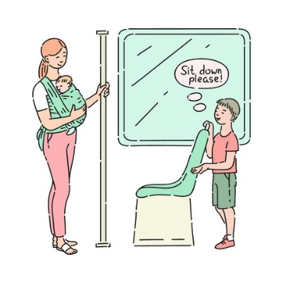

Calmly shyly bravely aggressively politely

   

Rudely nervously muscles tempting

   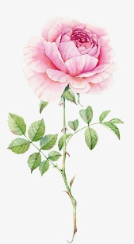

Mouth-watering wise greedy delicate

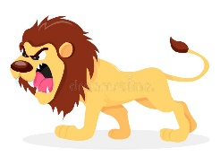  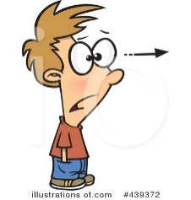 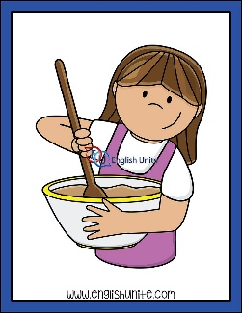 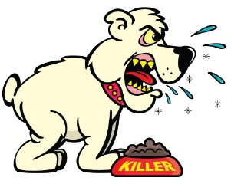

Fierce terrifying stare stir Growl

1. **Fill in the gaps with the correct words from the box.**

Growl_ Stir_ Stare_ Terrifying_ Fierce_ Delicate_ Greedy_ Wise_ Mouth-watering _ Tempting_ Muscles_ Nervously_ Rudely_ Politely_ Aggressively_ Bravely_ Shyly_ Calmly

1. She argued her case calmly and rationally.
2. She glanced shyly at him out of the corner of her eyes.
3. He fought bravely in the midst of the battle.
4. Even the most peaceful fish can act aggressively to newcomers in their territory.
5. He asked me politely for the book.
6. What was I saying, before we were so rudely interrupted?
7. He bit his lip nervously, trying not to cry.
8. The runner has firm muscles.
9. That cake looks very tempting.
10. This soup is mouth - watering.
11. Many receive advice, only the wise profit by it.
12. He looked at the gold with greedy eyes.
13. He touched the delicate petals with gentle fingers.
14. There was some fierce fighting.
15. It was a terrifying experience.
16. It isn't good manners to stare at people.
17. I need a teaspoon to stir my tea.
18. The dog is angry and growls at the stranger.
19. **Find the synonyms of the following words in the crossword and write them down.**

|  |  |  |  |  |  |  |  |  |  |  |  |
| --- | --- | --- | --- | --- | --- | --- | --- | --- | --- | --- | --- |
| v | e | c | b | a | r | k | e | g | f | i | n |
| a | w | h | i | s | k | n | g | e | a | r | y |
| u | n | g | a | z | e | a | i | n | b | n | m |
| s | f | v | i | o | l | e | n | t | n | a | d |
| g | r | f | i | n | e | p | p | y | o | r | h |
| r | a | w | c | k | i | n | d | l | y | e | n |
| e | c | i | m | p | o | l | i | t | e | l | y |
| t | q | u | i | e | t | l | y | i | y | n | v |

1. Growl bark 2. Stir whisk

3. Stare gaze 4. Fierce violent

5. Delicate fine 6. Politely kindly

7. Rudely impolitely 8. Calmly quietly

Coordinator’s Signature: -------------------

Teacher: Mirna Nawaf Al-Sahawneh.