
Worksheet (6)
Grade Two
Name: Date: 1 / 5/2023 _______________________________________________________________
Objective: To write the words in alphabetical order.
Alphabetical Order
A. Read through the alphabet.
a b c d e f g h i j k l m n o p q r s t u v w x y z

B. Underline the vowels.

C. The remaining letters are called consonants.

D. Complete the following letter sequences.

d | e | f | g | h | i
t | u | v | w | x | y
l | m | n | o | p | q

E. List the following words in alphabetical order.
1.
peach apple
banana banana
grapes grapes
orange orange
apple peach

2.
bread bread
tea coffee
coffee jam
sugar sugar
jam tea

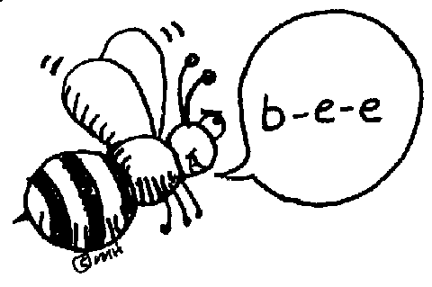

T.Taghreed Alnimri Coordinator’s Signature:

