

**Web Design – Expression Web4**

**Worksheet#1**

**Name ………………………………. 6th Grade, section …………**

**Date…………………………………. 2nd semester 2022-2023**

**Start Expression Web 4**

1. Create a new web page [File – new – Blank page].
2. Save this page using the name: [Animals.htm].
3. Change the background color to Blue.

Format 🡪 Background 🡪 Select the background color.

1. Type the heading “**Amazing Animals**”.

Change the font to be: font Name: Snap ITC – font size- 50pt, Font color – Dark Blue, Font style – Bold, Alignment – Center.

1. 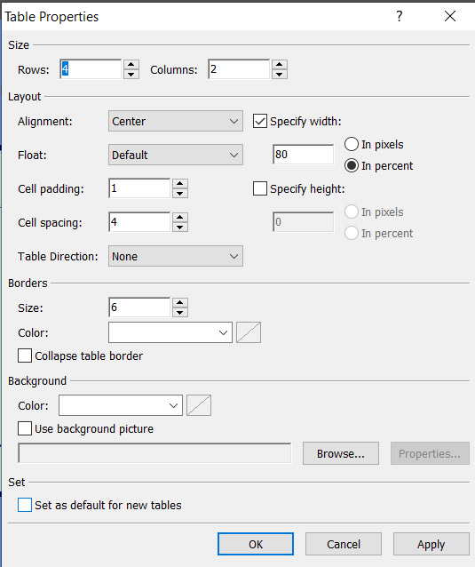Below the Header create a table:

* Number of rows:4 / Number of Columns: 2
* Change the width of the table so that it fills **80% of the width** of the window.
* Border size: 5 – Border color: Dark Blue
* Table Background color: light blue.
* Cell spacing: 4 [spaces between the cells]
* Align the table in the center

1. Merge the Cells so you will get the following table:

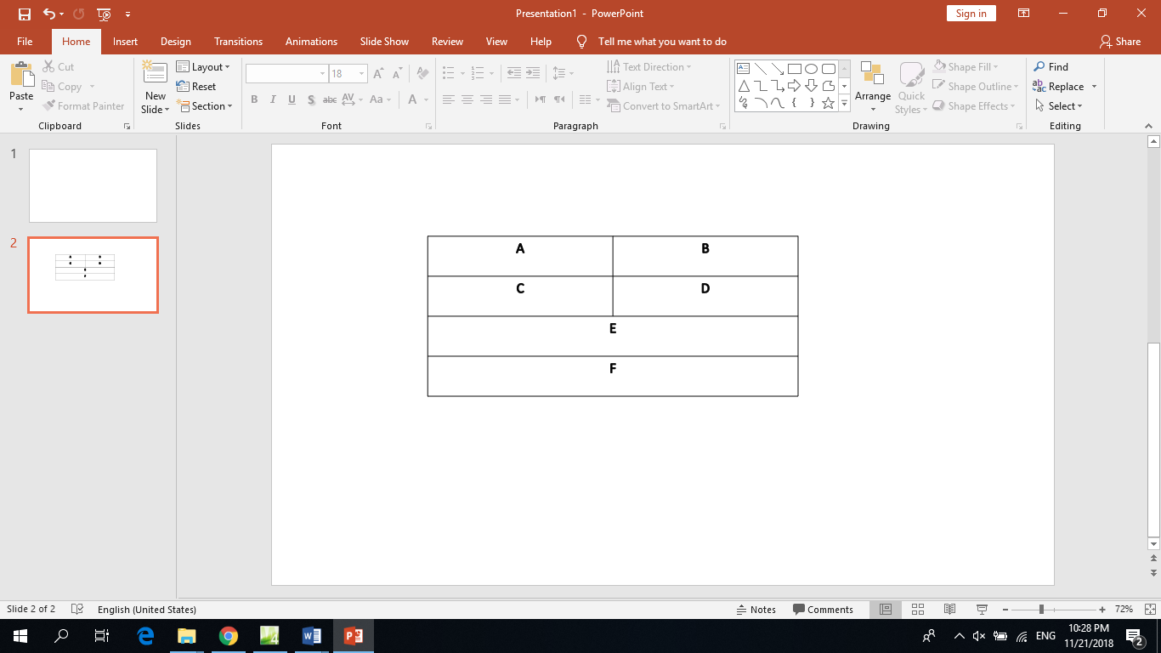

1. In **cell A** insert the Text: **Emperor Penguin**

Change the Text: Font – Comic Sans MS, Size -32pt, Bold, color – Dark Blue, Align - Center.

1. In **cell B** insert the Text: **Great White Shark**

Change the Text: Font – Comic Sans MS, Size -36pt, Bold, color – Dark Blue, Align - Center.

1. In the **cell C** insert the image: **penguin.jpg**

Change the width of the image to be 400 pixels, and the height to 250 pixels, do not keep the aspect ratio

1. In the **cell D** insert the image: **Shark.jpg**

Change the width of the image to be 400 pixels, and the height to 250 pixels, do not keep the aspect ratio.

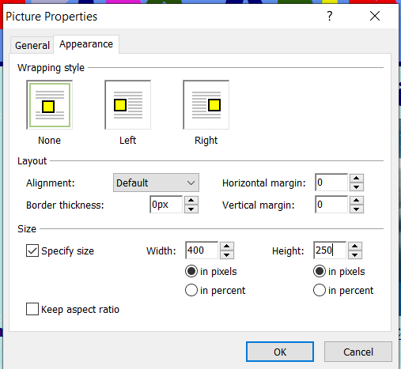

1. **In** **cell E** insert the Text: [For more information visit our website [animalfactguide.com](http://www.animalfactguide.com)].

Change the Text: Font – Comic Sans MS, Size -18pt, Bold, color – Dark Blue, Align - Center.

1. **Create** a hyperlink from the word [**animalfactguide.com**](http://www.animalfactguide.com) to the website URL : **www.**[**animalfactguide.com**](http://www.animalfactguide.com).

* Highlight the text [**animalfactguide.com**](http://www.animalfactguide.com)**.**
* Insert 🡪 Hyperlink
* 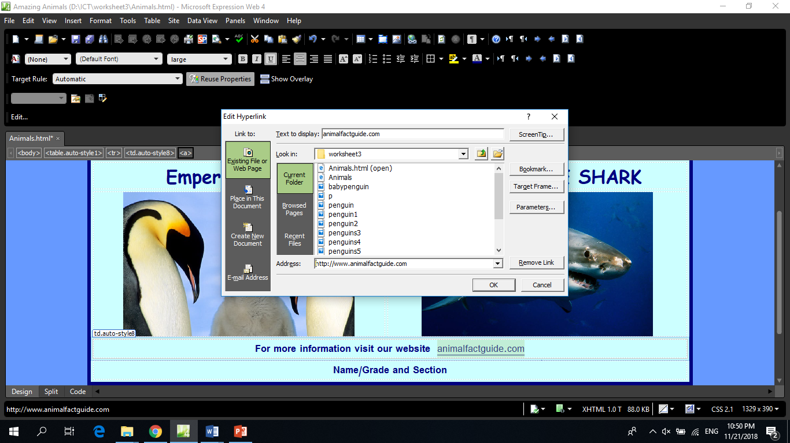Type the URL of the website **www.**[**animalfactguide.com**](http://www.animalfactguide.com).

1. In **cell F** insert: Your name -Grade and section

Change the Text: Font – Comic Sans MS, Size -24pt, Bold, color – Dark Blue, Align - Center.

1. Save the page.

**Create new page**

1. File – new – blank page
2. Save as [**Penguins.htm**]
3. Change the background color to Blue.
4. Insert the heading “**Emperor Penguins**”.

Change the font to be: font Name: Snap ITC – font size - 50pt, Font color – Dark Blue, Font style – Bold, Alignment – Center.

1. Below the heading, insert three interactive buttons: Home, Penguins, and White Sharks.

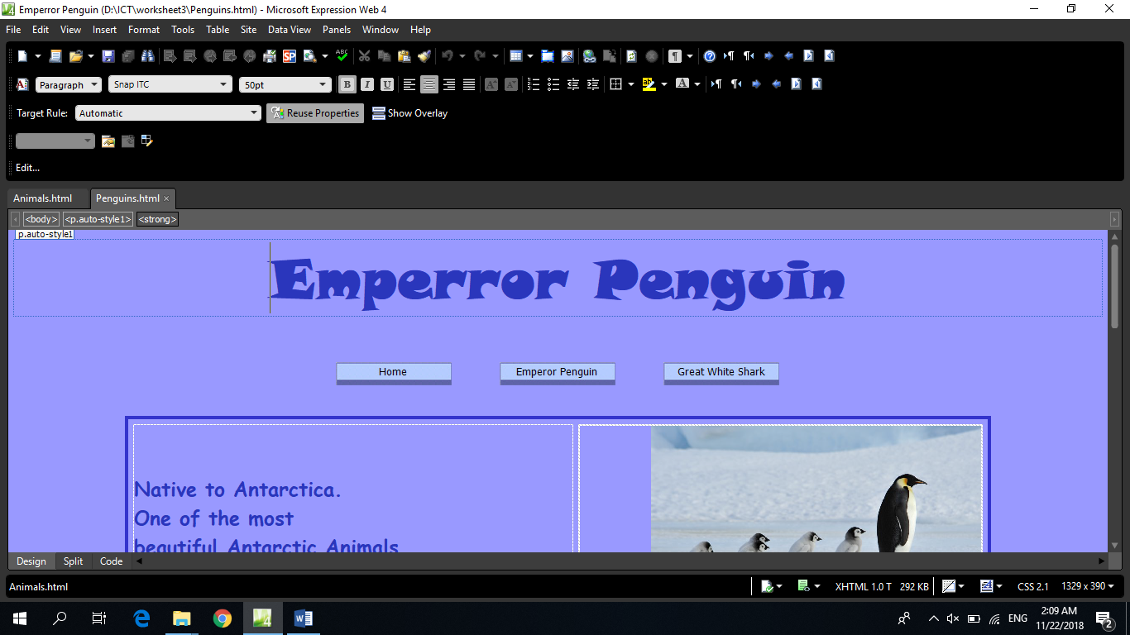

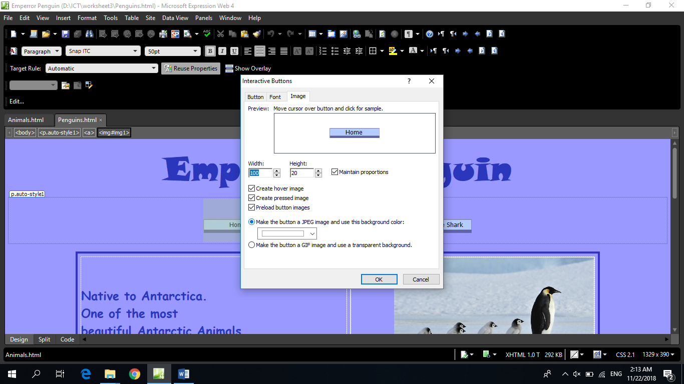

* Button Type: Border Bottom1
* Change the width of Each button to 150 pixels.
* Font size for the Button text is 12
* Create a hyperlink from the button HOME to the page Animals.

1. Below the heading, create a new table which has 3 rows and 2 columns.

* *Change the width of the table so that it fills* **80% of the width** *of the window.*
* *Border size: 5 /Border color: Dark Blue*
* *Cell spacing: 6[spaces between* the cells]
* *Align the table in the center*

1. Merge the cells to create the table as shown below.

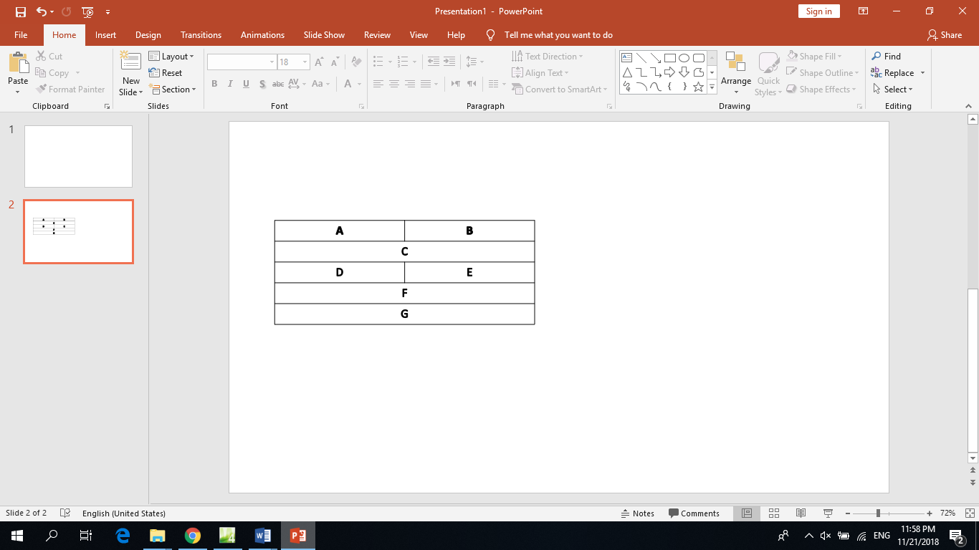

1. Using the file **Animalsdata.docx,** Copy the data [They are native … Antarctic Animals] in **cell A**.

Change the text so that: Font-Comic Sans MS, size- 24, color: Dark Blue.

1. In cells **B insert the image penguins6.jpg**.

Set the **image width** to **400 pixels**, and maintain the aspect ratio.

1. Using the file **Animalsdata.docx,** Copy the data [The Emperor… fish in Antarctica] in **cell C**.

Change the text so that: Font-Comic Sans MS, size- 24, color: Dark Blue, Alignment –

center

1. In cells **D insert the image penguins3.jpg**.

Set the **image width** to **400 pixels**, and the **height to 300**, and do not maintain the aspect

ratio.

1. In cells **E insert the image penguins5.jpg.**

Set the **image width** to **400 pixels**, and the **height to 300**, and do not maintain the aspect

ratio.

1. At the end of the page add the text [HOMEPAGE], and then create a hyperlink from the world [HOMEPAGE] to the page Amazing animals.htm.
2. Save the page.
3. Return to the page **Animals.HTM.**

Create a hyperlink from the text **Emperor Penguin** to the page **Penguins.htm.**

**Create New Page**

1. Save the page using the name [Shark.HTM].
2. Using the data about Great white shark in the file **Animalsdata.docx,** and the images in the folder, **design a page** about **Great white shark** and complete your website by creating the suitable hyperlinks.
3. Preview **your web pages in Browser .**