**The National Orthodox School / Shmaisani**

**Subject: Biology Worksheet : Cycles**

**Name:**

**Date:** **Grade 9 IB**

**Question 1 :**

(a) Which of A - D is the carbon cycle process by which carbon enters the tissues of living organisms from the atmosphere?

☐ A Decomposition

☐ B Photosynthesis

☐ C Aerobic respiration

☐ D Evaporation

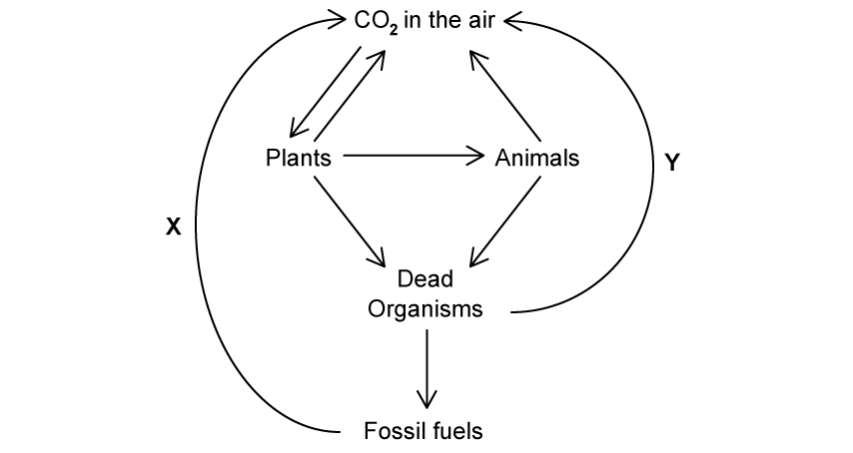(b) Part of the carbon cycle is shown in the diagram below.

Name processes X and Y in the diagram.

……………………………………………………………………………………………………….

(c) Describe how carbon is released during process Y in part (b).

………………………………………………………………………………………………………………………………………………………………………………………………………………………………

(d) Carbon is an element that is present in biological molecules such as proteins. Name two other elements that are present in all protein molecules.

…………………………………………………………………………………………………….

**Question 2**

(a) State one role of nitrogen in living organisms.

………………………………………………………………………………………………………………………………………………………………………………………………………………………………

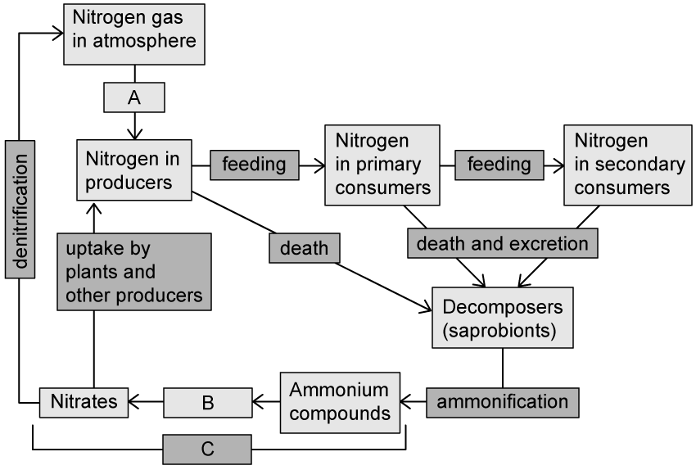(b)The diagram below shows a representation of the nitrogen cycle.

Identify the processes or molecules marked A-C in the diagram.

……………………………………………………………………………………………………………………………………………………………………………………………………………………………..

(b) Describe the process of denitriﬁcation shown in part (b).

…………………………………………………………………………………………………………………………………………………………………………………………………………………………….

(d) The process of denitriﬁcation occurs faster in soil that is ﬂooded with water, reducing the availability of nitrates in the soil. Suggest how this might affect the appearance of any plants growing in ﬂooded soil.

…………………………………………………………………………………………………………………………………………………………………………………………………………………………………………………………………………………………………………………………………………………………………………………………………………………………………………………………….

**Question 3:**

(a) The diagram below shows a representation of the carbon cycle.

Explain how carbon is returned to the atmosphere at the stage labelled Y.

…………………………………………………………………………………………………………..

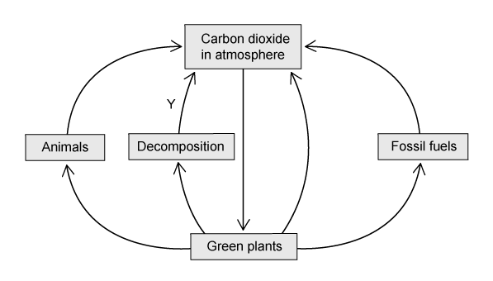

(b) The diagram in part (a) is missing many details of the carbon cycle.

Label the diagram as follows to show where each of the processes occurs within the carbon cycle.

1. Use a letter R to show where respiration occurs.
2. Use a letter P to show where photosynthesis occurs.
3. Use a letter F to show where feeding occurs.

(c) Carbon from fossil fuels enters the atmosphere during combustion.

(i) Explain how this process contributes to rising average global temperatures.

…………………………………………………………………………………………………………………………………………………………………………………………………………………………………………………………………………………………………………………………………………….

(ii) Explain how cutting down trees during deforestation increases the problem described in part (i).

……………………………………………………………………………………………………………………………………………………………………………………………………………………………………………………………………………………………………………………………………………..