[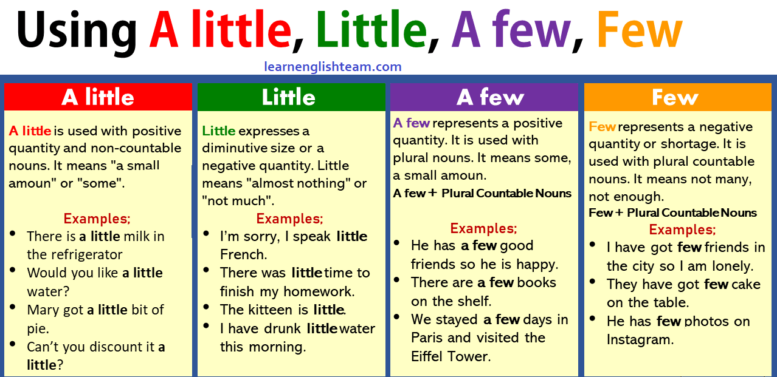](https://www.learnenglishteam.com/wp-content/uploads/2019/01/difference-A-little-Little-A-few-Few.png)

**A Little – Little**

**A little** and **little** refer to **uncountable** nouns, and are used with the singular form:

**Examples:**  
There’s little water left in the bottle.  
I’ve put a little sugar into your tea.