

The National Orthodox School/AL-Ashrafieh

Science Worksheet

**Unit 9: Magnets**

Grade: 5(A+B) Date: / /2023

Name:

*Q1.* Find out whether these magnets will ***attract***or ***repel***

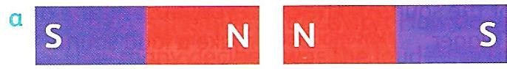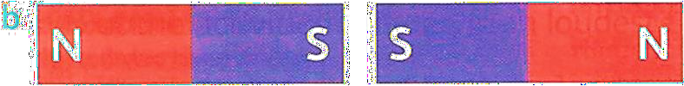

_____repel___________ repel

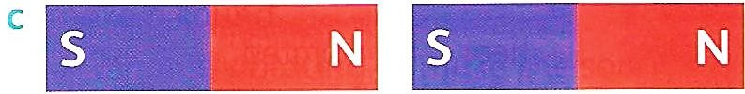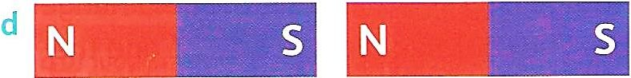

___________attract_____ ______attract_____

*Q2*. **Tick [ ✓] the metals that magnets can pick up:**

|  |  |  |  |
| --- | --- | --- | --- |
| * Gold | * Cobalt | * Iron | * Copper |
| * Aluminium | * Silver | * Steel | * Nickel |

*Q3* . **Fill in the blanks with the correct word to complete the statements**.

1- Magnets have two One is called the north (N) pole and the other is the south (S) pole.

2- Opposite poles of two magnets will attracteach other.

3- You can increase the power of an electromagnet by adding more batteries and increasing the number of turns.

4- The area around a magnet where the force of magnet can be felt is called magnetic field

5- A magnet can be demagnetized by heatingor striking or beating

***Q4.*  Write True or False**

1. The magnetic field strength of a magnet is weakest at the poles. [ F]
2. An electromagnet is a permanent magnet. [ F ]
3. Magnets produce an area of magnetic force called a magnetic field. [ T ]

1. Iron, Nickel, Steel and Cobalt are magnetic materials. [ T ]
2. Coiling the wires more will decrease the power of electromagnets. [ F ]

***Q5.* Label the electromagnet.**

