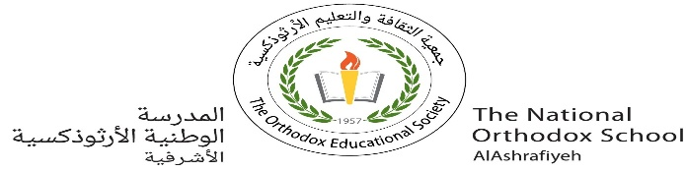

The National Orthodox School/AL-Ashrafieh

Science Worksheet / **Unit 5: Water**

Name: Date: / /2023

Grade: 4(A+B)

The Water Cycle

Water cycle is made up of four main stages:

1- evaporation 2- condensation 3- precipitation 4- collection

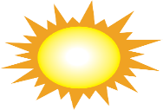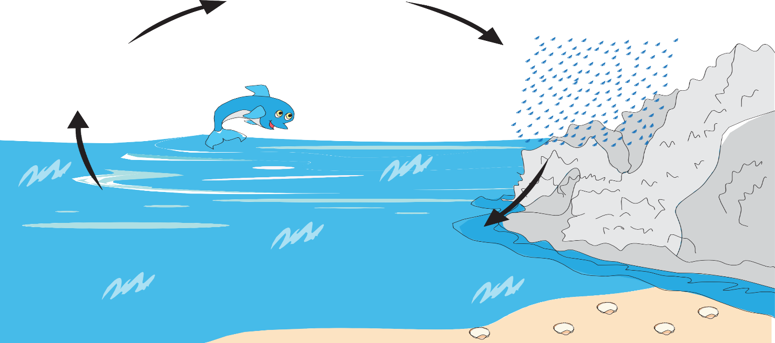

Precipitation

(Rain, snow ,hail)

condensation

collection

evaporation

1- ***Evaporation*** is when the heat from the sun warms up rivers, lakes or oceans and it turns the water into water vapor or steam.

2- **Condensation**happens when water vapor becomes liquid and clouds formed.

3- ***Precipitation*** is the fall of water from the sky that that can be hail, snow or rain.

4- **Collection**: Oceans, rivers and lakes collect water that falls from the sky.

1- Label the 4 steps of the water cycle.

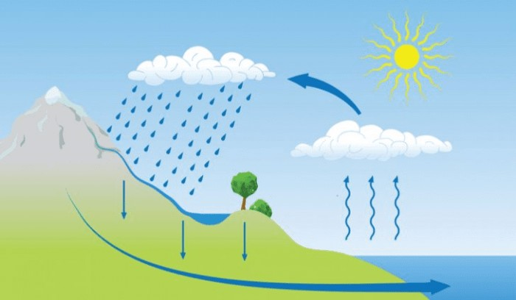

2-To which stage of the water cycle does each statement relate?

* The sun heats water and produce water vapor. __________
* The water vapor goes up and form clouds. __________
* When the clouds become too heavy and cannot hold more water inside, so the water falls back to earth. ____________.

Mention three types of precipitation.

1. _______________ 2. _______________ 3. _______________

Teacher: Diala Alazrai