

The National Orthodox School/AL-Ashrafieh

Science Worksheet / **Unit 5: Water**

Name: Date: / /2023

Grade: 4(A+B)

The Water Cycle

1) Label the parts of the water cycle then color the picture.

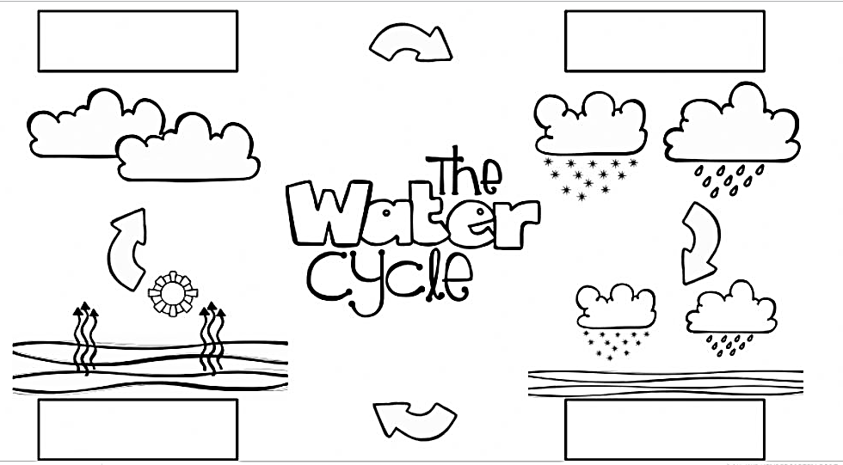

2 ) Write true or false.

1- Precipitation can be rain or snow. ______

2- Evaporation is when the water of the seas, oceans and lakes turns into vapor and forms a cloud. _____

3- Precipitation only happens on the sea. _____

4- The water in the clouds is in gaseous state. _____

5- Evaporation happens when the liquid water gets cold. ____