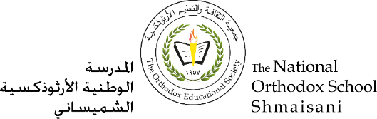

**The Primary Stage of Grades (4-5)**

**School Year 2022 - 2023**

**Name**: ___________ **Subject**: **Vocabulary Worksheet #2**

**Date: / / Class: Grade 4 CP (All Sections)**

**_____________________________________________________________**

**Objective/s: To use the following words correctly.**

|  |  |  |
| --- | --- | --- |
| **Word** | **Meaning** | **Synonym** |
| 1. Memorable (adj): | worth remembering often because it’s unusual. | unforgettable. |
| 2. Current (adj): | of the present time. | present |
| 3. Insightful (adj): | understanding the truth about things. | understanding |
| 4. Launched (v): | started or set in motion. | began |
| 5. Published (v): | printed to be sold. | issued |
| 6. Content (n): | the articles or parts contained in a magazine or book. | topics |
| 7. Inspire (v): | to make someone feel that they want to do something and can do it. | motivate |
| 8. Dynamic (adj): | having a lot of ideas and enthusiasm. | energetic |
| 9. Thought- provoking  (adj): | making you think a lot about a subject. | challenging |
| 10. Outstanding (adj): | clearly very much better than what is usual. | excellent |

|  |
| --- |
| **dynamic content current outstanding published launched inspired thought-provoking insightful memorable** |

**1. Fill in the spaces with the correct word from the box:**

1. He told me the ___________ of the letter.
2. The lavish production makes this musical truly ____________.
3. Who is the _________ editor of the Times?
4. She has written an _______________ account of the modern art world.
5. The programme was _*______* a year ago.
6. The names of the winners of the competition will be _*_____________* in June.
7. After her trip to Venezuela, she felt  ____________ to learn Spanish.
8. She’s young and ___________ and will be a great edition to the team.
9. Reading books is__________________.
10. Ajloun is an area of ________________ natural beauty.

**2. Use the following words in meaningful sentences:**

Thought-provoking: _________________________________________________

________________________________________________________________

Dynamic: __________________________________________________________

________________________________________________________________

Inspire:_________________________________________________________________________________________________________________________