**Linking words / Conditional sentences/ If clauses**

1. A conditional sentence is made up of:

If __if clause____, ____main clause___



Main clause if if clause



2.

|  |  |
| --- | --- |
| Modal 1 | Modal 2 |
| will | would |
| can | could |
| May | might |

3.Modals mustn’t be used in the if clause but in the main clause

If I will notify ,

4. tenses

Present simple

Subject + verb /s /es / S+ don’t + doesn’t +v

Simple past

S+ regular +ed irregular/ negative didn’t + base verb

Past perfect

S + had + P.P Negative had + not +p.p

5. Words that can be used instead of if to express a condition. (formal)

If, provided that



Unless (if not)



even if



when



as long as



Type 0--------- facts// things that are always true

(inevitable consequence)

If +S+ V1 (present simple), S+ present simple

If she _________ water, it boils. (heat)



When can replace if in Zero conditional.

If you heat water to 100C, it boils.

When you heat water to 100C, it boils.

If people don’t eat, they __________ **(get)** hungry.



When you freeze water, it ________ **(turn)** ice.

If/when you press that button, the machine___ **(work)**

If Laith travels to the USA, his English will improve/improves.

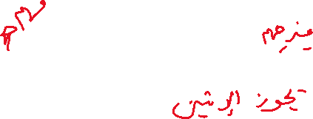

Type 1 …. Future outcome

If +S +V1 (Present) ………, S+ Modal 1 + base



S+ Modal 1 + base if +S +Present



If he notifies me, I will guide him.

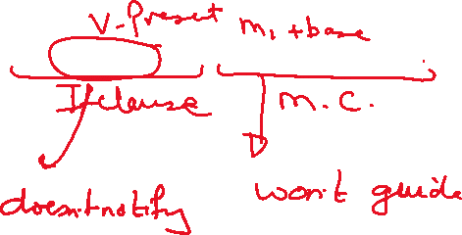

If she ___________ abroad, she will be introduced to a new culture. **(travel)**

Type two

1. (hypothetical, imaginary situations) +

2. Advice

If +S +V2 (Past simple) ………, S+ Modal 2 + base

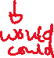

S+ Modal 2 + base if +S +Past simple



Imaginary

If they _______ hard, they would achieve high grades. (work)

+ not



How would you behave if she __________ on time? (not/come)

2.Advice

If I were you, I would study harder.

I would join a gym if I were you.

Type 3 imaginary past situations (impossible and didn’t happen

If +S +( had+p.p)………, S+ Modal 2 +have +P.P



S+ (Modal 2 +have +P. P) if +S+ (had + P.P)

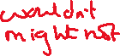

I ______________ much money if I hadn’t done the work experience first. (not, have)



Rewrite

First idea

If ----- Unless

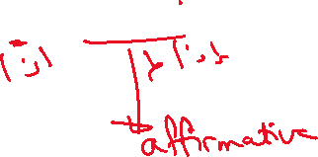

1. If you study hard, you will pass the test.

Unless_______________________________

2.If Salma doesn’t submit her assignment today, she will lose her marks.

Unless_____________________________

3.If he calls me, I will tell him.

Unless___________________________



4.If she doesn’t inform me, I will be angry.

Unless___________________________

5. If it isn’t expensive, I will buy it.

Unless _______________________

6.We will miss the train if we don’t start now.

________________________ unless_________

7.Unless he proves his language, he won’t be accepted.

If _________________________________



Second idea

Advice

To give a piece of advice we can use may forms:

1. If I were you, I would ……. .

1. Why don’t you ………………..…?
2. Subject + could …..
3. Subject + would …….

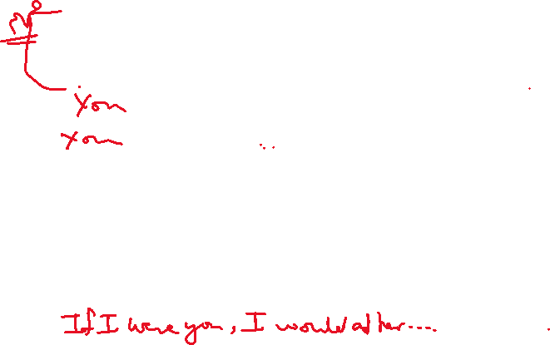

\*\*\***Rewrite the following sentences giving advice / suggestions.**

You should adhere to such rules.

___________________________. (were/if)



________________________? (why/don’t)

______________________ (could)(would)

Important Note:

It ………………….. a good idea to………



It is a good idea to study regularly.



_______________________ ? (why)

_______________________. (were)

________________________ (could)

________________________ (would)

Third Idea



Type 3 imaginary past situations (impossible and didn’t happen

….

If +S +( had+p.p)………, S+ Modal 2 +have +P.P



S+ (Modal 2 +have +P. P) if +S+ (had + P.P)



These expressions indicate result

(so, and so, as a result, that’s why, that’s how, and)



Sami left his camera at home so he won’t be able to take photos. (could)



Result >>>>>>>>>>>>>>>>>>>>> Main clause



If Sami_________________________________



2. You had a brightly colored T shirt on. That’s how I noticed you. (might)



If _____________________________

The teacher didn’t correct your paper so you weren’t able to take …..



IF____________________________________



They worked hard, so they didn’t experience any difficulty.



If _______________________________ if/could/would)



She didn’t study properly, and she failed.



_________________________________



(might /not)



They prepared well that is why they were able to answer.



_______________________(If /could/ not)

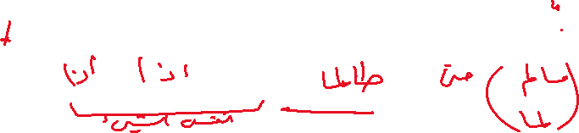

If, provided that , as long as ,even if , unless when



We couldn’t go to the stadium **because/as/since** there weren’t any tickets left.

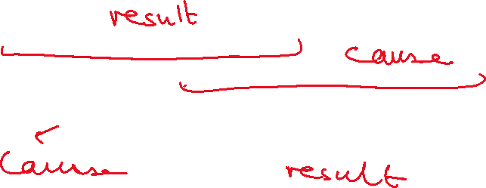

If ______________________________

