

**Microsoft Excel – Classwork#4**

**Name: 2nd Semester 2022/ 2023**

**Date: Grade 6 – Section ………**

**The school send a survey to the student to collect information about students interests, the responses file was given to you so you can analyze the data and create charts.**

Open the file **Students Interests_Responses.xlsx** using MS-Excel and then apply the steps below:

* 1. Change the row height for Row#1 to 50 points.
  2. Set the width of column E, F to 25 points.
  3. In the range [A1:F1], align the text: center and middle, and wrap the text over many lines.
  4. Select the Range [A1: F57] and then select [DATA 🡪 FILTER].

**Task 1**

* 1. 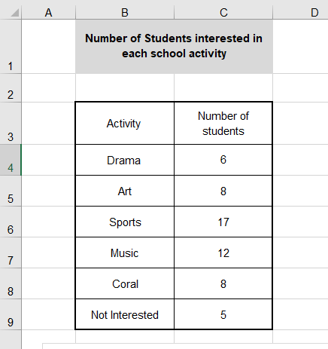 Create a new sheet and rename to **[Task 1]**.
  2. In the sheet **[Task 1]** create the following table.
  3. Use the same alignments as appear in the image.
  4. Use suitable row height and column width.
  5. Use the data in the **[Form Responses] Sheet,** to fill the given table with data.
  6. Create a pie chart to show the percentage of students interested in different types of activities.
     1. Add a chart title "Students Interest Distribution"
     2. Display the percentage.
     3. Show the legend

**[Task2]**

* 1. Create a new sheet and rename to [Task 2].
  2. In the sheet [Task 2] create the following table.

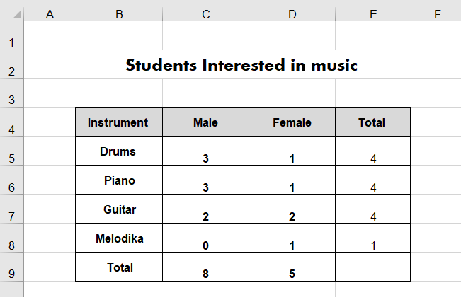

* 1. Use the same alignments as appear in the image.
  2. In cell E5 insert a function to calculate the total number of students interested in playing Drums.

Replicate this function over the cells [E6:E8].

* 1. Use suitable row height and column width.
  2. Create a pie chart to show the percentage of students interested in playing different types of instruments.
     1. Add a chart title “Musical instrument performers”.
     2. Show the Legend.
     3. Display the percentage.
  3. In Cell B9 add the word [Total].
  4. In the cell C9 insert a function to calculate the total number of Male interested in Music.
  5. In the cell D9 insert a function to calculate the total number of Female interested in Music.
  6. Create a pie chart to show the percentage of Male/Female interested in Music.
     1. Add a chart title “Male/Female interested in Music”.
     2. Show the Legend.
     3. Display the percentage.

**Presentation**

* 1. Create the following PowerPoint presentation taking into consideration each of the following:
     1. Select suitable slide layout.
     2. Copy the charts from the excel file.



