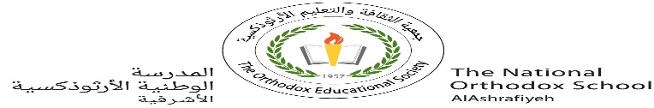

**Value*:*** “Respect yourself above all.”

The National Orthodox School

Science Worksheet

Name: Grade: 7(A+B)

Date: / /2023 Unit: 3

***Lesson 2: Metallic and Non-metallic Substances***

### - *Elements can be divided into metals and nonmetals* .

**aluminum / copper**

**mercury**

**Oxygen Sulphur carbon**

### Difference between metals and nonmetals

1. *Match the following terms to their definitions*

electrical conductor lustrous malleable

hardness ductile thermal conductor

|  |  |  |
| --- | --- | --- |
| **Lustrous** |  | All metals are shiny when polished or freshly cut |
|  |  |
|  |  |  |
| **Hardness** |  | Metals do not break – they bend |
|  |  |  |
| **Ductile** |  | Metals can be drawn into wires |
|  |  |  |
| **Malleable** |  | Metals can be hammered into sheets |
|  |  |  |
| **Electrical conductor** |  | All metals conduct electricity |
|  |  |
|  |  |  |
| **Thermal (heat ) conductor** |  | Metals allow energy to flow through them, causing heating |
|  |  |  |

2. *Which of the following are NOT properties of most metals? Circles your answers*

strong magnetic high melting point

brittle hard