** Vocabulary _ Unit 6 (What a Character!)**

**Our value: Self – belief and hard work will always earn you success**

**Name………………… Grade (7)**

|  |
| --- |
| **Objectives**  **1. Identify the meaning of the new words.**  **2. Practice using the new words in sentences.** |

**Verbs**

|  |  |  |  |
| --- | --- | --- | --- |
| **Word** | **Synonym** | **Meaning** | **Example** |
| Simmer | Boil gently | To bubble gently over heat. | The soup was simmering on the stove. |
| Waft | Float | To float in the air. | The smell of fine coffee wafted out of the café. |
| Droop |  | To hang down. | The long scarf drooped from her shoulder. |
| Lean | Bend | To bend the body in the middle. | He leaned back in his car. |
| Perch |  | To sit on the edge of something. | The bird perched on the mast. |
| Scrutinise | Examine | To look very carefully. | My dad scrutinised the crack in the wall. |
| Polish | Varnish | A substance used to give a shiny surface to objects. | He used a good quality polish after he painted his car. |
| Wink | Blink | To shut then open one’s eye quickly while looking at someone. | He winked at Nicole as he passed. |
| Grin | Smile | To give a big smile. | Meg grinned cheerfully when she got the reward. |
| Carve | Sculpt | To make an object by cutting from wood or stone. | He carved the statue using only one tool. |
| Mind | Object | To not want to do something. | I don’t mind getting out tonight. |

**Adjectives**

|  |  |  |  |
| --- | --- | --- | --- |
| **Word** | **Synonym** | **Meaning** | **Example** |
| Crimson | Dark red | Of a rich deep red colour. | My face blushed crimson with embarrassment. |
| Laden | Loaded | Heavily loaded with weight. | The tree is laden with apples. |
| Delicate | fragile | Can be easily damaged. | The spider’s web is delicate. |

**Nouns**

|  |  |  |  |
| --- | --- | --- | --- |
| **Word** | **Synonym** | **Meaning** | **Example** |
| Tools | Instruments | Instruments used for particular functions. | I bought all the gardening tools. |
| Workshop | Workroom | A building for making things in. | We are decorating the workshop. |
| Passageway | Corridor | A long way that connects rooms or buildings. | Visitors were asked to take the passageway to reach the hall. |
| Glimpse | Quick look | A very quick look at something. | She caught a glimpse of the ocean. |
| Screwdriver |  | A tool for driving in screws. | Don’t use old screwdrivers to fix the joints. |
| Chisel |  | A tool used to shape hard materials. | The statue can’t be made without a chisel. |
| Pliers | Pincers | Pincers used to grip small objects or bend wires. | Bend the wires using pliers. |
| Rack | Framework | A framework used to hold tools. | I use a rack to keep my tools organized. |
| Hammer | Mallet | A tool used to break things or to drive nails in. | These nuts need a hammer to be broken. |
| Saw |  | A tool with a blade used to cut wood and other materials. | Make a mark on the tree’s trunk using a saw. |
| Screw | Bolt | A small metal pin used to join things together by being rotated. | The wooden pieces are held together by screws. |
| Nail | Pin | A pin used to join things together by being hit with a hammer. | I need a nail to hang the picture on the wall. |
| Concentration | Focus | The power to give full attention to something. | Try not to lose your concentration while studying. |
| Satisfaction | Pleasure | A pleased feeling that something is good. | He smiled with satisfaction. |
| Stove | Oven | An oven used for cooking. | I forgot the pie in the stove. |
| Rim | Edge | The outer edge of an object. | The rim of the cup is painted with gold. |
| Apron | Overall | A protective garment worn over your clothes and tied at the back. | Don’t forget to wear your apron when you start painting. |
| Expression | Look | The look at someone’s face. | He immediately showed a sad expression. |

**Adverbs**

|  |  |  |
| --- | --- | --- |
| **Word** | **Meaning** | **Example** |
| Intricately | In a complicated manner. | He made an intricately detailed model of the house. |

**Q1:Write the words below the correct pictures.**

|  |
| --- |
| stove_ rim_ passageway _ tools_ rack_ apron _ nails _ screw _hammer _expressions _ pliers _ chisel _ workshop _ screwdriver _ saw |

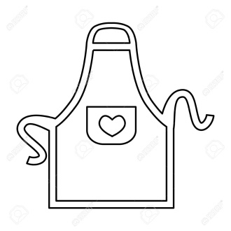 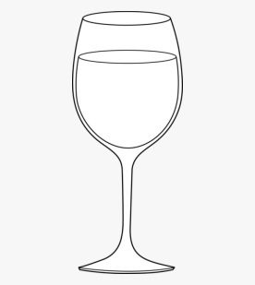 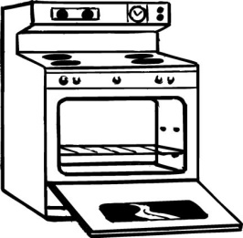 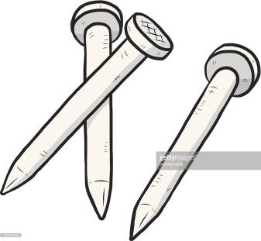 

______apron _____ _____rim_____ _______stove____ _______ nails_____ ______screw____

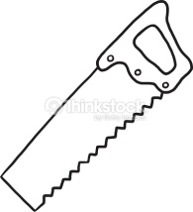 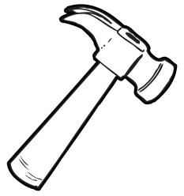  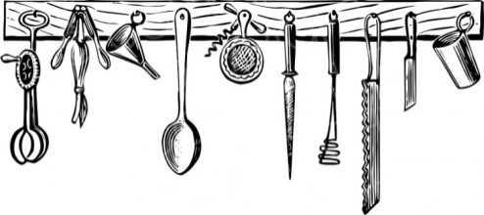

____saw______ ______hammer _____ _____ tools _______ ________rack ________

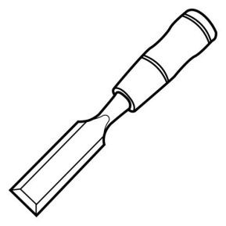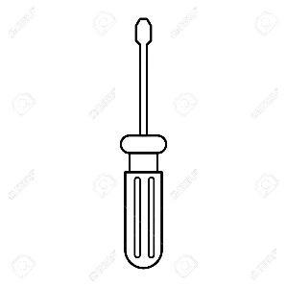 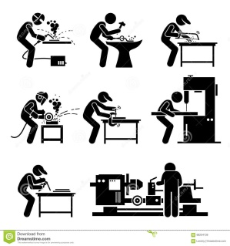 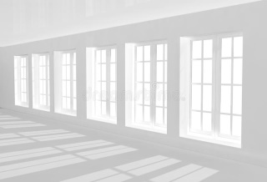

_____chisel ____ ______screwdriver_______ _____workshop________ __passageway________

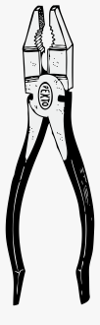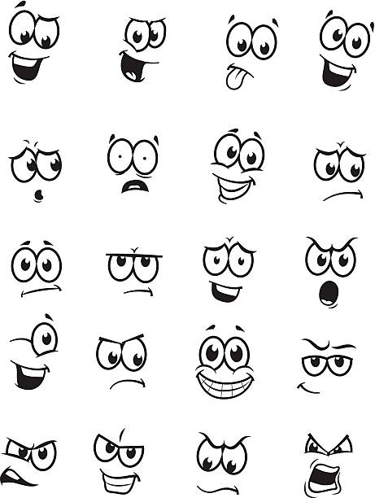

_ expressions____ ___pliers _____

**Q1: Fill in the gaps with suitable words from the box.**

scrutinized_ droop_ mind_ crimson_ intricately_ satisfaction_ simmer_ perch_ glimpse _ concentration

1. The __intricately ____ designed crown worth a million dollars.
2. He smiled in _ satisfaction ____ when he won the race.
3. The leaves of this kind of trees turn _crimson___ in autumn.
4. I would never ___mind___ having the party in my house.
5. Leave the vegetables to _ simmer____ for a few minutes.
6. The plant needs some water, it’s starting to ___droop ___.
7. My father used to __perch__ me on front of his bike.
8. This lesson needs all your ___ concentration __.
9. He caught a __glimpse___ of her in the theatre last night.

**10.**The teacher _ scrutinised__ my painting to evaluate it and give me a mark.

**Q2: Use these words in sentences of your own.**

1. Waft:_ The smell of the cake wafted in the house.
2. Lean:_ He was leaning out of the window.
3. Polish:_ I had polished my shoes.
4. Wink: He gave her a wink. I want you to give me the gun when I wink at you.
5. Grin: He looked at me with a wide grin.
6. Carve: My father carved a big statue.
7. Laden: This tree is laden with apricots.
8. Delicate: I have a delicate set of brushes. She has delicate feelings.

**Good Luck**