**Science Worksheet #2/ Term 2**

Explaining Chemical Changes

Name: __________________ Grade **7A**

Date:  **/3/2023**

**1 -** Match each of the acids with its use. Draw lines between the matching pairs.

|  |  |  |
| --- | --- | --- |
| a) Sulfuric acid |  | This is found in vinegar and is used for pickling foods |
| b) Nitric acid |  | This is found in citrus fruits and can be used as a food preservative |
| c) Ethanoic acid |  | This is found in tea. |
| d) Citric acid |  | This can be used in fertilisers and car batteries |
| e) Tannic acid |  | This can be used in fertilisers, paints and explosives |

**2-** Identify what each hazard symbol means.

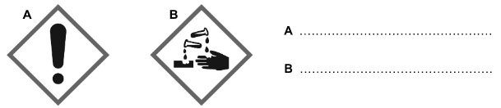

b) What precautions would you take when working with an acid labelled with each of the hazard symbols?

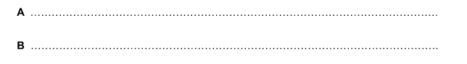

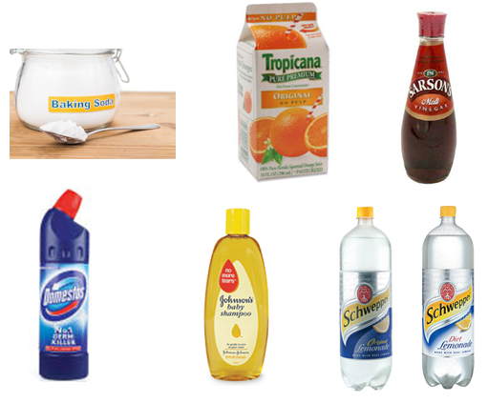

**3-** Circle the alkalis from the substances below.

**4-** Some alkalis are so weak that we can put them on our skin or even take them into our bodies. Other alkalis are too harmful to put directly on our skin or in our bodies.

1. Describe three products that contain alkali that are safe enough to use on our skin or to eat.

|  |
| --- |
|  |
|  |

b) Each of the products below can be dangerous. For each product, decide whether it is **harmful** (caution) or **corrosive.**

* Bleach ________________________
* Oven cleaner __________________
* Caustic soda __________________
* Bathroom cleaning fluid _____________________

ii)

**5-** For each of the acids and alkalis, identify the elements that it contains.

|  |  |
| --- | --- |
| Sodium hydroxide, NaOH : |  |
| Hydrochloric acid, HCl : |  |
| Magnesium hydroxide, Mg(OH)2 : |  |
| Sulfuric acid, H2SO4 : |  |

**6-** Copy and complete the paragraph using the following words:

|  |
| --- |
| **indicator      colour      blue      litmus      red** |

**What are indicators?**

A substance that can tell us whether something is an acid or an alkali is known as an ________________. Indicators change _______________ in acids and alkalis.

One type of indicator is __________________. This turns _____________ in acid and _____________ in alkali.

**7-** Use the information in the table to decide whether each of the unknown substances A, B and C is an acid or an alkali. Write the answer under each diagram

|  |  |  |
| --- | --- | --- |
| **Indicator** | **Colour in acid** | **Colour in alkali** |
| beetroot | red | purple |
| geranium petals | orange-red | blue |
| red onion | pale red | green |

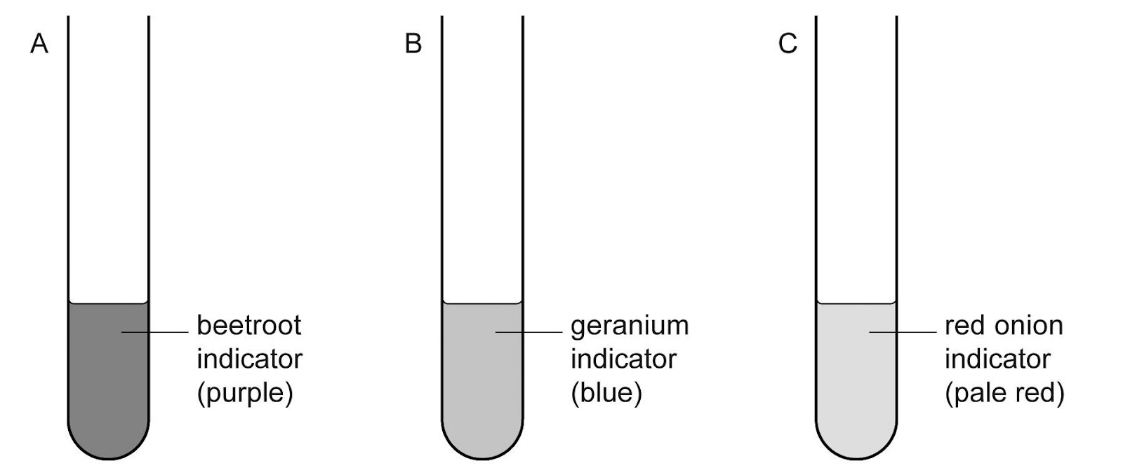

**8-** The pH scale demonstrates how strong an acid or an alkali is. The colours on a pH colour chart show the colour that universal indicator turns with acids and alkalis of different strengths.

a) Colour the pH colour chart below to show what colour universal indicator turns with different strengths of acids and alkalis.

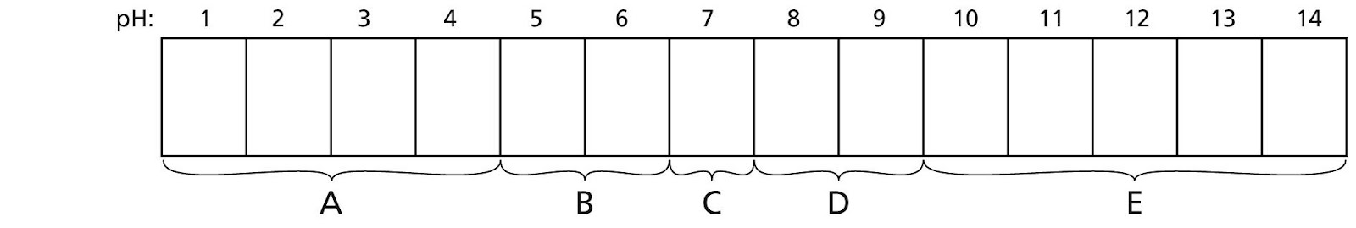

b) Identify the labels A to E, choosing from the words below and write the label against the pointer.

|  |
| --- |
| **strong acid      weak acid      strong alkali      weak alkali      neutral** |

A ………......................………….

B ………......................………….

C …………......…………………..….

D ………......……………….……….

E ………......................………….