

**Our value: Self – belief and hard work will always earn you success**

Grammar Unit 11: Passive Voice

Grade 5 (A + B)

Name: Date: / /2023

Objectives: To identify the transitive & intransitive verbs.

To identify the passive voice.

To practise using the passive voice.

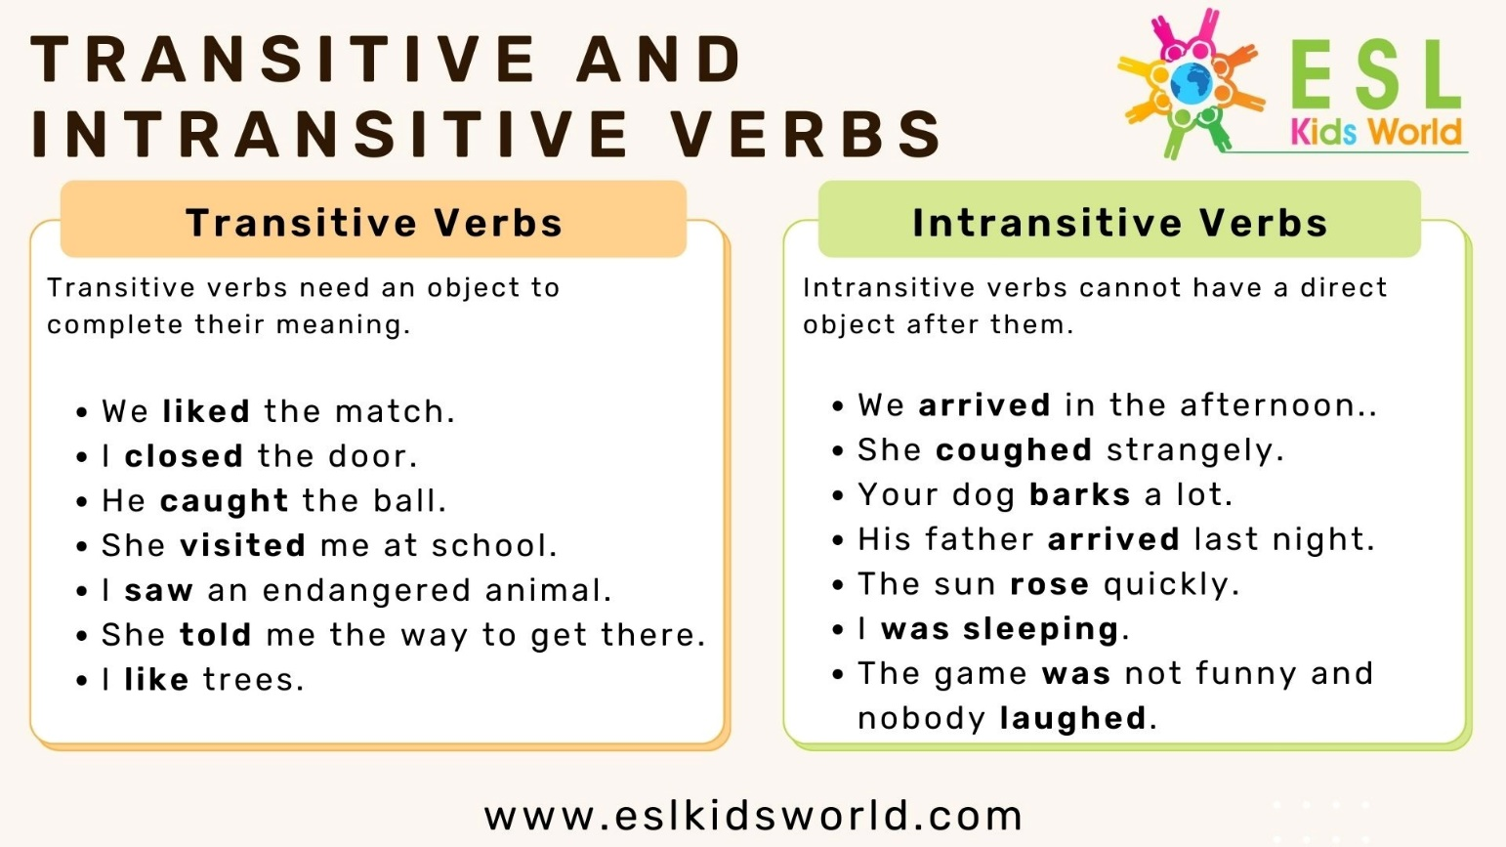

**Only transitive verbs (verbs followed by an object) can be changed into the passive. While intransitive verbs (verbs not followed by an object) cannot be changed into the passive.

**What is an easy way to explain transitive verbs?**

A transitive verb is a verb that uses a direct object, which shows who or what receives the action in a sentence. In the example “she gives a gift,” **gives** is a **transitive verb** and a **gift** is the **direct object**.

S V Obj

-Peter feeds the cows. (feeds = transitive verb)

The cows are fed by Peter.

S Prepositional phrase

-They go to school every day. (go = intransitive verb)

This sentence cannot be changed.

**Passive Voice: Definition**

In the active voice, the subject of the sentence **DOES the action:**

* **John painted** the **house** last week.  
  **Doer (subject) / verb / object**

In the passive voice, the subject of the sentence **RECEIVES the action.**

* The **house was painted** last week.  
  **Receiver (object) / verb**

Notice that the **object** of the active sentence (house) became the **subject** of the passive sentence.

***\*\*Forming Simple Present Passive***

Affirmative Form

**Object + am / is / are + verb3 (past participle)**

Something is done by someone regularly / everyday / as expected...

[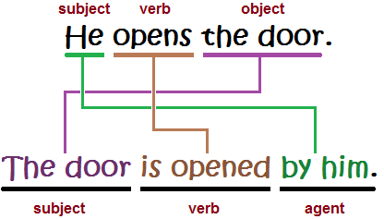](https://www.google.com/url?sa=i&rct=j&q=&esrc=s&source=images&cd=&cad=rja&uact=8&ved=2ahUKEwjK6raC4p3hAhVB26QKHYpJBzsQjRx6BAgBEAU&url=http://lucycripps.com/2017/05/02/breaking-the-passive-habit/&psig=AOvVaw1vnjMOa0EPHNo3m1sd3-7p&ust=1553619548583100)

***\*\*Forming Simple Past Passive***

**Object + was / were + verb3 (past participle)**

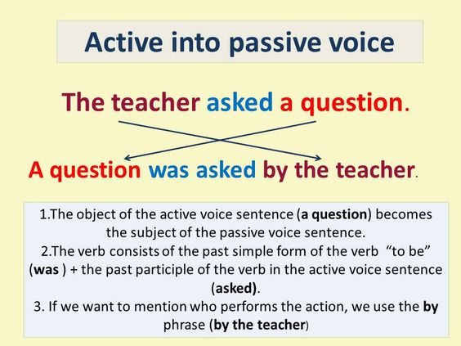

[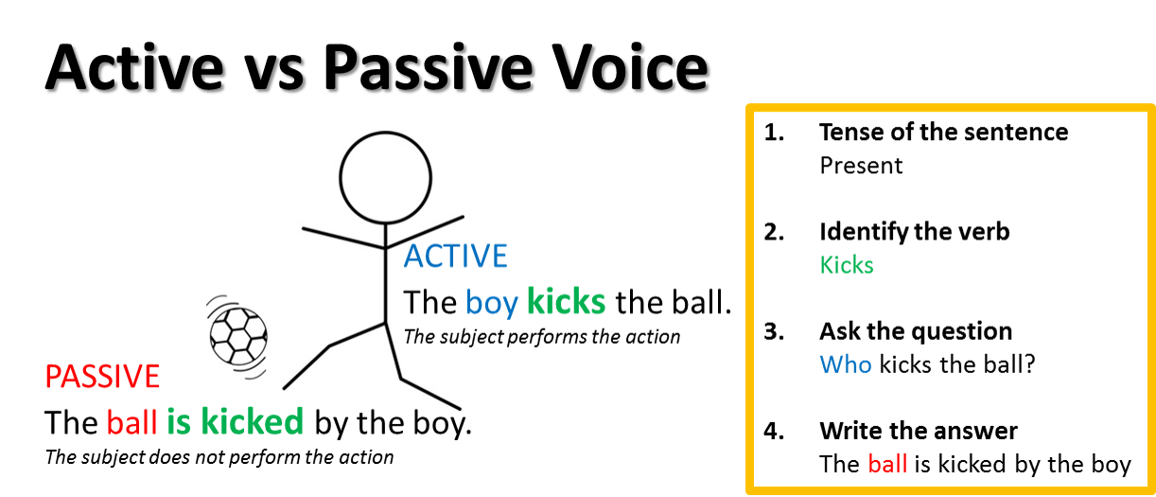](https://www.google.com/url?sa=i&rct=j&q=&esrc=s&source=images&cd=&cad=rja&uact=8&ved=2ahUKEwjyr4TL4p3hAhVNDOwKHXD4AkgQjRx6BAgBEAU&url=https://medium.com/@polishedpaper/professional-editors-corner-active-versus-passive-voice-510dc215a94e&psig=AOvVaw1vnjMOa0EPHNo3m1sd3-7p&ust=1553619548583100)

*** Don’t forget to change the pronouns in the passive:

For example: He kicks the ball. (Active)

The ball is kicked by him. (Passive)

I me

She her

He him

It it

You you

We us

They them

**\*\*Change the following sentences into past passive.**

1. **She played football**

**Football was played by her.**

1. **He wrote a letter.**

**A letter was written by him.**

1. **She sang a song.**

**A song was sung by her.**

***\*\*Change these active sentences into present passive.***

1. **The farmers produce food.**

**Food is produced by the farmers.**

1. **The magician knows tricks.**

**Tricks are known by the magician.**

**3. She writes a book.**

**A book is written by her.**

***\*\*Change these active sentences into present or past passive ones.***

* 1. **She bought four apples.**

**Four apples were bought by her.**

**2. We won the match.**

**The match was won by us.**

1. **The man stole the blue car.**

**The blue car was stolen by the man.**

1. **The police arrested the thieves.**

**The thieves were arrested by the police.**

1. **Jack swam the 200 meters.**

**The 200 meters were swum by Jack.**

1. **Mr. Jones watches films.**

**Films are watched by Mr. Jones**

1. **People speak English.**

**English is spoken by people.**

1. **He reads comics.**

**Comics are read by him.**

1. **We play volleyball.**

**Volleyball is played by us.**

**10.She does the housework.**

**The housework is done by her.**

Coordinator’s Signature: -------------------

Teacher: Mirna Nawaf Al-Sahawneh.

