

**Writing A Newspaper Article**

**Name: ……………………………**

**Grade: 8 CS:…………………….**

**What is a newspaper report?**

Newspapers report on news stories from around the world every day. They are written in the past tense because they are reporting on things that have already happened.



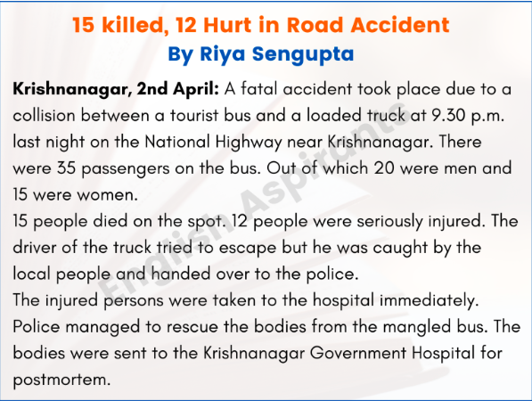

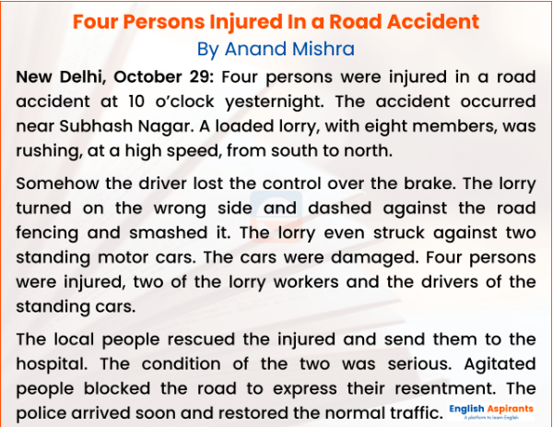

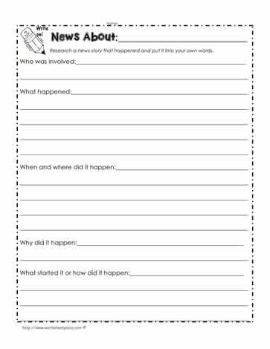

* The key elements of a News Report are:
  1. **Headline**

Catches your attention

Sums up the story

* 1. **Byline**

Writer’s name

Writer’s Specialty, e.g. sports, food, crime, current events

* 1. **Lead**

4.

The opening section

Gives most important information

Should answer most of the 5W's

* 1. **Body**

Supplies detail

Most important details come first

Simple true statements

**5.Quotation**

What someone actually said

Adds accuracy

Adds “at the scene” feeling